ANNAMACHARYA INSTITUTE OF TECHNOLOGY & SCIENCES
KADAPA-516003

SERVICE RULES

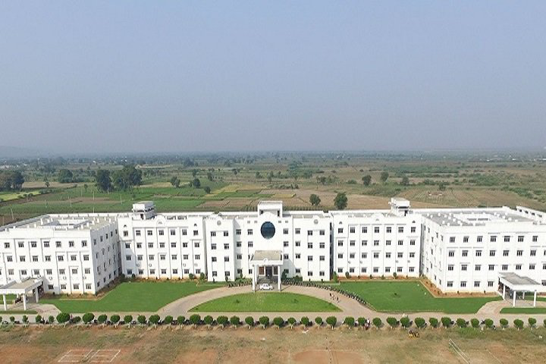

Prepared by
INTERNAL QUALITY ASSURANCE CELL

ANNAMACHARYA INSTITUTE OF TECHNOLOGY AND SCIENCES
Utukur (Post), Chinthakomma Dinne (V&M), Kadapa, YSR (Distt.),
Andhra Pradesh - 516 003.
(Approved by AICTE, New Delhi & Affiliated to JNTUA, Anantapuramu)

Speak to Us (08562) 201003 Fax (08562) 201005

Mobile +919603999591 / +919603999592 Email aitskadapa@gmail.com

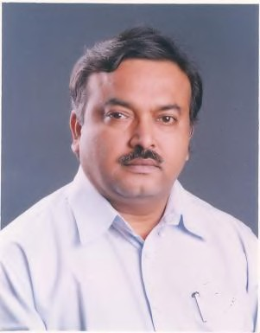

Sri Gangi Reddy Choppa, Founder & Honorary Secretary Annamacharya Educational Trust (AET)

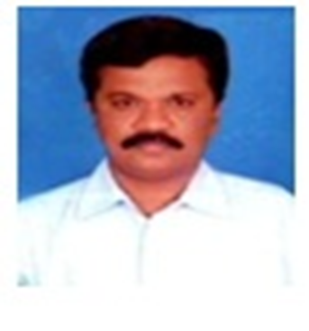

Dr. A. Sudhakara Reddy Sri. C.Abhishek Reddy
PRINCIPAL TREASURER, AET
About Institute
Annamacharya Institute of Technology and Sciences was established in the year of 2010 at kadapa. The college is affiliated to Jawaharlal Nehru Technological University Anantapur, Ananthapuramu. Annamacharya Institute of Technology and Sciences, Kadapa was founded by Sri Choppa Gangi Reddy garu, under the auspices of Annamacharya Educational Trust. He put in all his heart and sinew to raise technocrats and managers of high academic standards and character. In his leadership, Annamacharya Group, consequently, founded three engineering colleges located at different parts in Andhra Pradesh and Telangana.
Annamacharya Institute of Technology and Sciences, Kadapa is an exemplary institution of higher learning with a mission of pursuing excellence in education and research. Having made a humble beginning in 2010 with an annual intake of 300 in five streams, AITS Kadapa now offers graduate engineering degree in Civil, Mechanical, EEE, ECE, CSE and AI&DS. Post graduate programmes in Structural Engineering, Thermal Engineering, VLSI System Design, EPS, and CSE are offered. For this academic year around 1350 students are studying in the campus.
Since its inception, AITS Kadapa is committed to develop and nurture technological education and intends to produce technical manpower of high quality, comparable to the best in the world.

ANNAMACHARYA INSTITUTE OF TECHNOLOGY & SCIENCES

INSTITUTE VISION

To emerge into excellence meeting the changing needs of society by fostering on its traditions of knowledge, innovation, problem solving, professional and technological acumen, and discipline. Transforming individuals into highly enlightened professionals enriched with innovative technical skills entwined with intellectual, ethical and humane sensitivities.

INSTITUTE MISSION
- Our primary mission is to move frontiers of technological knowledge, enrich and elevate the rural education seekers, endow them with technical skills, ethics, innovative thinking and leadership qualities enabling them to utilize their competencies for the sustainable development of the nation and mankind.
- Emerge into premier institute by imparting quality technical education to enhance knowledge and employability skills.
- Promote up gradation of teaching and research skills to cater to the societal needs.
QUALITY POLICY

AITS is committed to achieve excellence in Teaching, Research and Consultancy
- By imparting truly Global Focused Education
- By Creating World Class Professionals
- By Establishing Synergic Relationships with Research hub and Society
- By Developing State-of-art-Infrastructure and Well Endowed Faculty
- By Imparting Knowledge through Team Work and Incessant Effort

 | CONTENTS
PART | Description | Page No
PART-I | SERVICE RECORDS
1.1 | General | 1
1.2 | Definition | 1
1.3 | Service Records | 1
1.3.1 | Service of records | 1
1.3.2
Service conditions for the staff (Permanent/Ad-hoc)
Termination of
2
1.3.3
3

 | Service/Resignation
PART- II | METHOD OF RECRUITMENT
2.1 | Screening | 4
2.2 | Interview | 5
2.3 | Pay fixation | 5
2.4 | Promotion policy | 5
2.5 | Retirement | 5
PART-III | CONDUCT & DISCIPLINE
3.1 | Conduct | 5
3.2 | Discipline | 7
PART – IV | LEAVE RULES
4.1 | General | 7
4.2 | Appointed on Regular Basis (on  scale) | 8
4.2.1 | Earned Leave | 8
4.2.2 | Vacation Leave | 8
4.2.3 | Accumulation of earned leaves | 9
4.2.4 | Maternity Leave | 9
4.3 | Temporary and Ad-hoc Basis and  on Consolidated Salary | 9
4.3.1 | Earned Leave | 9
4.3.2 | Vacation Leave | 10
4.3.3 | Accumulation of earned leaves | 10
4.4 | On Duty rules | 10

PART- V
REGULATIONS FOR STAFF MEMBERS
DEPARTMENT RULES CLASS ROOM TEACHING LABORATORY TESTS/EXAMINATIONS
STUDENT - FACULTY REPORT
Financial assistance for faculty
Pay Scales
11
PART- VI PART VII PART –VIII
PART- IX PART- X
Annexure 1
Annexure 2
12
12
13
14
14

PART I: GENERAL RULES

  - GENERAL

    - These rules shall be called “Annamacharya Institute of Technology & Sciences, Kadapa Service and Conduct Rules” and shall come into force from the date May 2011 as decided by the Annamacharya Educational Trust. These rules were framed from the rules which are already in force.

    - These rules shall apply to all categories of staff members (Teaching, Non-Teaching and Supporting Staff).

DEFINITION:

    - ‘Institute’ means “Annamacharya Institute of Technology & Sciences , Kadapa”
    - ‘Trust’ means “Annamacharya Educational Trust, Hyderabad”
    - ‘Teaching Post’ means a post carrying a definite scale of pay / consolidated pay
    - ‘Supporting Staff’ means a person appointed in a Non-Teaching post to which no other person holds a lien.

SERVICE RECORDS
    - Records of Service
      - A service book for keeping the record of service of staff shall be maintained by Office in respect of each employee of the Institute.
      - All activities of a staff member in his/her official position shall be recorded in this service book, and each entry must be attested by the Administrative Officer (AO) or his/her superior.
      - The AO shall show the service book to each staff member in the month of April every year and the employee shall sign in the service book after verification.
    - Service conditions for the staff (Permanent/Ad-hoc)
      - Every staff member shall agree to abide by all the conditions herein stated and also such conditions as may be stipulated from time to time by the competent authority.

      - Every staff member shall employ himself/herself honestly, efficiently and diligently under the orders and instructions of the Principal/Director or other officers under whom he/she shall, from time to time, be placed. He/she shall discharge all duties pertaining to the office and perform in such a manner which may be required of him/her or which are necessary to be done in his/her capacity as aforesaid.
      - Every staff member shall devote his/her whole time to the duties of the said employment and shall not, either directly or indirectly, carry on or be concerned/involved in any trade, business or canvassing/private consulting work, private tuition or the like of a remunerative kind or of an honorary nature without the specific written permission of the Chairman/Director/Principal.
      - Notwithstanding anything contained above, whenever any consultation work for any private firm or institution is undertaken by the Institute, such members of the staff as are required will be commissioned by the institute, with/without additional remuneration or honorarium as prescribed by the institute, from time to time.
      - Any staff member, on appointment, except on contract, shall be on probation for a period of two years.
      - All the teaching staff on permanent basis shall be paid AICTE scale of pay and other allowances as per Institute norms. In addition, contribution shall be made by the management towards the employees’ provident fund, at a rate fixed by the Government of Andhra Pradesh
      - Staff attendance should be signed every day in staff attendance register and swipe the attendance machine while he/she enters into institute and swipe while he/she leaves the institute.
      - Staff should be available in the Institute premises during the entire period of office hours, on all working days.
      - If a staff member on any kind of leave has to be out of station, he/she should intimate the Principal/Head of the Department his/her exact out station address and phone numbers in his/her leave application.
      - No faculty member shall apply, during the period of his/her service in this institution, for an appointment outside or send an application for study or training, except with the prior permission of the management and such application should be routed through the Principal/Director. Any violation of this rule will be viewed seriously and suitable disciplinary action will be taken. The management may permit not more than two such applications in an academic year, but reserves the right to refuse the forwarding of such applications in case there is

any bond for the employee for a particular period of service in the institute.
      - The Principal/Director shall have the right to place any staff under suspension on charges of misconduct.
      - In a case wherein a member of the teaching or non-teaching staff commits any misconduct in discharge of his/her duties, the Secretary has got discretion to award punishment such as warning, censure, withholding of increment with or without cumulative effect after conducting an enquiry by a committee constituted by Principal.
      - For the development and progress of the institute/department, all members of the staff should work as a team and they should also maintain a cordial relationship with other departments.
      - In any meeting or assembly, decorum should be maintained and difference of opinion, if any, shall be expressed politely in diplomatic words without hurting the feelings of others.
      - Staff members should get prior permission from Management/Principal/Director to contact any outside agency or government departments for any matter related to the institute/hostels.
      - If a staff member draws advance from the institute to meet financial expenses for official tour or for arrangement of an institute event, he/she shall settle the account within 10 days from the date of withdrawal of advance, failing which the advance shall be adjusted from his/her salary.
      - Staff Members, if and when relinquishing their job, shall hand over their jobs and responsibilities and get the NOC from all departments concerned.
      - All members of the staff shall be governed by general rules / norms also practiced by institute from time to time.
      - The appointing authority shall have the power to terminate the service of any member of the staff by 3 months’ notice if on the medical grounds, certified by a medical authority nominated by the Governing Body; his retention in service is considered undesirable by such authority.
      - The management shall have the power to terminate the service of any member of the staff on grounds of retrenchment or economy by giving to the person concerned 3 months’ notice in writing.
    - Termination of Service/Resignation

      - If in the opinion of the appointing authority, the efficiency of an employee has been impaired due to any infirmity, due to which his retention in service is considered undesirable, by such appointing authority, his services may be terminated.

      - Faculty member, when resigns, has to give the following information.
        - Nature of appointment at this institute (Consolidated or on scale)
        - Notice period (2 Months/3 Months)
        - Reasons for resignation (unless it is confidential)
        - Date of relief, before the end of the notice period
      - The member will be relieved on any day before the end of the notice period as decided by the Principal of the Institute. However, the Principal of the Institute has the right to detain the member beyond the notice period till the end of the semester or academic year.
      - The decision regarding the date of relief will depend on a number of factors like the appointment of a substitute, completion of the responsibilities like covering the syllabus, valuation of the answer scripts, completion of a particular assignment entrusted to the member, etc.
      - The other terms and conditions of such employment shall be specified by the appointing authority in the letter of appointment.

PART- II - METHOD OF RECRUITMENT
  - SCREENING
    - Recruitment is normally done twice in a year.
    - Number of vacancies is notified by Principal/Director based on student strength/resignations or terminations of staff members, to the management for approval/information.
    - Vacancies are advertised in leading newspapers – both Telugu and English.
    - Screening of applications is done by the respective screening committee.
    - Short listed candidates are informed through call letters
    - At times, Walk- in interviews is also conducted for immediate postings.

INTERVIEW
    - Interview Committee consists of Hon. Secretary, Principal, Director, faculty member; subject expert from outside the institute and respective Heads of the department.
    - In case of large number of applications, a written test is conducted for Lecturers post and short listed candidates shall be called for personal interview and selection be made on merit.
    - Direct interview is conducted for senior posts. Selection committee shall be constituted by the Secretary as per the guidelines approved by the Governing body.

PAY FIXATION
    - Pay for the selected candidates is fixed by the selection committee as per the pay scale approved by the Governing Body for the respective post based upon the qualification and experience of the candidate.
    - Higher Pay Packages for exceptional and experienced candidates are fixed by the selection committee subject to the approval of the Chairman of the Annamacharya Educational Trust.

PROMOTION POLICY
    - Person entering the teaching profession with PG Degree shall be designated as Assistant Professor and shall be placed in the Pay Band of Rs.15000 with AGP of Rs.6000
    - Assistant Professors with Ph.D. having 5 years of experience or Assistant Professor with completed service of 10 years can be promoted as Associate Professor and shall be in the Pay Band of Rs.37400- 67000 with AGP of Rs.9000
    - Associate Professors completing Ph.D. having 10 years of Experience shall be promoted as Professor and can be in Pay Band of 37400-67000 with AGP of Rs.10,000

RETIREMENT
    - The age of retirement of teaching faculty member shall be as per AICTE Norms.
    - The age of retirement of other non – teaching staff shall be as per State Government Rules or as may be decided by the Management.

PART III CONDUCT & DISCIPLINE
3. 1 CONDUCT
    - Every staff member shall, at all times, maintain absolute integrity and devotion to duty and do nothing which is unbecoming of an employee of an educational institution.

    - Every staff member shall abide by and comply with the rules and regulations of the institute and all orders and directions of his/her superior authorities, under whose control, he/she is placed.
    - Every staff member shall extend utmost courtesy and attention to all persons with whom he/she is to deal with in the course of his/her duties.
    - Every staff member shall Endeavour to promote the interest of the institute and shall not act in any manner prejudicial thereto.
    - No staff member shall be a member, or be otherwise associated with, any political party or any organization which takes part in politics, nor shall he/she take part in, subscribe in aid of, or assist, in any other manner any political movement or activity.
    - No staff member shall join, or continue to be a member of an association the objectives or activities of which are prejudicial to the interests of the autonomy and integrity of India or public order or morality.
    - No staff member shall engage directly or indirectly in any trade or business or undertake any other employment. For undertaking honorary work of a social and charitable nature or work of a literary, artistic or scientific character the staff member shall obtain prior permission of the Principal/Director.
    - A staff member of this institute shall strictly abide by any law relating to alcoholic drink or drug in force in any area in which he may happen to be for the time being and not to be under the influence of any alcoholic drink or drug during the course of his duty and shall also take due care that the performance of his duties at any time is not affected in any way by the influence of such drink or drug.
    - Obligation to maintain secrecy: Every staff member shall maintain the strictest secrecy regarding the institute affairs and the affairs of its constituents and shall not divulge, directly or indirectly, any information of confidential nature either to a member of the public or of the institute staff, unless compelled to do so by a judicial or other authority or unless instructed to do so by a superior officer in the discharge of his duties.
    - No staff member of the institute shall enter into any partnership, accept any fees, endowment or commission whatsoever from any part other than the institute, except with the prior permission of the Hon. Secretary.
    - Acceptance of gifts: A staff member shall not solicit or accept any gift from any subordinate employee, provided that such gifts, grants and donations shall be received by a staff member in the official discharge of his duties for the Institute.

DISCIPLINE
    - The Chairman/ Secretary or any other competent authority may place a staff member under suspension when disciplinary proceedings against him/her are contemplated or are pending or a case against him/her in respect of any criminal offence is under investigation, inquiry or trial.
    - A staff member who is detained in police or judicial custody, whether on a criminal charge or otherwise for a period exceeding 48 hours or is sentenced to a term of imprisonment exceeding 48 hours by a court of law and is not forthwith dismissed or removed or compulsorily retired consequent to such conviction, shall be deemed to have been suspended with effect from the date of his detention/conviction by an order of the Chairman/Secretary and shall remain under suspension until further orders.
    - An order of suspension made or deemed to have been made under this bye-law shall continue to remain in force until it is modified or revoked by the authority competent to do so.

PART IV – LEAVE RULES
  - General
    - Leave accounts shall be maintained for each staff member in appropriate forms.
    - Leave is earned by “Duty” only. Duty for the purpose of leave includes, in addition to the days on duty;
    - Leave cannot be claimed as a matter of right. The sanctioning authority has full discretion to refuse or revoke leave of any description when the exigencies of service so demand or based on the reason for leave application.
    - A staff member who tenders resignation will not be eligible for any Leave excepting the casual leave for the proportionate period
    - The sanctioning authority may recall a staff member to duty before the expiry of his leave or vacation.
    - Unauthorized absence from duty may be treated as misbehavior involving disciplinary action.
    - A Staff member on leave shall not take up any service or accept any employment without the prior sanction of the sanctioning authority.
    - The Principal shall be the authority competent to sanction leave to all staff member. In the case of the Principal, Chairman of the Governing Body will be the authority to sanction leave.
    - Casual leave will be admissible to a staff member of the Institute for a total period not exceeding 15 days in a calendar year. It may be granted for a period not exceeding 10 days at a time, including holidays. It may also be granted for half a day. Any balance period of C.L. shall lapse with the Calendar year.

    - Casual Leave should not be combined with any kind of regular leave or vacation or with Special Casual Leave.
    - Academic leave: A faculty member is eligible for 15 days of academic leave in a calendar year, which can be sanctioned only for JNTUA examination work (Spot valuation, observer, etc.)
    - Extra-ordinary Leave: Extra–ordinary leave maybe granted in the special circumstances mentioned below:
      - When no other leave is admissible, or
      - When other leave being admissible, the employee applied in writing for extraordinary leave. Such leave is not debited against leave account.
    - Leave Salary:
      - A staff member on Leave is entitled to Leave Salary equal to the pay drawn in his/her post before the day leave commences.
      - A staff member on Extra-ordinary leave is not entitled to any leave salary.
  - Staff members appointed on Regular Basis (on scale)
    - Earned Leave: The earned leave admissible to a staff member will be computed by using the following formulae.
A. For staff member on scale of pay Earned leave = [[³⁰ ∗ (N − n₁ − n₂)] − n₃]
N
Where
N = Number of calendar days i. e., 365/366
n₁ = No. of days of Extra Ordinary leave (i. e., leave on loss of pay)
+ No. of calendar days lost due to late joining in the year
n₂ = Number of days of earned leaves availed in the year n₃ = Number of days of vacation availed in the year ÷ 2

Note: The earned leave calculated as above, on 31st December of the year, will be credited to the employee’s Earned leave account on 1st January of next year.
    - Vacation Leave:
      - The Teaching staff and such other members of staff declared as vacation staff shall be eligible for 30 days of vacation in a calendar year. The Earned Leave calculated as in ‘4.2.1’
      - Vacation may be taken in combination with any kind of leave excepting the Casual Leave provided the total duration of vacation and leave shall not exceed 60 days.

    - Accumulation of earned leaves: An employee will, however, cease to earn such leave when the earned leave due amounts to 240 days. Further, the grant of earned leave at a time shall not exceed 60 days. This limit May, however, be relaxed by the competent authority who may grant earned leave in excess of 60 days for special reasons.
    - Maternity Leave: Maternity leave on full pay may be granted to a woman employee for a total period of 90 days to be availed in the entire career. This will be granted subject to the production of Medical Certificate from the Doctor specifying the period of leave recommended. Maternity leave may be combined with earned leave. Extraordinary leave may be granted if Medical certificate supports the request. Maternity leave may also be granted in case of miscarriage including abortion subject to the condition that the total leave granted in respect of this to a woman employee in her career is not more than 90 days and the application for leave is supported by Medical Certificate. Maternity leave will be sanctioned only in case of woman employee with a minimum of three years’ service at this Institute, once during the service period.
    - Special C.L. not exceeding 6 days commencing from the date of operation shall be granted to male employee when he undergoes sterilization operation under the family planning scheme, once during the service period. This will be granted subject to the production of a Medical Certificate from the Doctor who performs the operation to the effect that the operation has been performed on him.
    - The minimum period of leave under these categories is 3 days and must be applied at least 3 days before proceeding on leave. The employee can proceed on leave only after getting such leave sanctioned.
  - Staff members on Temporary and Ad-hoc Basis and on Consolidated Salary

    - Earned Leave
The earned leave admissible to an employee will be computed by using the following formulae.
A. For staff member on Adhoc scale of pay
Earned leave = [[¹⁵ ∗ (N − n₁ − n₂)] − ^{n3}]
N 2
Where
N = Number of calendar days i. e., 365/366
n₁ = No. of days of Extra Ordinary leave (i. e., leave on loss of pay)
+ No. of calendar days lost due to late joining in the year
n₂ = Number of days of earned leaves availed in the year

n₃ = Number of days of vacation availed in the year ÷ 2
Note: The earned leave calculated as above, on 31st December of the year, will be credited to the employee’s Earned leave account on 1st January of next year.
    - Vacation Leave: The Teaching staff and such other members of staff declared as vacation staff shall be eligible for 30 days of vacation in a calendar year provided that the employee has been in service for more than a year. The Earned Leave calculated in 4.3.1 above will be reduced by ¼ of vacation days availed by the candidate.
    - An employee will however cease to earn such leave when the earned leave due amounts to 120 days. Further, the grant of earned leave at a time shall not exceed 30 days. This limit May, however, be relaxed by the competent authority who may grant earned leave in excess of 30 days for special reasons. In case an employee dies while in service, cash equivalent of leave salary that the deceased employee who had got, had he gone on earned leave but for death, due and admissible on the date immediately following the date of death subject to a maximum leave for 120 days shall be paid to the family.
    - The minimum period of leave under these categories is 3 days and must be applied at least 3 days before proceeding on leave. The employee can proceed on leave only after getting such leave sanctioned.
    - Maternity Leave: Maternity leave on full pay may be granted to a woman employee for a total period of 30 days to be availed in the entire career. This will be granted subject to the production of Medical Certificate from the Doctor specifying the period of leave recommended. Maternity leave may be combined with earned leave. Extraordinary leave may be granted if Medical certificate supports the request. Maternity leave may also be granted in case of miscarriage including abortion subject to the condition that the total leave granted in respect of this to a woman employee in her career is not more than 30 days and the application for leave is supported by Medical Certificate. Maternity leave will be sanctioned only in case of woman employee with a minimum of one year service at this Institute, only once in the total service period.

ON DUTY

    - Teaching staff members shall be permitted to avail Special Casual Leave (SCL) for a maximum period of 15 days for University examination duty purpose. Staff member shall be permitted to avail on duty for attending FDP/Workshop/Conference/Symposiums/Seminars etc., in an academic year. ON DUTY shall be availed only with prior approval of the Head of the Institution (Principal).

    - Teaching staff who are deputed for specific purpose on “Other Duty” should submit a detailed report to the Principal about the purpose for which they are deputed, on the next day without fail.
    - The staff members who are proceeding on “Other Duty” with the approval of Principal should produce the “Attendance Certificate” immediately on the date of joining duty after availing “OD”.
PART V: GENERAL REGULATIONS FOR STAFF MEMBERS

  - The Faculty Member should come to the institute at least 15 minutes before the commencement of classes and should leave the Institute not earlier than 15 minutes after the end of the last hour.
  - All the Faculty Members are expected to follow the rules and regulations of the Institution as prevalent from time to time.
  - The work load of all the staff shall be fixed by the management. The work load of the teacher should not be less than 40 hours a week, of which teaching contact hours should be at least as follows:
    - Principal 8 hours/week
    - Dean / Professor 12 hours / week
    - Associate Professor 16 hours / week
    - Assistant Professor/Senior Lecturer/Lecturer 22 hours/week

For the above stipulations, two tutorial hours/two ~ three laboratory/Drawing hours will be counted as one teaching hour.
The work plan of teachers shall ensure, in the most productive manner, the utilization of stipulated 40 working hours per week, with regard to the roles, jobs and targets assigned to them by the Department/Institution.
  - Faculty Members are expected to update their knowledge by attending seminars/workshops/conference, after obtaining necessary permission from the Principal/Management.
  - Faculty Members should attempt to publish text books, research papers in reputed International / Indian Journals / Conferences.
  - The Faculty Member must strive to prepare himself/herself academically to meet all the challenges and requirements in the methodology of teaching so that the input may be useful for the student community at large. Every Faculty Member is expected to extend his/her beneficial influence in building up the personality of students and he/she should associate himself/herself actively with such extra-curricular activities which he / she is interested in or assigned to him/her from time to time.
  - Groupism of any kind should be absolutely avoided. Faculty Members found indulging in such activities will be subject to discipline proceedings.

PART VI: DEPARTMENT RULES
  - The Faculty Member should talk to the HOD and keep the HOD in confidence about the member’s professional and personal activities.
  - The teaching load will be allotted by the HOD after taking into account of the Faculty member’s interests.
  - In addition to the teaching, the Faculty Member should take additional responsibilities as assigned by Principal / HOD in academic, co-curricular or extra-curricular activities.
  - Every Faculty Member must give seminar at least once in each semester to other faculty.
  - Every Faculty Member has to post the student attendance online in ARP portal and simultaneously the absentees Hall Tickets should be noted every day in the Master attendance Register maintained in the Department as soon as the classes/laboratory hours are over.
  - Whenever a Faculty Member intends to take leave, the Faculty Member should get the leave sanctioned in advance and with proper alternate arrangements made for class/lab/ invigilation duty. In case of emergency, the HOD or the next senior faculty must be informed with appropriate alternate arrangements suggested.
  - The Faculty Member should make him/her presentable. The Faculty Member should show no partiality to any segment / individual student.
  - The Faculty Advisor must update the student’s personal file regularly and put up for inspection by HOD/Principal as the case may be.

PART VII: CLASS ROOM TEACHING RULES
  - Once the subject is allotted the Faculty Member should prepare the lecture hour wise lesson plan.
  - The Faculty Member should get the lesson plan and course file approved by HOD and Principal. The course file consists of preface, previous year university question papers, notes, handouts, OHP sheets, test/exam question papers, two model answer scripts for each test/exam, Assignments.
  - The Faculty Member’s Diary must be regularly updated and put up for inspection by HOD/Principal as the case may be.
7.4 The Faculty Member should refer to more reference manuals than text books and prepare his/her detailed lecture notes. The Faculty Member should not dictate the notes in the class.
  - The Faculty Member should go to the class at least 5 minutes before and enter the class without delay when the bell rings.

  - The Faculty Member should engage the full 55 minutes and should not leave the class early.
  - For the first 5 minutes the faculty member should recall the lessons of the previous lecture, and brief for 2 minutes about what they are going to learn in this session, then go on lecture up to 45 minutes and in the last 3 minutes conclude and say what we will see in the next class.
  - The Faculty Member should cultivate to include humor in the lecture, to break the monotony.
  - Should practice/rehearse the lecture well before going to the class.
  - The Faculty Member should make use of OHP/LCD, Models etc., as teaching learning aids.
  - The Faculty Member should encourage students asking doubts / questions.
  - The Faculty Member should get the feedback from students and act/adjust the teaching appropriately.
  - The Faculty Member should take care of academically backward students and pay special attention to their needs in special classes.
  - In problem oriented subject, regular tutorials have to be conducted. The Tutorial problems have to be handed over to the students at least one week in advance of actual class.
  - The Faculty Member should sign in the class log book every day after he/she complete the lecture.
  - The Faculty Member should interact with the class coordinator or counselor and inform him / her about the habitual absentees, academically backward student, objectionable behavior etc.
  - The Faculty Member should always aim for 100% pass results in his /her subjects and work accordingly.
  - The Faculty member should regularly visit library and read the latest journals / magazines in his / her specialty and keep oneself abreast of latest advancements.
  - The Faculty Member should be available for doubt clearance.
  - The Faculty Member should motivate the students and bring out the creativity/originality in the students.

PART-VIII LABORATORY
  - The Faculty Member going for laboratory class must perform the experiments personally and be satisfied with the results before asking the students to conduct the experiments.
  - Whenever possible, additional experiments to clarify or enlighten the students must be given.

  - The lab observations must be corrected then and there and the records before the next class.
PART IX: TESTs / EXAMs
  - While setting question paper, the Faculty Member should also prepare the detailed answer and making scheme and submit to HOD for approval.
  - During invigilation, the Faculty Member should be continuously moving around. He / She should not sit in a place for a prolonged time. He/ She should watch closely so that nobody resorts to any malpractice in the exam/test.
  - Whenever any malpractice is noticed, the Faculty Member should get a written statement from the student and inform the Chief Controller examinations / Controller of examinations.
  - The test papers must be corrected within three days from the date of examination and marks submitted to the HOD for forwarding to Academic Cell / Principal with remarks.
  - The faculty members should be very fair and impartial in awarding of internal marks to students or in selecting the outstanding students of the department and on similar occasions, it should be done strictly as per the prescribed norms. It should not have any bearing with region, language, religion, caste, status of parents, personal relations, etc.,

PART X: STUDENT - FACULTY REPORT
  - The Faculty Member should have a good control of students.
  - As soon as the Faculty Member enters the class, He / She should mark attendance. If anybody enters late beyond 5 minutes, the student may be permitted to attend the class but marked absent. In case of repeaters or habitual late comers the teacher should try to correct the student through personal counseling and if it does not bring any change the student must be directed to meet the student counselor / HOD.
  - The Faculty Member should act with tact and deal with students gently.
  - The Faculty Member should be strict but not harsh. Never use harsh words, which would hurt the feeling of the students.

Interpretation:

Notwithstanding anything contained in these Rules, the Governing Body shall have the power to decide on any matter when any difficulty arises, regarding the interpretation or implementation of any of the above Rules.

Financial assistance for Paper Presentation / Publications for staff members
Given below are the norms for getting the financial assistance regarding Paper Presentations / Publications by the faculty members at the National and International Conferences, International Journals with immediate effect.
- A letter is to be put-up to the Principal, recommended by the concerned Head of the Department, enclosing a copy of communication received from the organizers accepting the presentation / publication of the paper. The letter must necessarily give an estimate of expenditure involved including T.A, D.A, Registration fee etc., if any, etc.,
- The paper must be presented by the faculty member in A.I.T.S., fixing-up a convenient date in consultation with the AITS Seminar Organizer. This presentation can be either before or after receiving the acceptance letter from the conference organizers / publisher.
- After the presentation of the paper in the conference, a claim is to be made by the faculty member giving the details of expenditure incurred showing the proof of such expenditure.
- Faculty members are eligible for T.A & D.A. as per the Institute rules but must produce the tickets or Xerox copies of the tickets, receipt of registration fee, as the proof of such expenditure. However, no proof is required for claiming the D.A.
- The actual expenditure incurred in the above forms, subject to a maximum of Rs.3, 000/- will be sanctioned to the faculty member for paper presentations in the Conferences.
- Faculty members presenting papers in International conferences abroad will be eligible for a financial assistance of Rs.10, 000/-.
- Faculty members publishing papers in international journals are eligible to claim the expenditure involved in getting the paper published, subject to a maximum amount of Rs.5,000/-.
- A faculty member can avail such financial assistance from the Institute, to an extent of two conferences in a calendar year out of which only one can be for presentation abroad. However, the claim for international journal paper printing expenditure can be made once in a year irrespective of the claim for the presentation in Conference. If the faculty member presents papers more than twice in any calendar year, the financial assistance cannot be extended for those additional presentations. However, the period of absence on all such paper presentations will be treated as on duty.

TA, DA & incidentals for staff members

Grades | Salary (per Month) | T.A.  (actual subject to a maximum of) | D.A. |  | Rent  (actual subject to a maximum of)
 |  |  | State Capitals | Other places | State Capitals | Other places
I | Rs.40000/- & above | 1st class A/C | Rs.350 | Rs.200 | Rs.1500 | Rs.1000
II | Rs.20,000/- & above but less than Rs.40,000/- | 2nd class A/C | Rs.300 | Rs.170 | Rs.1200 | Rs.700
III | Rs.10,000/- & above  but less than Rs.20,000/- | 3rd class A/C | Rs.300 | Rs.170 | Rs.1000 | Rs.500
IV | Less than Rs.10,000/- | 2nd class Sleeper | Rs.250 | Rs.150 | Rs.800 | Rs.500

Incidentals at Actual Full D.A. for the 8 hrs to 24 hrs of absence from headquarters; 50% D.A. for the 4 hrs to 8 hrs of absence from headquarters; Nil D.A. for the less than 4 hrs of absence from headquarters

However, for journey undertaken by employees of any grade by Volvo bus to Hyderabad / Chennai etc., actual bus fare is to be taken as T.A. to be paid.

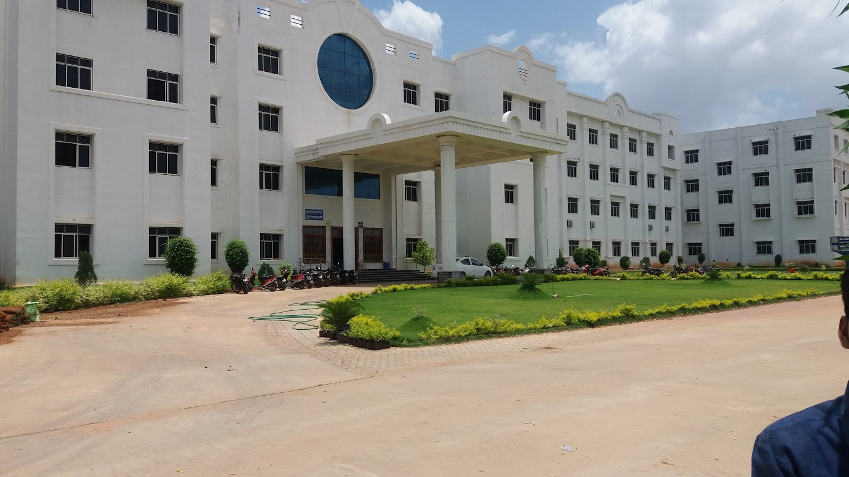

AITS is a Learning Center

ANNAMACHARYA INSTITUTE OF TECHNOLOGY AND SCIENCES
KADAPA
Utukur (Post), Chinthakomma Dinne (V&M), Kadapa, YSR (Dist.),
Andhra Pradesh - 516 003.
(Approved by AICTE, New Delhi & Affiliated to JNTUA, Anantapuramu)

Speak to Us (08562) 201003 Fax (08562) 201005

Mobile +919603999591 / +919603999592 Email aitskadapa@gmail.com

