 UNIT-1
Analysis of three phase balanced circuits

1

Overview
- An electric power distribution system looks like:
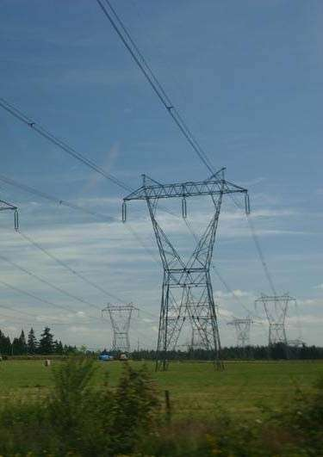
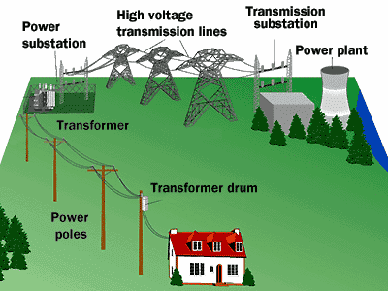
Where the power transmission uses“ balanced three-phase” configuration.

Whythree-phase?

- Three-phase generators can be driven by constant force or torque(to be discussed).
- Industrial applications, such as high-power motors, welding equipments, have constant power output if they are three-phase systems (to be discussed).

Keypoints

- What is a three-phase circuit (source, line, load)?
- Why a balanced three-phase circuit can be analyzedbyanequivalentone-phasecircuit?
- How to getalltheunknowns(e.g.linevoltageof the load) by the result of one-phase circuit analysis?
- Why the total instantaneous power of a balancedthree-phasecircuitisaconstant?



Section 11.1, 11.2 Three-PhaseSystems

  - Three-phase sources
  - Three-phasesystems

One-phase voltage sources

- One-phase ac generator: static magnets, one rotatingcoil,singleoutputvoltagev(t)=Vmcost.
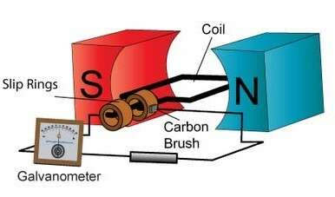
(www.ac-motors.us)

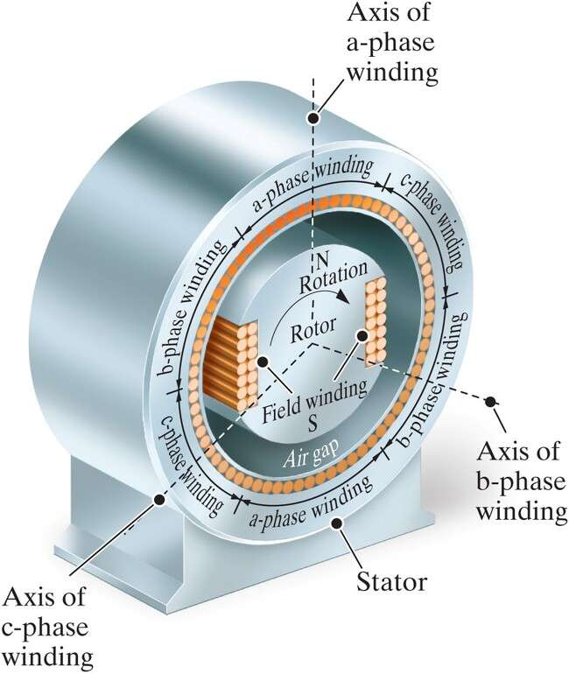
Three-phase voltage sources

- Three static coils, rotating magnets, threeoutputvoltages va(t), vb(t), vc(t).

IdealY-and -connected voltage sources

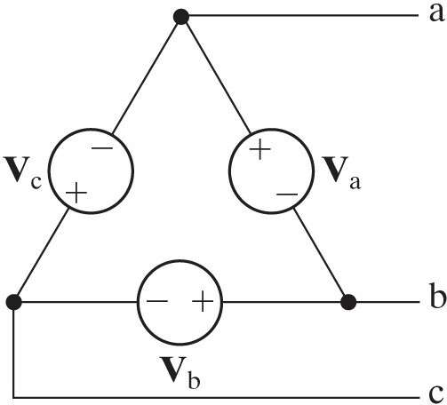
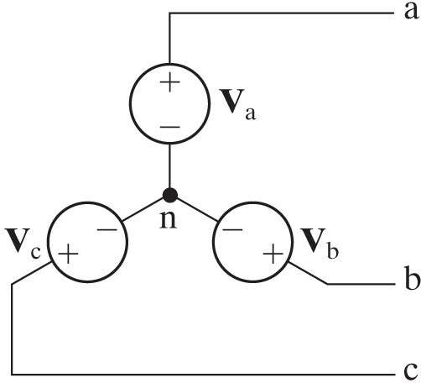
Neutral

RealY-and -connected voltage sources
- 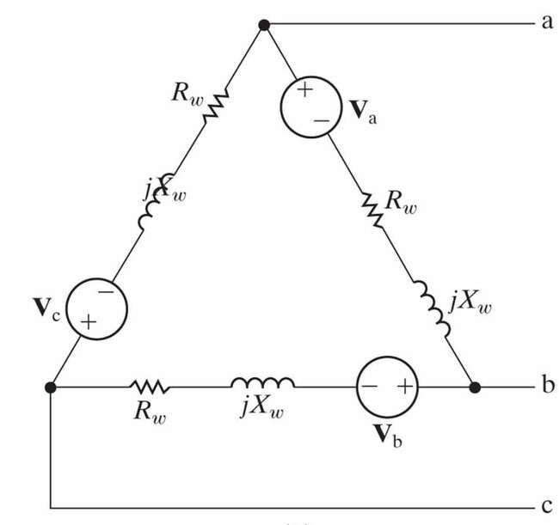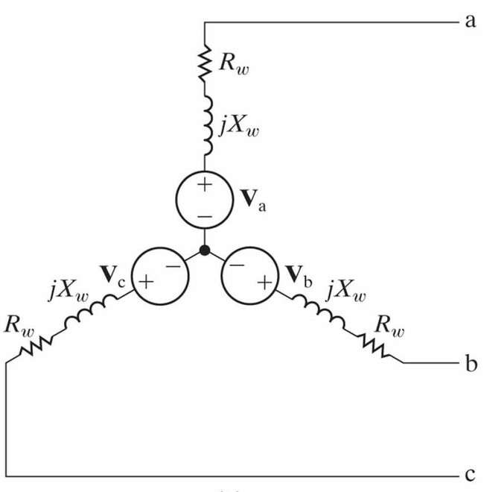Internalimpedanceofageneratorisusually inductive (due to the use of coils).

Balancedthree-phasevoltages

- Three sinusoidal voltages of the same amplitude,frequency,butdifferingby120phase difference with one another.
- There are two possible sequences:
- abc(positive)sequence: vb(t)lagsva(t)by120ͦ
- acb(negative)sequence:vb(t)leadsva(t)by
120ͦ.

abcsequence
  - vb(t) lags va(t) by120ͦ or T/3.

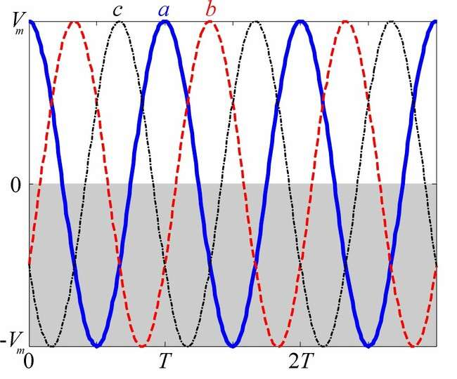
  - Va
=Vm
∟0∘,
Vb=Vm
∟120∘,
Vc=Vm
∟120∘.

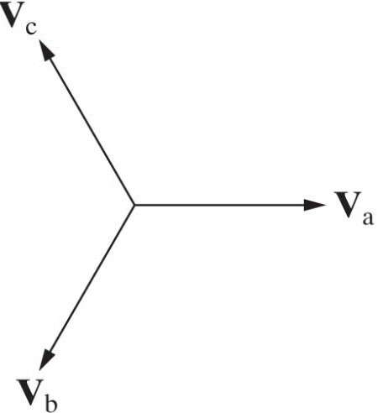

Three-phasesystems

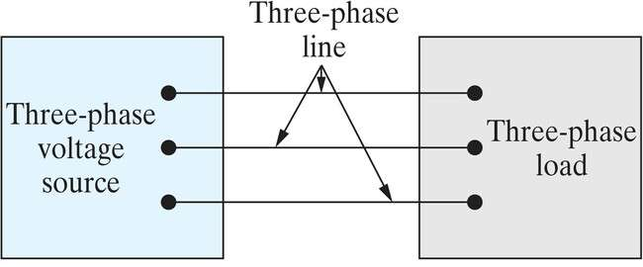
(Y or Δ)
(Y or Δ)
  - Source-load can be connected in four configurations: Y-Y, Y-∆, ∆-Y, ∆-∆
  - It’s sufficient to analyze Y-Y, while the others can be treated by ∆-Y and Y-∆ transformations.

Section11.3
AnalysisoftheY-YCircuit

- Equivalentone-phasecircuitfor balanced Y-Y circuit
- Linecurrents,phaseandline voltages

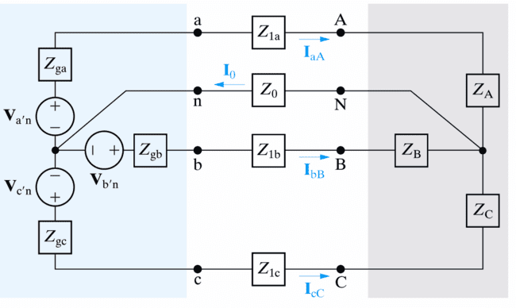General Y-Y circuit model

Ref.
The only essential node.

Unknowns to be solved
  - 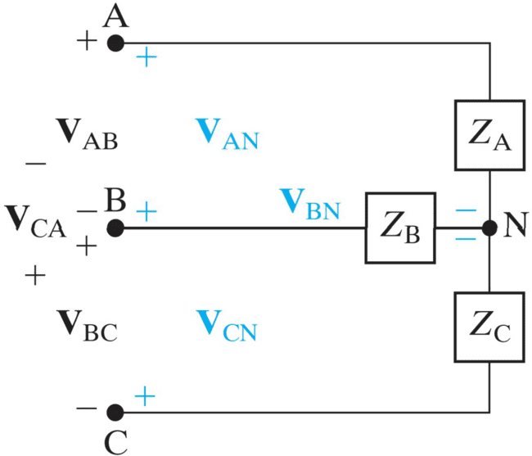Line (line-to-line) voltage: voltage acrossanypairof lines.
Linevoltage
Phase voltage
Phase current
  - Phase (line-to- neutral) voltage: voltageacrossa single phase.

Linecurrent

  - ForY-connectedload,linecurrentequalsphase current.

Solution to general three-phase circuit

  - Nomatterit’sbalancedorimbalanced three- phase circuit, KCL leads to one equation:

I0
IaA
- IbB
- IcC,

VN 
Van
- VN
  - Vbn
- VN
  - Vcn
- VN
…(1),

Z0 Zga
Z1a
ZA
Zgb
Z1b
ZB
Zgc
Z1c
ZC

Impedance of neutral line.
Total impedance alonglineaA.
Total impedance alonglinebB.
Total impedance alonglinecC.

whichissufficienttosolveVN(thustheentire circuit).

Solution to “balanced”three-phase circuit
- For balanced three-phase circuits,
- {Va'n,Vb'n,Vc'n}have equalmagnitude and120
relative phases;
- {Zga=Zgb= Zgc},{Z1a=Z1b=Z1c},{ZA=ZB= ZC};
total impedance along any line is the same
Zga+Z1a+ZA=… =Z.

  - Eq. (1) becomes:
VN 
Van
- VN
- Vbn
- VN
- Vcn
- VN,

Z0 Z Z Z


1
VN
⎜
Z0
3 Van



+ ⎟
Z
=
- Vbn
Z
- Vcn
0,
VN 0.

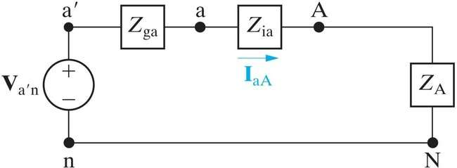
Meaning of the solution
  - VN= 0 means no voltage difference between nodes n andN inthepresenceof Z₀.Neutral line is both short (v = 0) and open (i = 0).
  - Thethree-phasecircuitcanbeseparatedinto3 one-phase circuits (open), while each of them has a short between nodes n and N.

Equivalent one-phase circuit

Linecurrent
Inn=0≠IaA
Phase voltage of load
Phase voltage ofsource
  - Directly giving the line current & phase voltages:

IaA

,VAN 
IaAZA,
Van
IaA
Z1a
ZA.

  - Unknownsofphasesb,ccanbedeterminedby the fixed (abc or acb) sequence relation.
(Z
ga
+Z +Z)=Z
Va′n−VN
1a
A
φ

The 3 line and phase currents in abcsequence
  - GivenI_{aA}V_{an}Z,theother2linecurrentsare:
I Vbn I 120∘, I Vcn I 120∘,
Z
Z

bB aA

cC

aA

which still followtheabc sequence relation.

IcC
IaA

IbB

The phase & line voltages of the load in abcseq.

VAN

Van
ZA,
Z

VBN

Vbn B
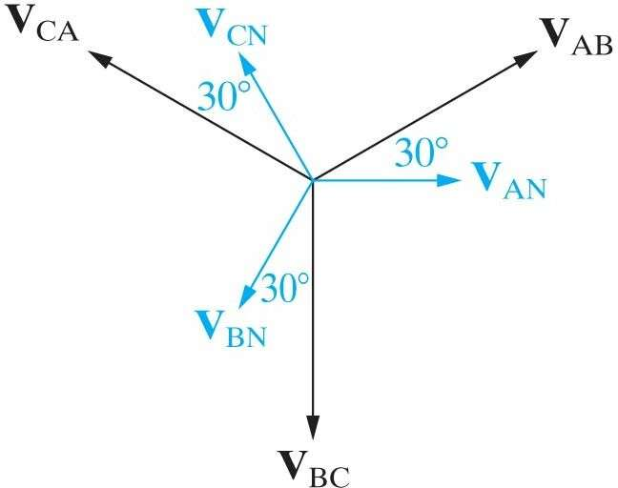Z
+120∘)
Phase
voltage
Line voltage
Z

VAN
120∘,

VCN

VAN
120∘.

VAB

VAN
VAN
−
−
VBN
(V
AN

120∘
(abc sequence)

 3VAN
(V
AN
AN
30∘,

VBC
120∘V 

 3VAN90∘,
(V

VCA 120∘
AN
VAN

 3VAN
150∘.

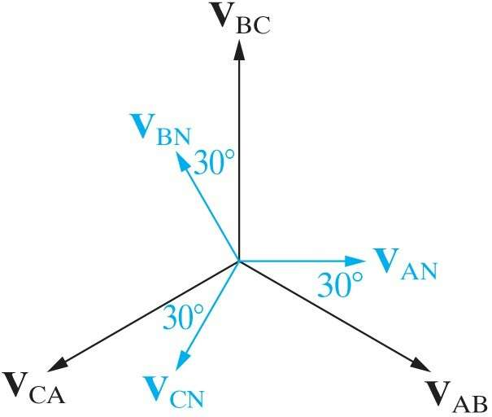
Thephase & line voltages of the load in acb seq.

VAB
VAN
VAN
- VBN
- AN
(V

120∘
(acb sequence)

 3VAN30∘,
Phase voltage
(V
(V

VBC 120∘
AN
AN
120∘

 3VAN90∘,
(V

VCA 120∘
Line voltage
AN
VAN

 3VAN
150∘.

  - Linevoltagesare 3 timesbigger,leading(abc) or lagging (acb) the phase voltages by 30.

Example 11.1 (1)
  - Q: What are the line currents, phase and line voltagesoftheloadandsource,respectively?

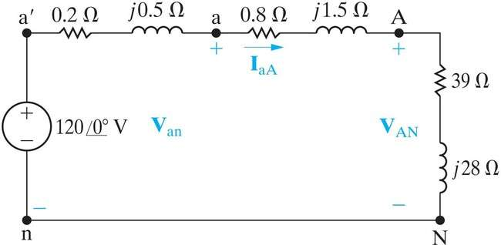Zga Z1a

Phase voltages ZA
(abc sequence)
Z=Zga+Z1a+ZA=40+j30.

Example 11.1 (2)

  - The 3 line currents(of both load & source) are:
a′n
2.4
36.87∘
A,

 V 
I
1200∘  

aA
Z
ga
- Z1a
- ZA
40
j30

IbB I
IaA
I
120∘
120∘
2.4156.87∘A,
2.483.13∘A.

cC aA
  - The3 phasevoltagesofthe load are:

VAN
IaAZA2.436.87∘39
j28115.221.19∘V.

VBN VCN
VAN120∘
VAN120∘
115.22121.19∘V,
115.22118.81∘V.

Example 11.1 (3)

  - The3 linevoltagesofthe loadare:

VAB

330∘V
330∘115.221.19∘
AN

199.5828.81∘V,

VBC
VAB
120∘

199.5891.19∘V,

VCA
VAB
120∘

199.58148.81∘V.

Example 11.1 (4)
  - The3 phasevoltagesofthe source are:

V VI Z 1202.436.87∘0.2
j0.5

an an aA ga
118.90.32∘V,

Vbn Vcn
Van
Van
120∘
120∘
118.9
118.9
120.32∘V,
119.68∘V.

  - Thethree linevoltagesofthesource are:
Vab330∘V 330∘118.90.32∘
an
205.9429.68∘V,

Vbc V
Vab
V
120∘
120∘
205.9490.32∘V,
205.94149.68∘V.

Section11.4
AnalysisoftheY-Circuit

Load in configuration

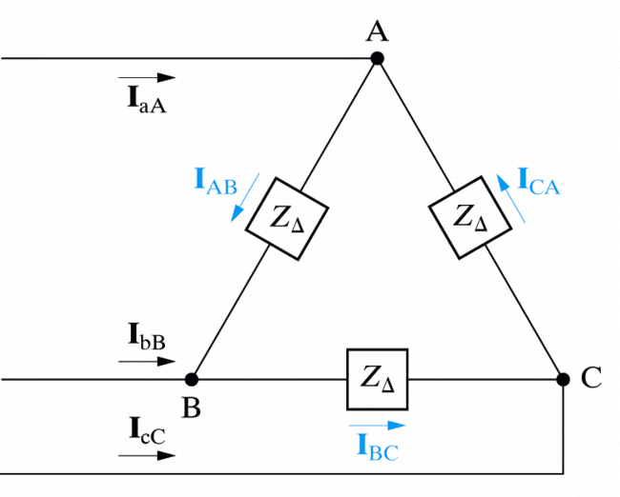
Linecurrent
Phase current
Linevoltage= Phasevoltage

-Y transformation for balanced 3-phase load
- The impedance of each leg in Y-configuration
(ZY)is one-third ofthat in -configuration(Z):
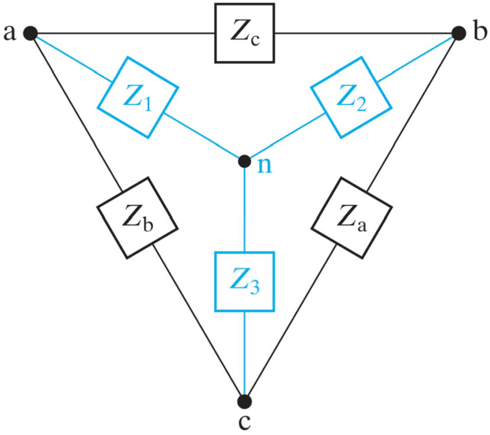
Z ZbZc ,
1
Z
+
Z
+
Z
a b c
Z  ZcZa ,
2
Z
+
Z
+
Z
a b c
Z  ZaZb .
3
Z
+
Z
+
Z
a b c
ZΔ
3

ZY
ZZ
3Z
 .



Equivalent one-phase circuit

- The1-phaseequivalentcircuitinY-Yconfig. continues to work if ZAis replaced by Z/3:
Linecurrent
Line-to-neutral voltage ≠Phasevoltage
≠Line voltage

directly giving the line current:I 
Van ,

aA
ga
Z1aZA

and line-to-neutral voltage:
Z
VAN
IaAZA.

The 3 phase currents of the load in abcseq.
- Canbesolvedby3nodeequationsoncethe3 line currents IaA, IbB, IcCare known:

IaA
IAB
- ICA,
IbB
IBC
- IAB,
IcC
ICA
- IBC.

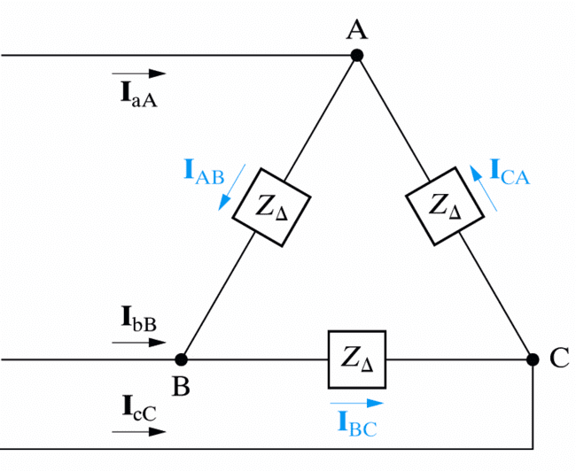
Linecurrent
Phase current

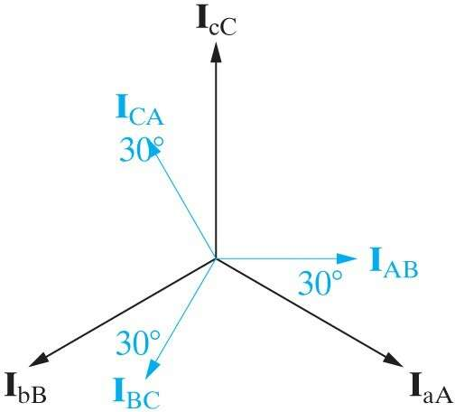
(abc
sequence)
Linecurrent
Phase current

Section11.5
Power Calculations in BalancedThree-Phase Circuits
- Complexpowersofone-phaseand the entire Y-Load
- Thetotalinstantaneouspower

Average power of balanced Y-Load

- The average power delivered toZAis:
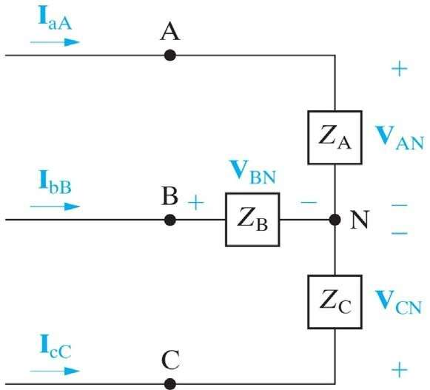
PAVIcos,

V
VAN
VL ,


I

IaA
3
IL,
(rmsvalue)


⎩
V
- I
ZA.

  - The total powerdelivered to the Y-Load is:

Ptot
3PA
3VI
cos
3VLIL
cos.

Complex power of a balanced Y-Load

  - Thereactivepowersofonephaseandthe entire Y-Load are:

Q

VIsin,

Qtot
3VI
sin
3VLIL
sin.

  - Thecomplexpowersofonephaseandthe entire Y-Load are:

S P
jQ
VI
ej
V I*;

 

    
j j
φ

S

tot
3S
3V
Ie 
3VL
ILe .

One-phase instantaneous powers
- The instantaneous power of load ZAis:
pA(t)vAN(t)iaA(t)VmImcostcos(t).
  - 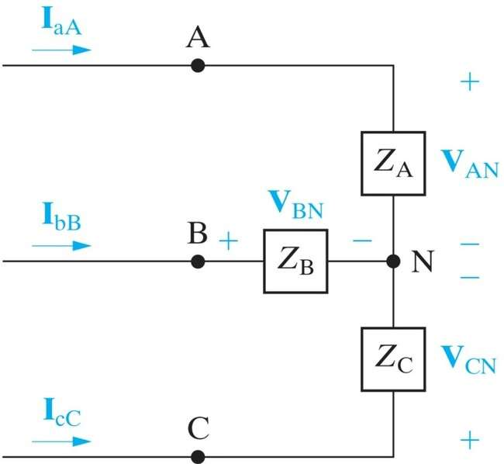The instantaneous powersofZA,ZCare:

(abc sequence)
pB(t) vBN(t)ibB(t)
VmImcost120∘
cost120∘,
pC(t)VmImcost120∘
cost120∘.

Total instantaneous power
- TheinstantaneouspoweroftheentireY-Load is a constant independent of time!

ptot(t)pA(t)
pB(t)
pC(t)1.5VmIm
cos

1.5
2V2I
cos
3VI
cos.

- Thetorquedevelopedattheshaftofa3-phase motor is constant, less vibration in machinery powered by 3-phase motors.
- The torque required to empower a 3-phase generatorisconstant,needsteadyinput.

Example 11.5 (1)
- Q: What are the complex powers provided by
the source and dissipated by the line of a-phase?
- Theequivalentone-phasecircuitinY-Y configuration is:
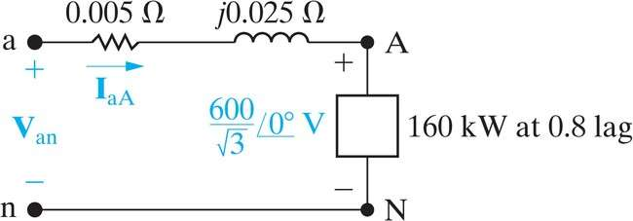
Z1a
Sφ
(rmsvalue)

Example 11.5 (2)
- Thelinecurrentofa-phasecanbecalculatedby the complex power is:

S
VI*,
160
j12010³

600*
aA
3
I
,

IaA
φ

577.35
36.87∘A.

- Thea-phasevoltageof thesource is:

VanVAN
IaAZ1a

600 3577.35
36.87∘0.005
j0.025

357.511.57∘V.

Example 11.5 (3)
- Thecomplexpowerprovidedbythe sourceofa- phase is:
I
=

San
Van
* 357.511.57∘577.3536.87∘

206.4138.44∘kVA.
aA
- Thecomplexpowerdissipatedbythelineofa- phase is:

SaA
IaA
Z1a
577.3520.005
j0.025

8.5078.66∘kVA.
2

Keypoints

- What is a three-phase circuit (source, line, load)?
- Why a balanced three-phase circuit can be analyzedbyanequivalentone-phasecircuit?
- Howtogetalltheunknowns(e.g.linevoltageof the load) by the result of one-phase circuit analysis?
- Why the total instantaneous power of a balancedthree-phasecircuitisaconstant?

S.Boyd EE102

UNIT-II
The Laplace transform

- definition&examples

- properties&formulas
  - linearity
  - theinverseLaplacetransform
  - timescaling
  - exponentialscaling
  - timedelay
  - derivative
  - integral
  - multiplicationbyt
  - convolution

Idea

theLaplacetransformconvertsintegralanddifferentialequationsinto
algebraicequations

thisislikephasors,but
- appliestogeneralsignals,notjustsinusoids
- handlesnon-steady-stateconditions

allowsustoanalyze
- LCCODEs
- complicatedcircuitswithsources,Ls,Rs,andCs
- complicatedsystemswithintegrators,differentiators,gains

Complexnumbers
complexnumberinCartesianform:z=x+jy
- x=঩z,therealpart ofz
- y==z,theimaginarypartofz
j=√1(engineeringnotation);i=√1ispoliteterminmixed
- — —
company

complexnumberinpolarform:z=re^{jφ}
- risthemodulusormagnitudeofz
- φistheangleorphaseofz
- exp(jφ)=cosφ+jsinφ
complexexponentialofz=x+jy:
e^{z}=e^{x+jy}=e^{x}e^{jy}=e^{x}(cosy+jsiny)

TheLaplacetransform

we’llbeinterestedinsignalsdefinedfort≥0
theLaplacetransformofasignal(function)fisthefunctionF= (f)
L
definedby
∫

F(s)=
∞
f(t)e^{−st}dt
0

forthoses∈Cforwhichtheintegralmakessense

- Fisacomplex-valuedfunctionofcomplexnumbers
siscalledthe(complex)frequencyvariable,withunitssec⁻¹thetimevariable (insec);st isunitless
•
- fornow,weassumefcontainsnoimpulsesatt=0

;tiscalled

commonnotationconvention:lowercaseletterdenotessignal;capital letterdenotesitsLaplacetransform,e.g.,UdenotesL(u),V_{in}denotes L(v_{in}), etc.

Example
let’sfindLaplacetransformoff(t)=e^{t}:

F(s)=
∞

e^{t}e^{−st}dt=
∫
0
∞
e(1−s)tdt=
∫
0
1 1—s
(1−s)t
¯0
e
= 1
s—1
∞

providedwecansaye^{(1−s)t}→0ast→∞,whichistruefor঩s>1:

e(1−s)t = e−j(=s)t e(1−঩s)t =e(1−঩s)t
¯ ¯ ¯ ¯
¯ ¯
` =˛¸1 x
theintegraldefiningFmakessenseforalls Cwith s>1(the
- ∈ ঩

‘regionofconvergence’ofF)
- buttheresultingformulaforFmakessenseforalls∈Cexcepts=1

we’llignorethese(sometimesimportant)detailsandjustsaythat

L(e^{t})=
1

s—1

Moreexamples

constant:(orunitstep)f(t)=1(fort≥0)

F(s)=
∞
e^{−st}dt=
∫
—
0
1e−st =1
s ¯0 s
∞

providedwecansaye^{−st}→0ast→∞,whichistruefor঩s>0since

¯e−st¯=¯e−j(=s)t¯ e−(঩s)t =e−(঩s)t
¯ ¯
` =˛¸1 x

- theintegraldefiningFmakessenseforallswith঩s>0
- buttheresultingformulaforFmakessenseforallsexcepts=0

sinusoid:firstexpressf(t)=cosωtas

f(t)=(1/2)e^{jωt}+(1/2)e^{−jωt}

nowwecanfindFas
∞
∫
F(s) =
0

e−st

¡(1/2)e^{jωt}+(1/2)e^{−jωt}¢dt

= (12)∫∞
+(12)∫∞

/ e(−s+jω)tdt
0
/ e(−s−jω)tdt
0

= (1/2) 1
s—jω
+(1/2) 1
s+jω

= s
s2+ω2
(validfor঩s>0;finalformulaOKfors/=±jω)

powers of t: f(t) =t^{n}(n≥1) we’llintegratebyparts,i.e.,use
∫_{b}
u(t)v′(t)dt=u(t)v(t)

a

¯ ∫_{b}
a
a

withu(t)=t^{n},v′(t)=e^{−st},a=0,b=∞
∫∞ µ—e−st¶¯∞ n∫∞
b
¯
—
v(t)u′(t)dt
F(s)=
tne−stdt = tn
s
¯
+
tn−1e−stdt
n

0
0
s
0
= (t^{n−1})
L

s
providedt^{n}e^{−st}→0ift→∞,whichistruefor঩s>0
applyingtheformularecusively,weobtain
n!
F(s)=
sn+1
validfor঩s>0;finalformulaOKforalls/=0

Impulsesatt=0
iffcontainsimpulsesatt=0wechoosetoincludethemintheintegral defining F:
∫

F(s)=
∞
f(t)e^{−st}dt
0−

(youcanalsochoosetonotincludethem,butthischangessomeformulas we’ll see & use)
example:impulsefunction,f=δ
=1

F(s)=

∞
δ(t)e^{−st}dt=e^{−st}
∫
¯
0−
e
−st
¯
=ske−st¯
=s^{k}

t=0

similarlyforf=δ^{(k)}wehave
∫∞
δ^{(k)}(t)e^{−st}dt=(—1)^{k}

F(s)=

0−

dk ¯ ¯

dtk
t=0
t=0

Linearity

theLaplacetransformislinear:iffandgareanysignals,anda isany scalar,wehave

L(af)=aF, L(f+g)=F+G

i.e.,homogeneity &superposition hold

example:

L3δ(t)—2e^{t} = 3L(δ(t))—2L(e^{t})
¡ ¢
= 3 2
—
s—1
= 3s—5
s—1

One-to-oneproperty
theLaplacetransformisone-to-one:ifL(f)=L(g)thenf=g
(well,almost;seebelow)

- Fdeterminesf

- inverseLaplacetransformL
−1
(noteasytoshow)
example(previouspage):
iswelldefined

L−1µ3s—5¶=3δ(t)—2e^{t}
s—1

inotherwords,theonlyfunctionfsuchthat
F(s)=3s—5
s—1
isf(t)=3δ(t)—2e^{t}

what‘almost’means:iffandgdifferonlyatafinitenumberofpoints
(wheretherearen’timpulses)thenF=G

examples:
- fdefinedas

f(t)=

1 t=2
0
½

hasF=0

- fdefinedas

f(t)=

½1/2
t/=2

t=0

1 t>0
hasF=1/s(sameasunitstep)

InverseLaplacetransform

inprinciplewecanrecoverffromFvia
()=1∫σ+j∞ ()
st

ft 2πj Fse ds
σ−j∞
whereσislargeenoughthatF(s)isdefinedfor঩s≥σ

surprisingly,thisformulaisn’treallyuseful!

Timescaling

definesignalgby g(t)=f(at),wherea>0; then

G(s)=(1/a)F(s/a)

makessense:timesarescaledbya,frequenciesby1/a
let’scheck:

G(s)=
∞
f(at)e^{−st}dt=(1/a)
∫
0
∞
f(τ)e^{−(s/a)τ}dτ=(1/a)F(s/a)
∫
0

whereτ=at
example:L(e^{t})=1/(s—1)so
at 1 1
L(e )=(1/a)(s/a)—1=s—a

Exponentialscaling

letfbeasignalandaascalar,anddefineg(t)=e^{at}f(t);then

G(s)=F(s—a)

let’scheck:

G(s)=

∞
e^{−st}e^{at}f(t)dt=
∫
0

∞
e^{−(s−a)t}f(t)dt=F(s a)
∫
—
0

example:L(cost)=s/(s²+1),andhence

L(e^{−t}
cost)=
s + 1 = (s + 1)2+ 1
s+1

s2+2s+2

Timedelay

letfbeasignalandT>0;definethesignalgas

0 0≤t<T f(t —T ) t ≥T
g(t)=½

(gisf,delayedbyTseconds&‘zero-padded’uptoT)

f(t) g(t)

t t

t=T

thenwehaveG(s)=e^{−sT}F(s)

derivation:

G(s)=

∞
e^{−st}g(t)dt =
∫
0

∞
e^{−st}f(t T)dt
∫
—
T
∫

∞
= e^{−s(τ+T)}f(τ)dτ
0
= e^{−sT}F(s)

example:let’sfindtheLaplacetransformofarectangularpulsesignal
f(t)=½ ≤≤
1 ifa t b
0 otherwise

where0<a<b
wecanwritefasf=f₁—f₂where
f₁(t)=½1 t≥a
0 t<a

f₂(t)=½1 t≥b
0 t<b

i.e.,fisaunitstepdelayedaseconds,minusaunitstepdelayedbseconds hence
F(s) = L(f₁)—L(f₂)
= e−as—e−bs
s
(cancheckbydirectintegration)

Derivative

ifsignalfiscontinuousatt=0,then

L(f′)=sF(s)—f(0)

time-domain differentiation becomesmultiplication byfrequency variables (aswithphasors)
•
- plus atermthatincludesinitialcondition(i.e.,—f(0)) higher-orderderivatives:applyingderivativeformulatwiceyields
L(f′′) | = | sL(f′)—f′(0)
 | = | s(sF(s)—f(0))—f′(0)
 | = | s²F(s)—sf(0)—f′(0)
similarformulasholdforL(f^{(k)})

examples

- f(t)=e^{t},sof′(t)=e^{t}and

L(f)=L(f

′)=

1

s—1

usingtheformula,L(f′)=s( 1 )—1,whichisthesame
s—1

- sinωt=—ω
1
dt
- cosωt,so

1
L(sinωt)=—ω
s s2+ω2
1 = ω
s2+ω2
—¶

  - fisunitramp,sof
µs
′
isunitstep
L(f′)=sµ1¶—0=1/s
s2

derivationofderivativeformula:startfromthedefiningintegral

G(s)=
∫∞
0
f′(t)e^{−st}dt

integrationbypartsyields

¯∞ ∫∞
G(s) = e^{−st}f(t)¯
—
f(t)(—se^{−st})dt

0
0

= lim
t→∞
f(t)e^{−st}—f(0)+sF(s)

for঩slargeenoughthelimitiszero,andwerecovertheformula

G(s)=sF(s)—f(0)

derivativeformulafordiscontinuousfunctions
ifsignalfisdiscontinuousatt=0,then

L(f′)=sF(s)—f(0—)

example:fisunitstep,sof′(t)=δ(t)
L(f′)=sµ1¶—0=1
s

Example:RCcircuit
1Ω

1F

u y

  - capacitorisunchargedatt=0,i.e.,y(0)=0
  - u(t)isaunitstep

fromlastlecture,
y′(t)+y(t)= u(t)
takeLaplacetransform,termbyterm:

sY(s)+Y(s)=1/s
(usingy(0)=0andU(s)=1/s)

solveforY(s)(just algebra!)toget

Y(s)=
1/s s+1
= 1
s(s+1)

tofindy,wefirstexpressYas

Y(s)=

1 1
s—s+1

(check!)therefore we have
y(t)=L−1(1/s) —L−1(1/(s+1))=1—e^{−t}

Laplacetransformturnedadifferentialequationintoanalgebraicequation
(moreonthislater)

Integral
letgbetherunningintegralofasignalf,i.e.,

then
g(t)=
f(τ)dτ
0
∫_{t}

1

G(s)=
F(s)
s

i.e.,time-domainintegralbecomesdivisionbyfrequencyvariables
example:f=δ,soF(s)=1;gistheunitstepfunction
G(s)=1/s
example:fis unit step function, so F(s) =1/s; gis the unit ramp function (g(t) = tfor t ≥0),
G(s)=1/s²

derivationofintegralformula:

G(s)=
∞

t=0
∫
t

τ=0
µ∫
f(τ)dτ¶

e^{−st}dt=
∞

t=0
∫
t

τ=0
∫

f(τ)e^{−st}dτdt

hereweintegratehorizontallyfirstoverthetriangle0≤τ≤t
t

τ
let’sswitchtheorder,i.e.,integrateverticallyfirst:

G(s)=
∞

τ=0
∫
∞

t=τ
∫

f(τ)e^{−st}dtdτ =
∞

τ=0
∫
∫

f(τ)
∞

t=τ
µ∫
e^{−st}dt¶dτ

= ∞
τ=0
f(τ
)(1/s
)e^{−sτ}dτ

= F(s)/s

Multiplicationbyt

letfbeasignalanddefine

g(t)=tf(t)

thenwehave

G(s)=—F′(s)

toverifyformula,justdifferentiatebothsidesof

F(s)=
∫∞
0
e^{−st}f(t)dt

withrespecttostoget

F′(s)=

∞
( t)e^{−st}f(t)dt
∫
—
0

examples

- f(t)=e^{−t},g(t)=te^{−t}

L(te^{−t}

) = d ds

1 =
s+1
—

1

(s+ 1)2

- f(t)=te^{−t},g(t)=t²e^{−t}

- ingeneral,
—
L(t²
e−t
) = d ds
1 =
(s+1)2

(k—1)!
2

(s+1)3

L(t^{k}e^{−t})=
(s+1)
k+1

Convolution
theconvolutionofsignalsfandg,denotedh=f∗g,isthesignal
∫_{t}

h(t)= f(τ)g(t τ)dτ
—
0
∫_{t}

- sameash(t)=
—
f(t τ)g(τ)dτ;inotherwords,
0
f∗g=g∗f

- (verygreat)importancewillsoonbecomeclear intermsofLaplacetransforms:
H(s)=F(s)G(s)

Laplacetransformturnsconvolutionintomultiplication

let’sshowthatL(f∗g)=F(s)G(s):
∫
µ∫

H(s) =
∞

t=0
∫

e−st
t

τ=0
f(τ)g(t—τ)dτ¶dt

= ∞
t=0
t

τ=0
∫
e^{−st}f(τ
)g(t—τ)
dτdt

whereweintegrateoverthetriangle0≤τ≤t
∫
∫

- changeorderofintegration:H(s)=
∞

τ=0
∞

t=τ
e−st
f(τ)g(t—τ)dtdτ

- changevariablettot=t—τ;dt=dt;regionofintegrationbecomes
τ≥0,t≥0
∫
∫

H(s) =
∞

τ=0
∞

t=0

e^{−s(t+τ)}f(τ)g(t)dtdτ

= µ∫∞ ( ) ¶µ∫∞ () ¶

τ=0

e^{−sτ}fτ dτ

t=0

e^{−st}gt dt

= F(s)G(s)

examples
- f= δ, F(s) = 1, gives whichisconsistentwith
t
∫

0

H(s)=G(s),

δ(τ)g(t—τ)dτ=g(t)

- f(t)=1,F(s)=e^{−sT}/s,gives
H(s)=G(s)/s

whichisconsistentwith

h(t)=

t
g(τ)dτ
∫
0

- moreinterestingexampleslaterinthecourse...

Finding the Laplace transform

youshouldknowtheLaplacetransformsofsomebasicsignals,e.g.,

- unitstep(F(s)=1/s),impulsefunction(F(s)=1)
- exponential:L(e^{at})=1/(s—a)
- sinusoidsL(cosωt)=s/(s²+ω²),L(sinωt)=ω/(s²+ω²)

these,combinedwithatableofLaplacetransformsandtheproperties givenabove(linearity,scaling,...)willgetyouprettyfar

andofcourseyoucanalwaysintegrate,usingthedefiningformula

F(s)=
∫∞
0
f(t)e^{−st}dt ...

Patterns

whilethedetailsdiffer,youcanseesomeinterestingsymmetricpatterns between

- thetimedomain(i.e.,signals),and
- thefrequencydomain(i.e.,theirLaplacetransforms)

differentiationinonedomaincorrespondstomultiplicationbythe variable in the other
•
multiplicationbyanexponentialinonedomaincorrespondstoashift (or delay) in the other
•

we’llseethesepatterns(andothers)throughoutthecourse

TRANSIENT ANALYSIS

7.1 INTRODUCTION
So far steady state analysis of electric circuits was discussed. Electric circuits will be subjected to sudden changes which may be in the form of opening and closing of switches or sudden changes in sources etc. Whenever such a change occurs, thecircuit which was in a particular steady state condition will go to another steady state condition. Transient analysis is the analysis of the circuits during the time it changes from one steady state condition to another steady state condition.
Transient analysis will reveal how the currents and voltages are changing during thetransient period.To get such time responses, the mathematical models should necessarily be a set of differential equations. Setting up the mathematical models for transient analysis and obtaining the solutions are dealt with in this chapter.
A quick review on various test signals is presented first. Transient response of simple circuits using classical method of solving differential equations is then discussed. Laplace Transform is a very useful tool for solving differential equations. After introducing the Laplace Transform, its application in getting the transient analysis isalso discussed.

WhatisTRANSIENTANALYSIS?
S1 R
S2
C

E

S1 R
S2

iC

E
1 vC

C

0
R
Withsteady vC
iC
1
state
condition,at
timet=0 C
switchposition
ischanged 0
fromS1andS2

Fort≥0,bothvCandiCchangewith respecttime.

Stepfunction

Stepfunctionisdenotedasu(t)andisdescribedby

u(t)=Xfort≥0

=0fort<0

Fig.(a)showsastepfunction.
u(t)
u(t)
X
1.0
0
t
0
t
(a)
(b)

The step function with X = 1 is called as unit step function. It is described asu(t) = 1.0 for t ≥ 0
=0fort<0

UnitstepfunctionisshowninFig.(b).

(7.2)

(7.3)

Exponentiallydecayingfunction
Exponentiallydecayingfunctionisdescribedby x(t) = X e ^{-αt}for t ≥ 0
= 0fort<0

(7.4)

ThevalueofthisfunctiondecreasesexponentiallywithtimeasshowninFig.below.

x(t)
x(t)
X
X
0
t
0
t
(a) (b)

For exponentially decaying function, the time required for the signal to reach zero value, when it is decreased at a constant rate, equal to the rate of decay at time t = 0, is called TIME CONSTANT. Time constant is the measure of rate of decay.
x(t)
X
0.368X
0
τ
t
Considertheexponentiallydecayingsignalshown anddescribedby

x(t)=Xe^{-αt} (7.5)

Itsslopeattimet =0isgivenby

t =0
dx
dt
=-αXe^{-αt}

t =0
= -αX (7.6)

Minussignindicatesthatthefunctionvalueisdecreasingwithincreaseintime.Then,

as statedbythedefinition,timeconstantτisgiven by τ=
X = 1 (7.7)

αX α

Forthisexponentiallydecayingfunction,knowing ατ=1,thevalueofx(t)attimet=τ
isobtainedas

x(t)

t=τ
=Xe-αt
=Xe -1=0.368X
t=τ

Therefore, for exponentially decayingfunction, timeconstantτis also defined as the time required for the function to reach 36.8 % of its value at time t = 0. This aspect is shown in previous Fig.
Nowconsiderthetwoexponentiallydecayingsignals shown.Theyaredescribedby

x1(t)=X

eα1t
x(t)

X
x1(t)=X e-α1t
x2(t)=Xe-α2t

x2(t)=X
eα2t

0 τ
τ
t
1 2

Their time constants are
τand
1
τrespectively.Itisseenthat
2
< τandhence
1 2
τ

α1>α2.Further,itcanbenotedthat,smallerthetimeconstantfasteristherateof decay.

Exponentiallyincreasingfunction
Theplotofx(t)=X(1-e-αt) (7.36)

is shown in the Fig. It is to be seen that at time t = 0, the function value is zero and the functionvalue tends to X as time t tends to ∞. Thisisknownasexponentiallyincreasing function
x(t)
X
0.632X
τ

t
For such exponentially increasing function, time constant,τ is the time required for the functiontoreachthefinalvalue,ifthefunctionisincreasingattherategivenattime t = 0.

t=0
dx
dt
=0+αXe-αt

t=0
=αX Therefore τ=
X 1
αX α
(7.37)

The valueof x(t) at time t =τ is obtained asx(t)= X (1 - e-1) = 0.632 X (7.38) Thus, for exponentially increasing function, time constantτ is also defined as the time taken for the functionto reach63.2 % ofthefinal value.Thisisshown inFig.above.

IntheFig.(a)shown below,x(t)iscontinuous.

x(t)
t1
t
(b)
x(t
)
0
t

0

(a)

InFig. (b) shown, x(t) hasdiscontinuityattimet=t1.The valueof tends to infinity.
dxattimet=t1
dt

CERTAINCOMMONASPECTSOFRCANDRLCIRCUITS

While doing transient analysis on simple RC and RL circuits,we need to make use ofthe following two facts.
- The voltage across a capacitor as well as the current in an inductor cannot have discontinuity.
- With dc excitation, at steady state, capacitor will act as an open circuit and inductor will act as a short circuit.
Thesetwoaspectscanbeexplainedasfollows.

The current through a capacitor is given by i_{C} = C (dv / dt). If the voltage across the capacitor has discontinuity, then at the time when the discontinuity occurs, dv / dt becomesinfinityresultingthecurrenti_{C}tobecomeinfinity.However,inphysical system, we exclude the possibility of infinite current. Then, we state that in a capacitor, the voltage cannot have discontinuity. Suppose, ifthe circuit condition is changed attimet=0,thecapacitorvoltagemustbecontinuousattimet=0andhence v_{C}(0⁺) = v_{C}(0⁻⁾. (7.14)
wheretime0⁺refersthetimejustaftert=0andtime0⁻refersthetimejustbeforet=0.

Similarly the voltage across an inductor is v_{L} = L (di / dt). If the current through the inductor has discontinuity, then at the time when the discontinuity occurs, di / dt becomes infinity resulting the voltage v_{L} to become infinity. However, in physicalsystem, we exclude the possibility of infinite voltage. Then, we state that in an inductor, the current cannot have discontinuity. Suppose, if the circuit condition is changed attimet=0,theinductorcurrentmustbecontinuousattimet=0andhencei_{L}(0⁺)=i_{L}(0⁻) (7.15)

With dc excitation, at steady state condition, all the element currents and voltages areof dc in nature. Therefore, both di / dt and dv / dt will be zero. Since i_{C} = C (dv / dt) and v_{L} = L (di / dt), with dc excitation, at steady state condition, the current through the capacitor as well as the voltage across the inductor will be zero. In other words, with dcexcitation, at steady state condition, the capacitor will act as an open circuit and theinductor will act as a short circuit.

Switchingoccursattimet=0
v_{C}(0⁺)=v_{C}(0⁻) i_{L}(0⁺)=i_{L}(0⁻)

With DC excitation, at steady state capacitor acts as OPEN CIRCUIT and inductor acts as SHORT CIRCUIT

TRANSIENTINRCCIRCUIT

Whilestudying the transient analysis of RC and RL circuits, we shall encounter with two types of circuits namely,source free circuit and driven circuit.
Sourcefreecircuit

A circuit that does not contain any source is called a source free circuit. Consider the circuit shown in Fig. 7.7 (a). Let us assume that the circuit was insteadystate condition withtheswitchisinpositionS1foralongtime.Now,thecapacitorischargedto voltageE and will act as open circuit.
S1 R R 1
S2
iC
vC
E C C

(a)
Fig.7.7SourcefreeRCcircuit.

(b) 0

Suddenly, at time t = 0, the switch is moved to position S2. The voltage across the capacitorandthecurrentthroughthecapacitoraredesignatedasvCandiC respectively.The voltageacrossthe capacitorwill becontinuous.Hence
vC(0+)=vC(0-)=E (7.16)

The circuit for time t > 0 is shown in Fig. 7.7 (b). We are interested in finding the voltage acrossthecapacitorasafunctionoftime.Later,ifrequired,currentthroughthe
capacitorcanbecalculatedfromi_{C}=Cdv.Voltageatnode1isthecapacitorvoltage
dt
v_{C}.Thenodeequationforthenode1is
R 1
v_{C}
i_{C}

vCCR
dvC0 dt
(7.17)
C

i.e.
dvC
dt
vC 0RC
(7.18)

Fig.7.7(b) 0

We have to solve this first order differential equation (DE) with the initial conditionv_{C}(0⁺) = E (7.19)
We notice that DE in Eq. (7.18) is a homogeneous equation and hence will have only complementary solution. Let us try v_{C}(t) = K e^{st} (7.20)
asa possiblesolution ofEq.(7.18).

dvC
dt
vC
RC
0withtheinitialconditionvC(0+)=E

A possible solutionis: vC(t)=K est Substitutingthe solutioninthe DE.weget

sKest 1
RC
Kest=0 i.e.Kest(s+
1)=0
RC

Theaboveequation willbesatisfiedif

K est=0andor(s+
1)=0
RC

FromEq.(7.20)itcan beseen thatKest=0willleadtothetrivialsolution ofvC(t)=0. Weare looking for the non-trivialsolution ofEq. (7.18). Therefore
s+ 1=0 (7.21)
RC

s+ 1 =0 (7.21)
RC

ThisisthecharacteristicequationoftheDEgiveninEq.(7.18).Itssolutions=-
1is
RC

calledtherootofthecharacteristicequation.Itisalsocalledasthenaturalfrequency becauseitcharacterizestheresponseofthecircuitintheabsenceofanyexternal

source.ThusthesolutionoftheDE(7.18)isobtainedbysubstitutings=- solution v_{C}(t) = K e^{st}. Therefore,
1inthe
RC

v_{C}(t)=K
− 1t
- RC
(7.22)

TheconstantKcanbefoundoutbyusingtheinitialconditionofv_{C}(0)=ESubstituting t = 0 in the above equation, we get
v_{C}(0)=K=E (7.23)

Thusthesolutionis v_{C}(t)=E
− 1t
eRC

(7.24)

Thus the solution is v_{C}(t)=E It can be checked that this solution satisfy
- 1t
eRC

(7.24)

dvC
dt
- vC 0 RC
withtheinitialconditionv_{C}(0⁺)= E

Obtained solutionissketchedinFig. 7.8.It isanexponentiallydecaying function.
v_{C}(t)
E
0
t
Fig.7.8Plotofv_{C}(t)asgivenbyEquation(7.24).

In this case, the time constantτ = RC. By varying values of R and C, we can get different exponentially decaying function for v_{C}(t). The dimension of time constant RC can be verified as time as shown below.

RC=
volt amp.
coulomb
volt
amp.sec.sec. amp.

v_{C}(t)=E
− 1t
eRC

(7.24)

Thecurrentthroughthecapacitor,inthedirectionasshowninFig.7.7(b),is givenby

i(t)=C

dvC

CE(
1 1t R 1
)eRC
v_{C}
i_{C}
Fig.7.7(b)
0

^{C} dt RC
C
E 1t

=- e^{RC}
R
(7.25)

Sincethecapacitorisdischarging,thecurrentisnegativeinthedirectionshownin Fig. 7.7 (b). The plot of capacitor current i_{C}(t) is shown in Fig. 7.9.

t
i_{C}(t)
E
R

-

Fig.7.9Plotofi_{C}(t)asgivenbyEquation(7.25).

Drivencircuit

Again consider thecircuit shown in Fig. 7.7(a) whichis reproduced inFig. 7.10 (a). Let ussaythattheswitch wasin position S2longenough sothat vC(t) = 0andiC(t) = 0i.e. all the energy in the capacitor is dissipated and the circuit is at rest. Now, the switch is moved to position S1. We shall measure time from this instant. As discussed earlier, since the capacitorvoltage cannot havediscontinuity,
vC(0+)=vC(0-)=0 (7.26)

Thecircuitapplicablefor timet>0,isshowninFig.7.10(b).

S1 R
S2

E C
R vC

E C
1
iC

(a)

Fig.7.10DrivenRCcircuit.
0
(b)

Nodeequationforthenode1gives

vCER
- C dvC0 dt

(7.27)
i.e.dvC
dt
- vC  E RC RC
(7.28)

dvC
dt
- vC  E RC RC
(7.28)

Unlike in the previous case, now the right hand side is not zero, but contains a term commonly called the forcing function. For this reason, this circuit is classified as driven circuit. The initial condition for the above DE is
v_{C}(0⁺)=0 (7.29)

Thecomplete solutionisgivenby

v_{C}(t)=v_{cs}(t)+v_{ps}(t) (7.30)

where v_{cs}(t) is the complementary solution andv_{ps}(t) is the particular solution. The complementary solution v_{cs}(t) is the solution of the homogeneous equation

dvC
dt
- vC 0 RC
(7.31)

Recalling thatEq.(7.22)isthesolutionofEq.(7.18),weget

v_{cs}(t)=K
1t
eRC

(7.32)

Sincetheforcingfunctionisaconstant,theparticularsolutioncanbetakenas

vps(t)=A

Since it satisfies the non-homogeneous equation given by Eq. (7.28), on substitution,we get

dvC
dt

- vC  E RC RC

0 A  E
RC RC
i.e.A=E.

Thus vps(t)=E (7.33)

Additionofvcs(t)andvps(t)yields vC(t)=K
1
eRC

t
+E (7.34)

TodeterminethevalueofK,applytheinitialconditionofvC(0)=0totheabove equation. Thus
0=K+E i.e.K=-E

Thus,thecompletesolutionis vC(t)=-E
1
eRC

t
+E = E (1-
1
eRC

t
) (7.35)

1
TheplotofcapacitorvoltagevC(t)=E(1-eRC
Forthisfunction,timeconstantτis=RC.
t
)isshowninFig.7.11.

Thecurrentthroughthecapacitoriscalculatedas

R v_{C}

i_{C}(t)=C

E
dv_{C}=C E
dt RC

- 1t
- 1t 1
eRC
E C
i_{C}

RC
e
=R
0
Fig.7.10(b)
(7.39)

Now, the capacitor current as markedin Fig. 7.10 (b), is positive and the capacitor gets charged. This capacitor current is plotted as shown in Fig. 7.12.
0
v_{C}(t)
E
0.632E
τ
t
Fig.7.11Plotofv_{C}(t)asgivenbyEqn. (7.35).

i_{C}(t)

E
R

t
Fig.7.12Plotofi_{C}(t)asgivenbyEqn.(7.39).

Wehavesolvedthecircuitsshown in Fig. 7.10(b)andthe resulting solutions are shown in Figs. 7.11and7.12. Theyare reproducedin Fig. 7.13.
iC(t)
R
vC
1
E
iC
C
E
R
0
t
vC(t)
E
t

0

Fig.7.13RCdrivencircuitandvoltageandcurrentresponses.

Theseresultscanbeobtainedstraightawayrecognizingthefollowingfacts.
The solution of first order differential equation will be either exponentially decreasing or exponentially increasing.Itisknown thatvC(0+)=0.With dcexcitation, at steady state, the capacitor will act as open circuit and hence vC() = E. Thus, the capacitor voltage exponentiallyincreases from 0 to E.

SincevC(0+)=0,initiallythecapacitorisshortcircuitedandhenceiC(0)=
E.Withdc
R

excitation,atsteadystate,thecapacitorwillactasopencircuitandhenceiC()=0.

Thusthecapacitorcurrentexponentiallydecreasesfrom
Etozero.
R

Similarreasoningoutispossible,inothercasesalso,toobtain theresponsesdirectly.

More general case offindingthecapacitor voltage

In the previous discussion, it was assumed that the initial capacitor voltage v_{C}(0) = 0. There may be very many situations wherein initial capacitor voltage is not zero. There may be initial charge in the capacitor resulting non-zero initial capacitor voltage (Example 7.8). Further, the circuit arrangements can also cause non-zero initial capacitor voltage. For this purpose consider the circuit shown below. The switch was in position S₁ for a long time. It is moved from position S₁ to S₂ at time t = 0.

R1 S1 S2 R₂
C

t=0

E₁ E2

R1 S₁ S₂ R2
C

t=0

E₁ E2

Weshallassumethefollowing:
- Attimet=0⁻thecircuitwasatsteadystateconditionwiththeswitchinpositionS₁
- After switching to position S₂, the circuit is allowed to reach the steady state conditionThus,weareinterestedaboutthetransientanalysisforoneswitchingperiodonly.
Initial capacitor voltage v_{C}(0) is E₁ and the final capacitor voltagev_{C}(),will be E₂.Themoregeneralexpressionforthecapacitorvoltagecanbeobtainedas

v_{C}(t)=v_{C}()+[v_{C}(0)-v_{C}()]
- 1 t
eR2C

(7.47)

SummaryofformulaeusefulfortransientanalysisonRCcircuits
- Timeconstantτ=RC α=1/RC
- WhenthecapacitorisdischargingfromtheinitialvoltageofE
v_{C}(t)
E
t

1

v_{C}(t)=E
- t
eRC

- WhenthecapacitorischargedfromzeroinitialvoltagetofinalvoltageofE
v_{C}(t)
E

1

v_{C}(t)=E(1-
− t
eRC )

- Whenthecapacitorvoltagechangesfromv_{C}(0)to
vC()
v_{C}(t)
t

v_{C}(t)=v_{C}()+[v_{C}(0)-v_{C}()]
- 1t
eRC
v_{C}(∞)

Plotofv_{C}(t)dependsonvaluesofv_{C}(0)andv_{C}()
dvC(t) t

- Capacitorcurrenti_{C}(t)=C dt
v_{C}(0)

Example7.1AnRCcircuithasR=20ΩandC=400µF.Whatisitstimeconstant?

Solution For RC circuit, time constantτ= RC. Therefore,τ= 20 x 400 x 10⁻⁶ s = 8 ms

Example7.2AcapacitorinanRCcircuitwithR=25ΩandC=50µFisbeing chargedwithinitialzerovoltage.Whatisthetimetakenforthecapacitorvoltageto reach 40 % of its steady state value?
SolutionWithR=25ΩandC=50µF,τ=RC=1.25x10⁻³s;hence1/RC=800s⁻¹.

TakingthecapacitorsteadystatevoltageasE, v_{C}(t)=E(1-
1t
eRC)

Lett₁bethetimeatwhichthecapacitorvoltagebecomes0.4E.Then

0.4E=E(1-e^{800t}1)i.e.0.4=1-e^{800t}1

e^{800t}1=0.6i.e.-800t₁=ln0.6=-0.5108

Therefore,t₁=
0.5108s 0.6385x10^{3}
800
s0.6385ms

Example 7.3In an RC circuit, having a time constant of 2.5 ms, the capacitordischarges with initial voltage of 80 V. (a) Find the time at which the capacitor voltage reaches 55V,30Vand10V(b) Calculate thecapacitor voltageattime1.2ms,3ms and 8 ms.

Solution (a) TimeconstantRC=2.5ms;Thus
1=1000=400s⁻¹
RC 2.5

Duringdischarge,capacitorvoltageisgivenby v_{C}(t)=80e^{-400t}V
Lett₁,t₂andt₃bethetimeatwhichcapacitorvoltagebecomes55V,30Vand10V.

55=80e^{400t}1;-400t₁=ln
55 =-0.3747;Thust₁=0.93765ms
80

30=80

10=80
e^{400t}2;-400t₂=ln

e^{400t}3;-400t₃=ln
30 =-0.9808;Thust₂=2.452ms
80
10=-2.0794;Thust₃=5.1985ms
80

- v_{C}(1.2x10⁻³)=80e^{-400t}=80e^{-0.48}=49.5027V
v_{C}(3x10⁻³)=80e^{-400t}=80e^{-1.2}=24.0955V
v_{C}(8x10⁻³)=80e^{-400t}=80e^{-3.2}=3.261V

Example 7.4 Considerthecircuitshownbelow.
Given
i
C

R
+
vC(t)
-
vC(t)= 56 e-250 t Vfor t > 0 i(t) = 7 e- 250 t mA fort>0

  - FindthevaluesofRandC. (b) Determinethetimeconstant.
(c) AtwhattimethevoltagevC(t)willreachhalfofitsinitialvalue?

Solution (a) GiventhatvC(t)=56 e-250tV.Thereforeτ=RC=
1 s
250

ResistanceR=vC(t)
i(t)
8000Ω;ThuscapacitanceC=
1 F
250X8000
0.5μF

  - Timeconstant=RC=4x10-3s=4ms
  - Lett1bethe timetakenforthevoltagetoreachhalfofitsinitialvalueof56V.

Then,56e^{250t}1=28; i.e.e^{250t}1=0.5 i.e.-250t1=ln0.5=-0.6931;

Timet1=
0.6931
s 2.7724x10
=
−3
250
s2.7724ms

Example7.5

FindthetimeconstantoftheRCcircuitshowninbelow.

20Ω
44Ω

30V
+
80Ω
0.5mF
-

Solution Thevenin’sequivalentacrossthecapacitor,isshownbelow.

RTh
20Ω
44Ω

VTh
+
0.5mF
-
80Ω
RTh

(a) (b)
Referring to Fig. (b) above, R_{Th} = 44 + (20││80) = 60 Ω Time constantτ= RC = 60 x 0.5 x 10⁻³ s = 30 ms

Example 7.6 The switch in circuit shown was in position1 fora long time.Itis moved from position1toposition2at timet =0. SketchthewaveformofvC(t)for t >0.
5kΩ
1
+
t=0
2
8kΩ
-

75V
500µF

Solution Withswitchisinposition1,capacitorgetschargedtoavoltageof75V.
i.e.vC(0+)= 75V.Theswitchismovedtoposition2attimet=0.

Time constantRC =8 X 103 X 500 X 10-6 = 4 s Finally thecapacitorvoltage decaystozero.Thus,
vC(t)=75e-0..25t

Waveformofthecapacitorvoltageisshown.
vC(t)

75
V
0
t

Example 7.7A series RC circuit has a constant voltage of E, applied at time t = 0 as showninFig.below.Thecapacitorhasnoinitialcharge.Findtheequationsfori,vR and vC.Sketch the wave shapes.

E=100 V
t=0
+ vR
-
1
R
C
i
+
E vC R=5000Ω
- C=20 µF
0
Solution Sincethereisnoinitialcharge,vC(0+)=vC(0-)=0
V
vC(t)
vR(t)

Fort ˃ 0, capacitorischargedtofinalvoltageof 100V. Time constantRC= 5000 x 20 x 10-6 = 0.1 sec.
100

vC(t)=E(1-

dvC
1
eRC
t
). Thus, vC(t)=100(1-e-10t)V t
i(t)
A
0
t

i(t)=C dt
=20 X10-6X100 x10e-10t=0.02e-10tA
0.02

Voltage acrosstheresistor isvR(t)= R i(t) = 100e-10tV Wave shapes of i, vR(t)and vC(t)are shown.

Example7.8A20µFcapacitorintheRCcircuitshownhasaninitialchargeof q₀=500µCwiththepolarityasshown.Theswitchisclosedattimet=0.Findthe current transient and the voltage across the capacitor. Find the time at which thecapacitor voltage is zero. Also sketch their wave shape.

-
R
1
t=0
C
i
E q0
E=50V
R=1000Ω

+ C=20µF
0
Solution Initialchargeofq₀inthecapacitorisequivalenttoinitialvoltageof

v_{C}(0)=-
q0
C
500X10^{6}
20X10^{6}
25V;
Further,v_{C}()=E=50V

TimeconstantRC=1000X20X10⁻⁶=20X10⁻³s. Thus1/RC=50s⁻¹

v_{C}(t)=v_{C}()+[v_{C}(0)-v_{C}()]
1t
eRC

v_{C}(t)=50+[-25-50]e^{-50t} =50-75e^{-50t}

Currenti(t)=C
dt
dvC=20X10⁻⁶X75X50e^{-50t}A=0.075e^{-50t}A

Lett1bethetime atwhichthecapacitorvoltagebecomeszero.Then

50-75
e50t1

=0 i.e.
e50t1
=0.6667

-50t1=-0.4054i.e.t1=8.108X 10-3s

Thecapacitorvoltagebecomeszeroattimet1=8.108ms

WaveformsareshowninFig.7.24
i(t)
vC(t)
V
t
V
50
0.075A

0 t - 25
Fig.7.24Waveforms-Example 7.8.

Example7.9

Consider the circuit shown below. The switch was in closed position for a long time. It is opened at time t = 0. Find the current i(t) for t > 0.
500Ω
t=0
+
50Ω
-
2mF
i

35V
200Ω

500Ω
Solution Circuitattimet=0⁻isshown.
-
i_{C}(t)
v_{C}(0⁻)
-
+
50Ω
+

v(0⁻)=35X 200 10V
35V
200Ω

^{C} 200500

For time t > 0, capacitor voltage of 10 V is discharged through a resistor of 250 Ω. Time constant RC = 250 X 2 X 10⁻³ = 0.5 s; v_{C}(t) = 10 e^{-2t} V
i_{C}(t)=CdvC=2X10-3X(-20)e^{-2t}A=-40X10⁻³e^{-2t}A=-0.04e^{-2t}A
dt

Thusi(t)=-i_{C}(t)=0.04e^{-2t}A

Example7.10Consider thecircuit shown. The switch was in open position for a long time. It is operatedasshown. Computeand plot the capacitor voltage for t > 0. Also find thetime at whichthe capacitor voltageis 50 V.
2.5F
+
vC
-
+
80V
t=0
20Ω
-
16Ω

3A

Solution Circuitattimet=0-is showninFig.(a).

A 2.5F B
+ vC(0) -
+
80V
-
16Ω

20Ω

0

3A 3A

(a) (b)
A
2.5F
B
+ vC
+
-
80V
-
16Ω
0
Capacitoractsas open circuit.I16 Ω=0. VoltageVA= 80 V andvoltageVB= 60 V ThusvC(0)= 20 V

Withtheswitchisinclosedposition,thecircuitwillbeasshowninFig.(b).Withthe steadystatereached,Capacitoractsasopen circuit.I16Ω= 0.
VoltageVA=80VandvoltageVB=0V. ThusvC()=80V

RC=16X2.5=40s

UsingvC(t)=vC()+[vC(0)-vC()]

− 1t
eRC

80

weget
vC(t)
V
V
t

vC(t)=80+[20-80]e-0.025t=80-60e-0.025tV 20
Plotofthecapacitorvoltageisshown.
Lett1bethetimeatwhichthecapacitorvoltage=50V.Then

80 -60
e0.025t1
=50 i.e.60
e0.025t1
=30 i.e.
e0.025t1
=0.5i.e.-0.025t1=-0.6932

Thust1=27.728s
Capacitorvoltagebecomes50Vattimet1=27.728s

Example7.11Consider the circuit shown below. The switch was in position S1for a longtime.Itisoperatedasshown. Computeandplot thecapacitor voltagefor t > 0. Also find the time at which the capacitor voltage becomes zero.
5Ω S2 S1 8Ω
t=0
+
-
20Ω
-
0.5F
+

25V
20V

Solution VoltagevC(0)=-20V
Circuitfortimet>0anditsThevenin’sequivalentareshownbelow.

5Ω S2
+
20Ω
-
i
+
-
i
RTh S2

25V 0.5F
VTh 0.5F

VTh=
20

205
X2520V
RTh=5││20=4Ω;ThusRC=4x0.5=2s

UsingvC(t)=vC()+[vC(0)-vC()]
1
eRC
t
weget

vC(t)=20+[-20-20]e-0.5t=20-40e-0.5tV

v_{C}(t)=20-40e^{-0.5t}V

i_{C}(t)=C
dt
dvC =0.5X20e-0.5tA=10e-0.5tA

Waveshapesofv_{C}(t)andi_{C}(t)areshownbelow.
v_{C}(t)
i(t)
A
0
t
20V 10

t

-20 V

Lett₁bethetimeatwhichthecapacitorvoltagereacheszerovalue.Then

20-40
e0.5t1
=0;i.e.
e0.5t1
=0.5;i.e.-0.5t₁=-0.6931;Thust₁=1.3863s

Capacitorvoltagereacheszerovalueattimet₁=1.3863s
So far wehavedonetransientanalysis for oneswitching period.Now weshall illustrate how tocarry outtransient analysisfortwoswitchingperiod through anexample.

Example7.12IntheinitiallyrelaxedRCcircuitshowntheswitchisclosedonto position S₁ at time t = 0. After one time constant, the switch is moved on to position S₂. Findthecompletecapacitorvoltageandcurrenttransientsandshowtheirwaveforms.

S1 R vC S₂
E₁ C
E
2 iC

0

E₁=20V;E₂=40V R = 500 Ω
C=0.5µF

Solution RC=500X0.5X10⁻⁶s=0.25X10⁻³s=0.25ms 1/RC=4000s⁻¹
Duringthefirstswitchingperiod,capacitorgetschargedfromzerovolt.Itsvoltage exponentially increases towards 20 V. Thus
v_{C}(t)=20 (1-e^{-4000t})V
Att=1timeconstant,v_{C}=20(1-e⁻¹)=12.64V
Forthesecondswitchingoperation,thereisinitialcapacitorvoltageof12.64V.

Letthesecondswitchingoccursattimet’=0.Timet’=0impliestimet=0.25X10-3s
i.e. t’= t - 0.25X10-3. For t’>0,capacitorvoltage changes fromits initialvalue,vC(0), of 12.64 V to final value, vC(), of - 40 V. Knowingthat

vC(t) =vC()+[vC(0)-vC()]
− 1 t
eRC

weget

vC(t’)=-40+[12.64+40]e-4000t’=52.64e-4000t’-40 V

Therefore,capacitorvoltagesforthetwoswitchingperiodsare

vC(t)=20 (1 - e- 4000t) Vfor t >0 and ≤ 0.00025 s vC(t)=52.64 e-4000(t -0.00025)-40 Vfor t ≥0.00025s with vC(0.00025-) = vC(0.00025+)= 12.64 V

(Notethatthecapacitorvoltageshallmaintaincontinuity)

Knowingthat
vC(t)= 20 (1 - e-4000 t) Vfor t > 0 and≤ 0.00025 s vC(t)= 52.64 e-4000(t- 0.00025)- 40Vfort≥0.00025s
Forthefirstswitchingperiod

CapacitorcurrentiC(t)=C
dvC =0.5X10-6X20X4000e-4000t=0.04e-4000tA
dt

iC(0.00025-)=0.04e-1=0.01472A

Forthe secondswitchingperiod, vC(t’)= 52.64 e-4000 t’- 40 V
iC(t’)=0.5X 10-6X(-52.64X4000e-4000t’)=-0.10528e-4000 t’A
i.e.iC(t-0.00025)=-0.10528e-4000 (t-0.00025)A iC(0.00025+)=-0.10528 A

1

0.04A

0.01472A
v_{C}(t)
20 V

2.64V

τ
t
τ
-40V

25ms
i_{C}(t)

t
τ

-0.10528A

Note:Attheswitchingtime,voltageacrossthecapacitordoesnothavediscontinuityi.e. v_{C}(0.25 X 10⁻³)⁻ =v_{C}(0.25 X 10⁻³)⁺. On the other hand,the currentthrough the capacitor has discontinuity at the instant of switching. The current just before switching and just after switching can be calculated by considering the circuit conditions at the respective

time. Attimet =(0.25 X10⁻³)⁻, current i=
2012.64

500
0.01472A

Attime t =(0.25X10⁻³)⁺, current i=
-4012.64

500
0.10528A

RCCircuit | RLCircuit
τ=RC α=1/RC | τ=L/R α=R/L
Switchingatt=0 v_{C}(0⁺)=v_{C}(0⁻) | Switchingatt=0 i_{L}(0⁺)=i_{L}(0⁻)
WithDC,atSScapacitoractsasopencircuit | WithDC,atSSinductoractsasshortcircuit
v_{C}(0)≠0;v_{C}()=0;Then   1 t  v_{C}(t)=v_{C}(0) e ^{RC} | i_{L}(0)≠0; i_{L}()=0;Then  Rt  i_{L}(t)=i_{L}(0)e L
v_{C}(0)=0;v_{C}()≠0;Then   1 t  v_{C}(t)=v_{C}() (1-e^{RC}) | i_{L}(0)=0;i_{L}()≠0; Then  Rt  i_{L}(t)=i_{L}()(1-e L )
v_{C}(0)≠0;v_{C}()≠0; Then   1 t  v_{C}(t)=v_{C}()+[v_{C}(0)-v_{C}()]e ^{RC} | i_{L}(0)≠0; i_{L}()≠0;Then  R   t  i_{L}(t)=i_{L}()+[i_{L}(0)-i_{L}()]e L
dvC(t)  i_{C}(t)=C dt | diL(t)  v_{L}(t)=L dt

TRANSIENTINRLCIRCUIT

NowweshallconsiderRLcircuitforthetransientanalysis.Asstatedearlier,

- Thecurrentinaninductorcannothavediscontinuityatthetimewhenswitching occurs.
- Withdcexcitation,atsteadystate,inductorwillactasashortcircuit.

NowalsoweshallendupwithfirstorderDEwhosesolutionwillbeexponentialin nature.
Sourcefreecircuit

A circuit that does not contain any source is called a source free circuit. Consider the circuitshowninFig.7.35(a).Letusassumethatthecircuitwasinsteadystate conditionwiththeswitchisinpositionS1foralongtime.Nowtheinductoractsasshort
circuitanditcarriesacurrentofE.
R

S1

E

(a)
R

L
iL
S2
iL

Fig.7.35SourcefreeRLcircuit.
R 1
vL
L
(b) 0

Suddenly,attimet=0,theswitchismovedtopositionS2.Thecurrentthroughthe
inductorandthevoltageacrosstheinductoraredesignatedasiLandvLrespectively. The currentthroughthe inductor will becontinuous.Hence
R 1
iL
vL

iL(0+)=iL(0-)=E
R

L

0 (7.49)

Thecircuitfortimet>0isshownabove.Weareinterestedinfindingthecurrent throughtheinductorasafunctionoftime.Later,ifrequired,voltageacrosstheinductor
canbecalculatedfromvL=Ldi.Themeshequationforthecircuitis
dt

RiL
- L diL0 dt
(7.50) i.e.
diL dt
- R i 0 L L
(7.51)

Weneedtosolvetheaboveequationwiththeinitialcondition

iL(0+)=
E (7.52)
R

Thestructureoftheequation(7.51)isthesameasEq.(7.18).Inthiscase,thetime

constant,τis
L. The inductorcurrentexponentiallydecays fromthe initialvalue ofE R R

tothefinalvalueofzero.Thusthesolutionofequation7.51yields

iL(t)=E
R
Rt
e L
(7.53)

TheplotofinductorcurrentisshowninFig.(a).

t
iL(t)
E
R
vL(t)
0
t
- E
(a) (b)

ItcanbeseenthatthedimensionofL/Ristime.Dimensionally

LFluxlinkage R amp.
amp.
volt
Flux linkage Fluxlinkage/ sec
sec.

Thevoltageacrosstheinductoris: vL(t)=Ldi
dt
=LE(-
R
R)e
L
- RtL
=-E
  - Rt
e L
(7.54)

TheplotofthevoltageacrosstheinductorisshowninFig.(b).

Drivencircuit

Consider the circuit shown in Fig. 7.37 (a). After the circuithas attained the steadystate with the switch in position S2, the switchis moved to positionS1at time t = 0. We like to find the inductor currentfor time t > 0.

S1 R
S2
iL

E L
R vL

E L
iL

0
(a) (b)
Fig.7.37DrivenRLcircuit.

Sincethecurrentthroughtheinductor mustbecontinuous
iL(0+)=iL(0-)=0 (7.55)
Thecircuitfortimet>0isshowninFig.7.37(b).Themeshequationis

RiL
- L diLE dt
(7.56) i.e.
diL dt
- R i E L L
(7.57)

WeneedtosolvetheaboveDEwiththeinitialconditioniL(0)=0

diL dt
- R i E L L

ics=K
Rt
e L
andips=A

SubstitutingipsintheDE,weget

0=R L
AE
L
andhenceAE
R

Thisgives,ips=E/R

Thetotalsolutionis iL(t)=K

Rt E
e L +
R

Usingtheinitialconditionintheabove, weget

0=K+
Ei.e.K= -E R R

Thereforetheinductorcurrentis

iL(t)=-
E Rt E
e L +
R R
=E(1-
R
- Rt
e L
) (7.58)

InductorcurrentiL(t)exponentiallyincreasesfrom0to shownin Fig. 7.38 (a).
Ewithtimeconstant,τ=
R
Las
R

E R
0.632E
R
iL(t)

τ
(a)
t

Fig.7.38PlotofiL(t)and vL(t).
vL(t)
E
0
t

(b)

Now,thevoltageacrosstheinductorisobtained as

vL(t)=L
diL E dt R
R Rt
e L
L
=Ee
- Rt L
(7.59)

ItcanbeseenthatthevoltagevL(t)exponentiallydecreasesfromEtozerowiththe time

constant,τ=
LasshowninFig.7.38(b).
R

It istobenotedthat theinitial andthefinal valuesof theinductor current and the voltage across it can be readily computed by considering the circuit condition at that time.

Moregeneralcaseoffindingtheinductorcurrent

In the previous discussion, it was assumed that the initial inductor current i_{L}(0) = 0. There may be very many situations wherein initial inductor current is not zero.
The circuit arrangements can cause non-zero initial inductor current. For this purpose consider the circuit shown below. The switch was in position S₁ for a long time. It is moved from position S₁ to S₂ at time t = 0.

R1 S1 S2 R₂
t=0

L

E₁ E2

R1 S₁ S₂ R2
t=0

L

E₁ E2

Weshallassumethefollowing:
- Attimet=0⁻thecircuitwasatsteadystateconditionwiththeswitchinpositionS₁
- After switching to position S₂, the circuit is allowed to reach the steady state condition Thus, we are interested about the transient analysis for one switching period only.
Initial inductor current i_{L}(0) is E₁/ R₁ and the final inductor current i_{L}(),will be E₂ / R₂. The more general expression for the inductor currentcan be obtained as

i_{L}(t)=i_{L}()+[i_{L}(0)-i_{L}()]
R2t
e L
(7.63)

SummaryofformulaeusefulfortransientanalysisonRLcircuits
- Timeconstantτ=L/R Henceα=R/L
- Whentheinductorcurrentisdecayingfromtheinitialvalueofi_{L}(0)tozero
i_{L}(t)
i_{L}(0)
0
t

R
  - t
i_{L}(t)=i_{L}(0)e L

- Whentheinductorcurrentisexponentiallyincreasingfromzerotoi_{L}()
i_{L}(t)
i_{L}(∞)

i_{L}(t)=i_{L}()(1-
Rt
eL )

- Whentheinductorcurrentchangesfromi_{L}(0)to
iL()

i(t)=i

()+[i

- -i
R
  - t
i_{L}(t)
i_{L}(∞)
t
i_{L}(0)
t
()]e L

L L L L

Plotofi_{L}(t)dependsonvaluesofi_{L}(0)andi_{L}()

di(t)
L
- Inductorvoltagev_{L}(t)=L dt

Example 7.13 AnRL circuit withR = 12 Ω has time constant of 5 ms. Find the value of the inductance.
Solution R=12Ω; Timeconstant,L/R=5X10-3s

InductanceL=12X5X10-3=60mH

Example7.14

InanRLcircuithavingtimeconstant400mstheinductorcurrent decaysanditsvalue at 500 msis 0.8 A. Findtheequationof iL(t) for t > 0.

R
− t
Solution L/R=400X10-3s; R/L=2.5s-1; AsiL(t)decays, iL(t)=iL(0)e L

Whent=500 ms, iL(t)=0.8A. Usingthis

0.8=iL(0)e-2.5X0.5=iL(0)e-1.25=0.2865iL(0)

ThusiL(0)=0.8/0.2865=2.7923A

ThereforeiL(t)=2.7923e-2.5t

Example 7.15 In a RL circuit with time constant of 1.25 s, inductor current increases from the initialvalueof zero to the final value of 1.2 A.
- Calculatetheinductorcurrentattime0.4s,0.8sand2s.

- Findthe time atwhich theinductor currentreaches 0.3A,0.6 Aand 0.9 A. Solution L / R = 1.25 s iL(0) = 0 iL() = 1.2 A α = 1/1.25 = 0.8 s⁻¹
- iL(t)=1.2(1-e-0.8t)A
When time t = 0.4s, iL = 1.2(1 - e-0.32)=0.3286 A Whentimet =0.8s,iL=1.2(1-e-0.64)=0.5672A
Whentimet=2s,iL=1.2(1-e-1.6)=0.9577A
- Lett1,t2andt3bethetimeatwhichcurrentreaches0.3A,0.6Aand0.9A.

0.3=1.2(1-

0.6=1.2(1-

0.9=1.2(1-
e0.8t1)

e0.8t2)

e0.8t3)
i.e.

i.e.

i.e.
e0.8t1

e0.8t2

e0.8t3
=0.75i.e.0.8t1=0.2877i.e.t1=0.3596s

=0.5i.e.0.8t2=0.6931i.e.t2=0.8664s

=0.25i.e.0.8t3=1.3863i.e.t3=1.7329s

Example7.16

IntheRLcircuitshowninFig.below,thevoltageacrosstheinductorfort>0isgiven
byvL(t)=0.16e^{200t}V.DeterminethevalueoftheinductorLandobtaintheequation
forcurrentiL(t).AlsocomputethevalueofvoltageE.

E L
t=0
0.2Ω
vL
iL

0
Solution vL(t)=0.16e^{200t}V; R=0.2Ω α=R200; i.e. L0.2H1mH
L 200
Whentheswitchisclosedinductorcurrentexponentiallyincreasesfrom0toiL().Itis

iL(t)=iL()(1-
Rt
eL )
AlsovL(t)=L
diL
dt
LiL
()R
L
Rt
e L
RiL
()e
- Rt L

ComparingvL(t)=
RiL()e
- Rt L
withvL(t)=0.16
e200tV

Therefore,0.2iL()=0.16 i.e. iL()=0.16/0.2=0.8A
Thus,iL(t)=0.8(1-e^{200t})

AlsoiL()= E
0.2
Therefore,
E 0.2
0.8;
ThusE0.16V

Example 7.17 The switchinthe circuit shownwas inopenpositionforalongtime.It is closed at time t = 0. Find iL(t) for time t > 0.
t=0
2Ω
+
8Ω
-
iL

24V
0.8H

Solution CurrentiL(0)=0
Whentheswitchisclosed,CurrentiL()=24/2=12A
Thevenin’sresistance = 8││2 = 1.6 Ω τ = L / R = 0.8 / 1.6 = 0.5 s ; α=2s-1 Inductorcurrentexponentiallyincreases from 0to 12A.
CurrentiL(t)=12(1-e-2t)A

SameresultcanbeobtainedbygettingtheThevenin’sequivalentcircuitfortimet>0

asshowninFig.below.
+
-
iL
1.6Ω

19.2V
0.8H

Example7.18 Theswitchinthecircuitshownwasinclosedpositionforalongtime.
FindcurrentiL(t)fortimet>0.
10Ω
t=0
+
iL
-
8Ω
30Ω

20V
0.5H

Solution
Circuit fort=0⁻andt=areshowninFig.(a)and(b)below.

10Ω 10Ω
+
20V
-
8Ω
iL(0)
30Ω
+
20V
-
i(∞)
L
30Ω
(a) (b)

CurrentiL(0)= 20/40=0.5A Further,currentiL() =20/40=0.5A

R
− t
Therefore,currentiL(t)=iL()+[iL(0)-iL()]e ^{L}

=0.5A

Example7.19 Inthecircuitshowntheswitchwasinopenpositionforalongtime.
DeterminethecurrentiL(t)andthevoltagevR(t)fortimet>0.
10Ω 30Ω

iL

Solution
+ vR -
+
2.5H
t=0
20V
-
Circuitfort=0-andt=areshowninFig.(a)and(b)below.

10Ω
30Ω
10Ω
30Ω

+ vR -
+
iL(0)
20V
-
+ vR -
+
iL(∞)
20V
-
(a) (b)
CurrentiL(0) = 20 / (10 + 30) = 0.5 A; CurrentiL()=0:Thevenin’sresistance =10Ω Time constant= L / R = 2.5 /10 = 0.25 s; α = 4 s-1
ThusiL(t)=0.5e-4tA VoltagevR(t)=-10iL(t)=-5e-4tV

Example7.20

Thecircuitshownwasinsteadystateconditionwiththeswitchopen.Findtheinductor
currentfortimet>0. 4Ω 4Ω
t=0
+
12Ω
iL

8V
1.4H

Solution
CurrentiL(0) = 8 / (4 + 4) = 1 A 4Ω Circuit for t =is
+
iL
-
12Ω
iT= 8 / 7 = 1.1429 A 8V iL() = (12/16)1.1429 A
=0.8571A
t=0

4Ω
-

Thevenin’sresistancewrt inductor =4+3 =7Ω Time constantL / R = 1.4 / 7 = 0.2 s;α =5 s-1

CurrentiL(t)=iL()+[iL(0)-iL()]
R
− t
e L=0.8571+[1-0.8571]e-5tA

=0.8571+0.1429e-5tA

Example 7.21With the switch open, the circuit shown below was in steady state condition. At time t = 0, the switch is closed. Find the inductor current for time t > 0 and sketch its wave form.
t=0
16Ω
40Ω
+
10Ω
i_{L}
-

12V 8H

Solution
Circuitfort=0⁻andt=areshowninFig.(a)and(b).
16Ω
40Ω
+
12V
10Ω
-
i_{L}(0)
40Ω
+
12V
10Ω
i(∞)
-
L

Tofindi_{L}(0):R_{T}=16+8=24Ω; I_{T}=12/24=0.5A; i_{L}(0)=0.5X

Tofindi_{L}(); 12/40=0.3A; Further,R_{Th}=40Ω
10=0.1A
50

Timeconstant= L/RTh= 8/40= 0.2 s α=5s-1

CurrentiL(t)=iL()+[iL(0)-iL()]

=0.3-0.2e-5 tA
R
− t
e L =0.3+[0.1-0.3]e-5t

CurrentwaveformisshowninFig.7,51.

0.3A
iL(t)

0.1A

0
t
Fig.7.51WaveformofiL(t)-Example7.21.

Example7.22

For the initially relaxed circuit shown, the switch is closed on to position S1at time t = 0 andchangedtoposition S2at time t = 0.5 ms. Obtain the equation for inductor current and voltageacross theinductor inboththeintervalsand sketch thetransients.

S1 R
S2
E2
iL

vL
E1=100V;E2=50V

E1 L R=100 Ω
L=0.2H
0
Solution

WiththeswitchisinpositionS1,inductorcurrentexponentiallyincreasesfromzeroto thesteadystatevalueof 100 / 100 = 1 A. KnowingthetimeconstantasL/ R =
0.2/100=1/500s,equationofinductorcurrentinthefirstswitchingintervalis

i_{L}(t)=1-e^{-500t}A Correspondingvoltageis

v_{L}(t)=L
diL =0.2X500e^{-500t}V=100e^{-500t}V for0.5X10⁻³≥t>0

dt

Therefore i_{L}(0.5X10⁻³)=1-e^{-0.25}=0.2212A

v_{L}(0.5X10⁻³)=100e^{-0.25}=77.88V
Letthesecondswitchingoccursattimet’=0. S1
S₂
E₂
i_{L}

R vL

Then,t’=t-0.5X10⁻³

Fortimet’>0,themeshequationis
E₁ L

0

Ri_{L}(t’)+L
diL=-E₂i.e.

dt'
diL+

dt'
Ri_{L}(t’)=-
L
E2 withi(0)=0.2212A

L

diL+
dt'
Ri_{L}(t’)=-
L
- Rt'
E2 withi(0)=0.2212A
L

i_{cs}=Ke L and i_{ps}=A
Substitutingtheparticularsolutiontothenon-homogeneousDE,weget

RA=-
L
E2 i.e.A=-
L
E2 =-0.5
R

Complete solutionis i_{L}(t’) = K e^{-500t’} - 0.5
Usingtheinitialcondition

K - 0.5 = 0.2212 i.e.K = 0.7212. Thus i_{L}(t’) = 0.7212 e^{-500t’} - 0.5A
v_{L}(t’)=0.2X(-0.7212X500)e^{-500t’}=-72.12e^{-500t’}V

Whent’=0,inductorvoltage=-72.12V
ThecurrentandvoltagetransientsareshowninFig.7.53.

1.0A
i_{L}(t)

100V

v_{L}(t)

77.88V

0.2212A

0
t_{C}

0 t
t tC

-0.5A
-72.12V

t_{C}=0.5ms
Fig.7.53Waveforms-Example7.22.

LAPLACETRANSFORM
In circuits with several capacitances and inductors, we often come across with integro- differential equations. Such equations can be rewritten as higher order DEs. Theclassical method of solving the DEs is rather involved. Here, the complimentary solution andtheparticularsolutionhavetobedeterminedandfinallythearbitraryconstants have to be obtained from the initial conditions. The Laplace Transform (LT) method is much superior to the classical method due to the following reasons.
- Laplace transformation transforms exponential and trigonometric functions into algebraic functions.
- Laplace transformation transforms differentiation and integration intomultiplication and division respectively.
- It transforms integro-differential equations into algebraic equations which aremuch simpler to handle.
- Thearbitraryconstantsneednotbedeterminedseparately.Completesolution will be obtained directly.

TheLToff(t)isdefinedby F(s)=
◎
f(t)
0

estdt

(7.65)

ThefollowingTable7.1givestheLTofsomeimportantfunctionsusedquiteoftenin transient analysis.
Table7.1Laplacetransformofcertaintimefunctions.

Timefunctionf(t) | LaplacetransformF(s) | Timefunctionf(t) | LaplacetransformF(s)
u(t) e-at  sinωt  cosωt  df dt    f(t)dt  0  f(t-t₁) | 1  s  1  sa  ω  s²ω²  s  s²ω²  sF(s)-f(0⁺)  F(s)  s  e^{t}1sF(s) | E  eat  sin(ωt+θ)  cos(ωt+ θ)  d²f  dt²  e^{-αt}f(t)t | E  s  1  sa  s sinθωcosθ s²ω²  s cosθ ωsinθ s²ω²  s²F(s)-sf(0⁺}-f’(0⁺)  F(s+α)  1  s2

WhilefindinginverseLaplaceTransform,in many cases, asafirst step, F(s)istobe split into sum of functions in s. This is done using partial fraction method. The results of two cases that are usedquite often are furnishedbelow.

- F(s)=
s²psq
= K1
- K2
- K3

(7.66)

(s
a)(sb)(s
c)
sa
sb
sc

Here K1=(s+a)F(s)

K2=(s+b)F(s)

K3=(s+c)F(s)
s= -a s=-b
s=-c

(7.67)

- F(s)=
A k1 k2 A1A 1

A(1 1 )

s (sB) s s+B Bs Bs
- B B s sB

TRANSFORMIMPEDANCEANDTRANSFORMCIRCUIT
WhenLTmethodisusedfortransientanalysis,TransformCircuit shall be arrived first.Inthetransformcircuit,allthecurrentsandvoltagesarethetransformed quantitiesofthecurrentsandvoltages.Further,alltheelementparametersare
replacedbytheirTransformImpedances.Transformimpedances element shall be arrived at as discussed below. | of | the | individual
Resistor  The terminal relationship for the resistor, in time domain is v(t) = R i(t) |  |  | (7.68)
TakingLTonbothsides, V(s)=RI(s) |  |  | (7.69)
Fig.belowshowstheterminalrelationshipsofresistorintimeandtransformdomains.

i(t)
R

+ v(t) -
I(s) R

+ V(s) -

Inductor Foraninductor,v-irelationshipsintimedomainare

di 1^{t} 

v(t)=L
dt
(7.70) i(t)=
vdti(0)
0
L
(7.71)

wherei(0⁺)isthecurrentflowingthroughtheinductorattimet=0⁺.OntakingLTof these equations, we get

V(s)=LsI(s)-Li(0

⁺) (7.72) I(s)=
V(s)
Ls
i(0) s

(7.73)

Notethatabovetwoequationsarenotdifferent.Fig.belowshowstherepresentationof

theterminalrelationshipofinductorintimeandtransformdomains.

i(0) s
I(s)
Ls
Li(0)
+

i(t)
L

i(0⁺)

I(s)
Ls

+ V(s) -
-
+

+ v(t) -
+ V(s) -

Itistobenotedthatboththetransformdomaincircuitsshownaboveareequivalentof each other. One can be obtained from the other using source transformation.

Capacitor Foracapacitor,v-irelationshipsintimedomainare

dv 1^{t} 

i(t)=C
dt
(7.74) v(t)=
idtv(0)
0
C
(7.75)

wherev(0⁺)isthevoltageacrossthecapacitorattimet=0⁺.OntakingLTofthese equations, we get

I(s)=CsV(s)-Cv(0⁺
) (7.76) V(s)=
I(s)
Cs
v(0) s
(7.77)

Notethattheabovetwoequationsarenotdifferent.Theyarewrittenindifferentform. Fig.belowshowstherepresentationoftheterminalrelationshipofcapacitorinthetime

andtransformdomains.
Cv(0⁺)

1 v(0)

i(t)
C

+ v(0⁺) -

1

I(s) Cs s

I(s)
+
-

+ v(t) -

Cs
+ V(s) -
+ V(s) -

Here again, both the transform domain circuits shown are equivalent of each other. One can be obtained from the other using source transformation.

Example7.23 Forthecircuitshownbelow,obtainthetransformcircuit.

C1 R1 R₃ L
i₀
R₂
+
i₁
e(t)
-
-
e₀
+
C₂
i₂

Solution Fig.belowshowsthetransformcircuit.

1
C1s
R₁
R₃
Ls
Li₀
i₀
-
+
R₂
+
I₁(s)
E(s)
1
C2s
I₂(s)
-
-

+
0
s
e

RLCIRCUIT
ConsidertheRLcircuitshowninFig.7.59(a).Assumethattheswitchisclosedattimet
=0andassumethatthecurrent iatthe timeofswitchingiszero.

v_{L} v_{L}
R
I(s)
R
S₁
i

E
E L s Ls

0 0
(a) (b)
Fig.7.59Timedomainandsdomain-R-Lcircuit.

Thetransformcircuitin sdomain isshowninFig.7.59(b).Fromthis,

I(s) =

E/s 
RLs

E/L

s(sR)

E/L1
⎜
R/Ls

1 =
⎟
sR
 
E1 1 
⎜
⎟
Rs sR

(7.78)

L

Taking inverseLT i(t) =



E(1e R
  
  L
L
Rt
L)

(7.79)

Thus,inductor currentrisesexponentiallywithtimeconstantL/R.

Voltageacrosstheinductorisgivenby

V(s)=LsI(s)=
E

sR
L
(7.80)

TakinginverseLT v_{L}(t)=E
Rt
e L
(7.81)

InductorvoltageincreasesexponentiallywithtimeconstantL/R.Thecurrentand voltage transients are shown in Fig. 7.60.

t
v_{L}(t)
E
0
τ
t
i(t)
E
R
τ

(a) (b)
Fig.7.60Plotofi_{L}(t)andv_{L}(t).

Consider the circuit shown in Fig.(a). Let us say that with the switch in position S₁, steady state condition is reached. The current flowing through the inductor is E / R. At time t = 0, the switch is turned to position S₂. Then
i(0⁺) =i(0⁻) =E/R

Thetransformcircuitfortimet>0isshowninFig.(b).
R V(s)

S1 R
S₂
Ls
I(s)
-
EL
R
+
0

E L

(a) (b)

Consideringthetransformedcircuit I(s)=
EL E

R R

(7.82)

E Rt
RLs
sR
L

TakinginverseLT i(t)= eL
R
(7.83)

ThecurrentdecaysexponentiallywithtimeconstantL/R.

SinceRI(s)+V(s)=0thevoltageacrosstheinductoris

V(s)=-RI(s)=-
E

sR
L
(7.84)

TakinginverseLT v_{L}(t)=-E
Rt
eL
(7.85)

The inductor voltage exponentially changes from - E to zero with time constant L / R. The current and voltage transients are given by the above two equations areshown.

t
v_{L}(t)
τ
E
i(t)
E
R
0
τ
t

-

Example 7.24Initially relaxed series RL circuit with R = 100 Ω and L = 20 H has dc voltage of 200 V applied at time t = 0. Find (a) the equation for current and voltages across different elements (b) the current at time t = 0.5 s and 1.0 s (c) the time at which the voltages across the resistor and inductor are equal.
SolutionTransformcircuitfortimet>0isshown.

200
s 10
1 1 

- I(s)=
100
=
20s
s(s5)
2
s
− 
s5
100
L
+ v_{R} -
I(s)
v

Therefore,currenti(t)=2(1-
e5t)A
200

Voltagev_{R}(t)=Ri(t)=200(1-
s
e5t)V
20s
0

Voltagev_{L}(t)=L
di20 X2 dt
X5e5t
200e^{5t}V

- i(0.5)=2(1-
e2.5)
=1.8358A i(1.0)=2(1-
e5)
=1.9865A

- Lett₁bethetimeatwhichv_{R}(t)=v_{L}(t).Then

200(1-
e^{5t}1)=200
e5t1
i.e.
e5t1
=0.5 Thisgivest₁=0.1386s

Example 7.25 For the circuit shown, with zero inductor current the switch is closed on topositionS₁attimet=0.AtonemilleseconditismovedtopositionS₂Obtainthe
equationforthecurrents inboththeintervals.
S1 R vL
E₁ = 100 V; E₂ = 50 V R = 50 Ω
L=0.2H
50
V(s)
0.2s
50
s
I(s)
-
0.08848
+
(b)
0
S₂

E₂
i_{L}

E₁ L

Solution Transformcircuitsareshown. 0
100
s
0.2s
-
Ls
I(s)
V(s)
R
v_{L}
50
50
v
L
100
s
0.2s
I(s)
0
(a)
ThetransformcircuitforthefirstintervalisshowninFig.7.65(a).Fromthis
0
+
I(s)
0

100
s

500

1 1 

I(s)=
=
500.2s
2
s(s250) s
− 
s250

Thus,i(t)=2(1-
e250t)
A i(0.001)=2(1-
e0.25)
=0.4424A

Attimet=0.001s,theswitchismovedtopositionS₂.Weshallsaythatthisisdoneat timet’= 0.Thust’=0impliesthatt=0andhencet’=t-0.001.
The transform circuit for time t’ > 0 is shown in Fig. 7.65 (b) in whichL i(0⁺) = 0.2 X 0.4424 = 0.08848
500.08848

Now,I(s)=

s 50 0.2s
=500.08848s s(50 0.2s)
2500.4424s
s(s250)
K1
s
 K2
s250

K₁=
250 0.4424s

s250

s=0
1 K₂=
2500.4424s

s

s=-250
-0.5576

Thus,I(s)=
10.5576
s s250

Taking inverse LT we get, current i(t’) = 1 - 0.5576 Thus for the two intervals currents are given by
e250t'

i(t)=2(1-
e250t)
A 0.001≥t>0

i(t)=1-0.5576
e250(t-0.001)A
t>0.001

Example 7.26 In the previous example, compute the voltage across the inductor inboth the intervals and sketch the wave form.

Solution Inthefirstinterval, i(t) =2(1-
e250t )A

v_{L}(t)=L
di0.2X2X250e^{250t}
dt
100e^{250t}V
v_{L}(0.001)=100
e^{0.25}77.88 V

Inthesecondinterval, i(t’)=1-0.5576
e250t'

v_{L}(t’)=L
di dt'
0.2X0.5576X250e^{250t'}

27.88e250t'27.88e-250(t-0.001)V

v_{L}(0.001)=v_{L}(t’)
t’=0
=27.88V

The waveformof thevoltageacrosstheinductor is shown below.

100V
v_{L}(t)
77.88V
t=0.001s

27.88V

0 t

Example7.27

In theinitially relaxedRL circuit shown, the sinusoidal source of e = 100 sin(500 t)V is appliedat timet = 0.Determinetheresultingtransientcurrentfor timet > 0.

e 0.01H
5Ω
+
~
i
-

Solution
e=100sin(500t)V;ItsLTis

100X500 
5X10⁴

E(s)=

s²250000

s²25X10⁴

Impedance=5+j0.01s

CurrentI(s)=

(s²
5X10⁴
25X10⁴)(50.01s)=

(s²
5X10⁶
25X10⁴)(s500)

= K1sK2 + K3

s²25X10⁴ s500

5X10⁶
K3= =10
s²25X10⁴ s=-500
5X10⁶ KsK 10

Since
= 1 2 +

(s²
25X10⁴)(s500)
s²25X10⁴
s500

5X106=(K1s+K2)(s+500)+10(s2+25X104)
=(K1+10)s2+(500K1+K2)s+(500K2+25X105)
Comparingthecoefficients, inLHS andRHS K1+ 10 = 0i.e. K1= - 10
500K1+K2=0i.e.K2=-500K1.ThusK2=5000

Therefore, I(s)=[
s2
-10s
25X10⁴

+s2
5000
25X10⁴
+ 10 ]
s500

OntakinginverseLT,weget i(t)=10[-cos500t+sin500t+e^{500t}]A

=14.14sin(500t-450)+10e^{500t}A

RC CIRCUIT Consider the RC circuit shown in Fig. 7.68 (a). Assume that the switch is closed at timet = 0 and assume that the voltage across the capacitor at the time of switching is zero.
R
v
C
i
0
S₁

E
R

E

C s I(s)
V_{C}(s)
1

Cs

0

(a) (b)
Fig.7.68Timedomainand s domain -RCcircuit.

Thetransformcircuitfortimet>0isshowninFig.7.68(b).Fromthis

I(s)=
E/s  EC

 E/R

(7.85)

R  1 Cs
RCs1
s  1 RC

TakinginverseLT i(t)=
EeRCt
R
1

1

E/RC


1 1
(7.86)




VoltageacrossthecapacitorisV_{C}(s)=
I(s)
E 
(7.87)

Cs s (s 1)
s s 1 


⎠
RC 
RC

1 E/RC
 
1 1 

VoltageacrossthecapacitorisV_{C}(s)=
I(s)
E 
(7.87)

Cs s(s 1)
s
 s 1 

TakinginverseLT,wegetthecapacitorvoltageas

RC 
⎠
RC

v_{C}(t)= E(1-
1t
eRC

) (7.88)

ThecircuitcurrentandthevoltageacrossthecapacitorvaryasshowninFig.below.
i(t)
v_{C}(t)
E
E R

0 t t
(a) (b)

Now,considerthecircuitshowninFig.(a).TheswitchwasinpositionS₁forsufficiently long time to establishsteady statecondition. Attimet= 0,itis movedto positionS₂.
BeforetheswitchismovedtopositionS₂,thecapacitorgetschargedtovoltageE. Since the voltage across the capacitor maintains continuity,

v(0⁺)=v(0⁻)=E
R V(s)

C C
I(s)
1
Cs
+
E
s
-
0
S1 R
S₂

E C

(a) (b)

Thetransformcircuitfortimet>0isshowninFig.(b).Fromthis

I(s)=-
E/s  EC

 E/R
(7.89)

R  1 Cs
RCs1
s  1 RC

TakinginverseLT i(t)=-
EeRCt
R
1
(7.90)

ItistobeseenthatRI(s)+V_{C}(s)=0

Thus V_{C}(s)=-RI(s)=
E

s 1
(7.91)

RC

Takinginverse LT v_{C}(t)=E
1t
eRC

(7.92)

Thewaveformofcircuitcurrentandthecapacitor voltageare showninFig.7.71.

v_{C}(t)
i(t)
0
E
R
E
0
t

t

−

(a) (b)

Fig.7.71Plotofi(t)andv_{C}(t)as givenbyEq.(7.90)and(7.92).

Example 7.28 In the RCcircuit shown below, the capacitor has aninitialcharge q0= 2500 µC. Attimet = 0,theswitchis closed. Findthecircuit currentfor timet > 0.

100V
10Ω
vC
i
-
50µF
q0
+
0
S1

SolutionvC(0)=-

q0
C

2500 X10^{6}
50X10^{6}

50V

10 V(s)
V(s)
R

Transformcircuitfortimet>0isshowninFig.7.73.

ReferringtoFig.7.73,

100
I(s)
106/50s

10050 s -
-

I(s)=

s s 
150
 15
50/s

10
20000

s

10s20000

s2000 +
+
0
0

TakinginverseLT,currenti(t)=15
e2000tA
Fig.7.73Circuit-Example7.28.

Example 7.29 For the circuit shown below, find the transient current, assuming that the initial charge on the capacitor as zero, when the switch is closed at time t = 0.

(200 sin500t)V 25µF
S₁
100Ω
+
~
-
0
v
C
i

Solution E(s)=
200X500;
1 10⁶

s²250000
Cs 25s

Therefore,I(s)=
10⁵

s²250000 

10⁵s

100
4X10⁴
s
(s²
250000)(100s4
X10⁴)

= 1000s
= K1sK2 + K3

(s²250000)(s
400)

s²250000

s400

K₃=
1000s

=-0.9756

s²250000
s=-400
Further, 1000s=(K₁s+K₂)(s+400)-0.9756(s²+250000)
=(K₁-0.9756)s²+(400K₁+K₂)s+(400K₂-0.9756X250000)
Comparing the coefficients, in LHS and RHS we have K₁ - 0.9756 = 0 and 400 K₁ + K₂ = 1000
Onsolving,K₁=0.9756;K₂=609.76

Thus,I(s)=
0.9756s +

609.76
- 0.9756

s²250000
s²250000
s400

=0.9756
s 1.2195
500
0.9756

s²500²
s²500²

s400

TakinginverseLT i(t)=0.9756cos500t+1.2195sin500t-0.9756
e400tA

Knowingthat
(0.9756)²+(1.2195)²
1.5617
andtan⁻¹(0.9756/1.2195)=38.66⁰

currenti(t)=1.5617sin(500t+38.66⁰)-0.9756
e400tA

RLCCIRCUIT
Consider the RLC series circuit shown in Fig. 7.75 (a). Assume that there is no initial charge on the capacitor and there is no initial current through the inductor. The switch is closed at time t = 0. Transform circuit for time t > 0 is shown in Fig. 7.75 (b).
I(s)

E
R
L
i
E C s
R Ls

1

Cs

(a) (b)
Fig.7.75Timedomainandsdomain-RLCcircuit.
Usingthe transform circuit, expressionforthecurrent isobtainedas

I(s) =
E/s  EC

 E/L

(7.93)

RLs  1
Cs
RCsLCs²1
s²R
L
s  1 LC

Therootsofthedenominatorpolynomialare
(R)²−
2L
1
LC

s₁,s₂=-
R
2L
αβ
(7.94)

whereα=-
Randβ (7.95)
2L
(R)²−
2L
1
LC

Dependingonwhether
(R)²
2L
> 1 ,
LC
(R)² =
2L
1 or
LC
(R)² <
2L
1 thediscriminant
LC

valuewillbepositive,zeroornegativeandthreedifferentcasesof solutionsare possible.
ThevalueofR,forwhichthediscriminantiszero,iscalledthecriticalresistance,R_{C}.
R² 1

Then
C ; 4L² LC

ThusRC
2
(7.96)

IfthecircuitresistanceR>R_{C}, then
IfthecircuitresistanceR<R_{C}, then

(R)²> 1 .
L
C
2L LC

(R)²< 1 .
2L LC

Case1

(R)²>
2L
1 i.e. R >R_{C} (7.97)
LC

The two roots s₁and s₂arerealanddistinct. s₁=α+βands₂ =α-β (7.98)

Then,I(s)=
K1 
s(αβ)
K2

s(αβ)
(7.99)

TakinginverseLT,weget

i(t)=K₁
e(αβ)t+K2
e(αβ)t
=eαt
[K1
eβt
- K2
eβt]
(7.100)

ItsplotisshowninFig.7.76.Inthiscasethecurrentissaidtobeover-damped.

0
i(t)
t
Fig.7.76RLCcircuitover-dampedresponse.

Case2

(R)²=
2L
1 i.e.R=R_{C} (7.101)
LC

Then,β=0andhencetherootsare s₁=s₂=α (7.102)

Thus,I(s)=
E/L (sα)²
 K
(sα)²
(7.103)

TakinginverseLT,weget i(t)=Kt
eαt
(7.104)

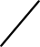The plot of this current transient is shown inFig. 7.77. In this case, the current is said tobe critically damped.
i(t)

0
t
Fig.7.77RLCcircuitcritically-dampedresponse.

Case3
(R)²<
2L
1 i.e.R<R_{C} (7.105)
LC

Forthiscase,therootsarecomplexconjugate, s₁=α+jβands₂=α-jβ (7.106)

Then,I(s)=
E/L
(sαjβ)(s -α

jβ)
= E/L =
(sα)²β²
E β

Lβ(sα)²

- β²
(7.107)

=A β
(sα)²

- β²
(7.108)

TakinginverseLT,weget i(t)=A
eαt
sinβt
(7.109)

AsseeninEquation7.95,αwillbeanegativenumber.Thus,forthisunderdamped
case,thecurrentisoscillatoryandatthesametimeitdecays.

Waveform shown is a exponentially decaying
i(t)
sinusoidalwave t

Example 7.30 For the RLC circuit shown, find the expression for the transient current when the switch is closed at time t = 0. Assume initially relaxed circuit conditions.

200V
0.1H
i
100Ω

100µF

Solution ThetransformcircuitisshowninFig.7.80.

200
s
100
0.1s

10000
I(s)

s

Fig.7.80Transformcircuit-Example7.30.

CurrentI(s)=
200/s

1000.1s 10000
s

0.1s²
200 
100s10000 s²
2000
1000s100000

CurrentI(s)=
200/s
1000.1s

10000

s

0.1s²
200 
100s10000 s²
2000
1000s100000

The roots of the denominator polynomialare

s₁,s₂=
1127and887.3
2
−10³± 10⁶−0.4X10⁶

Therefore,I(s)=
2000 
(s1127)(s 887.3)
K1 
s1127
K2

s887.3

K₁=

K₂=

2000

s112.7

s=-112.7

s=-887.3
2000
s+887.3
=2.582

=-2.582

Thus,I(s)=2.582[
1 
s112.7
1 ]
s887.3

TakinginverseLT,weget currenti(t)=2.582(e^{112.7t}
e887.3t )A

This isanexampleforover-damped.

Example 7.31 Takingtheinitial conditionsaszero,findthetransientcurrentinthe circuit shown in Fig. 7.81 when the switch is closed at time t = 0.

100V
0.1H
i
5Ω

500µF

Fig.7.81CircuitforExample7.31.

Solution Thetransform circuit isshown inFig.7.82.

100
s
5 0.1s

10⁶
I(s)

500 s

Fig.7.82Transformcircuit-Example7.31.

CurrentI(s)=
100/s
50.1s

10⁶

0.1s²
100 
5s2000 s²
1000
50s20000

500s

CurrentI(s)=
100/s 
100
 1000

50.1s
10⁶

500s
0.1s²
5s
2000
s²
50s
20000

Therootsofthedenominator polynomialare

s,s=
−50± 2500−80000
25
j139.1941

1 2 2

Itcanbeseenthat
s²+50s+20000=(s+25)²+(139.1941)²

Thus,I(s) =
1000
7.1842
139.1941

(s
25)²
(139.1941)²
(s
25)²(139.1941)²

TakinginverseLT,weget i(t)=7.1842
e25t
sin(139.1941t)A

Thisis anexampleforunder-damped.

UNIT–III

NETWORK PARAMETERS
Topics: Two port network parameters – Z, Y, ABCD and hybrid parameters and their relations. Conceptoftransformednetwork–Twoportnetworkparametersusingtransformedvariables- Cascaded networks and analysis of Two-Port networks using the above parameters.
INTRODUCTION:
Apairofterminalsat whicha signal mayenter orleave a networkis called a port. A port is defined as any pair of terminals into which energy is supplied or from which energy is withdrawn, or where the network variables may be measured, One such network having only one pair of terminals (1-1') is shown in Fig.(a).
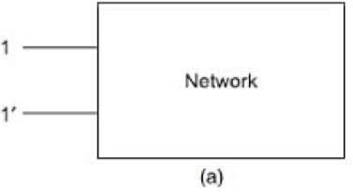
A two-port network is simply a network inside a black box, and the network has only two pairs of accessible terminals; usually one pair represents the input and the otherrepresents the output. Such a building block is very common in electronic systems, communication systems, transmission, and distribution systems. The Figure(b) shows a two- port network, or a two terminal pair network, in which the four terminals have beenpaired intoports 1-1' and 2-2'.
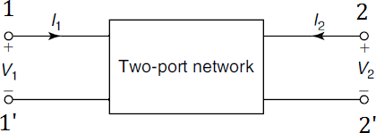
The terminals 1-1' together constitute a port. Similarly, the terminals 2-2' constitute another port. Two ports containing no sources in their branches are called passive ports;among them are power transmission lines and transformers. Two ports containing sources in their branches are called active ports. A voltage and current assigned to each of the two ports.
The voltage and current at the input terminals are V1 and I1; whereas V2 and I2 are specified at the output port. It is also assumed that the currents I1 and I2 are entering into the networkatthe upperterminals1and2,respectively.Thevariablesofthetwo-portnetworkare V1, V2, and I1, I2.Two of these are dependent variables; the other two are independent variables.The numberofpossible combinations generated bythe fourvariables, taken twoata time is six. Thus, there are six possible sets of equations describing a two-port network.

OPEN-CIRCUITIMPEDANCEPARAMETERS(ZPARAMETERS)

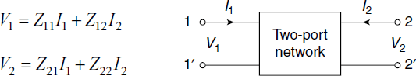
A two-port network is redrawn as in Figure. Here, we consider V1 and V2 as dependent variables and I1 and I2 as independent variables. Let Z11, Z12, Z21 and Z22 are the Z-parameters. The voltage V1 and V2 in terms of I1 and I2 are expressed as follows:
Intermsofmatrixequations,thefollowingcanbe obtained:
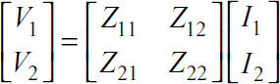


The individual Z-parameters can be found as indicated in the following. When the output-port is open-circuited, that is, when I2= 0, the equation will be as follows:
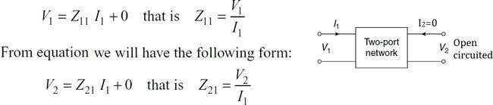
When the input port is open-circuited, that is, when I1= 0, then equation (11.1) will be given as follows:
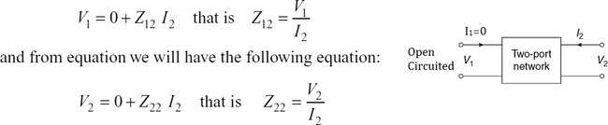
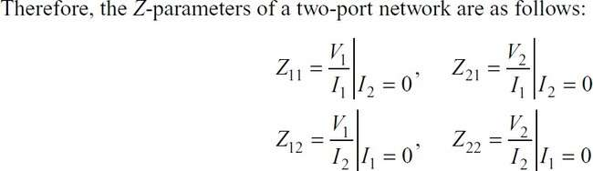

Alltheseparametersarealsocalled open-circuitimpedanceparameters.
Z11isknownasthedriving-pointimpedanceattheinputport,whenoutputportisopen- circuited.
Z21is known as the transfer impedance at the input port, when output port is open-circuited. Z22isknownasthedriving-pointimpedanceattheoutputport,wheninputportisopen- circuited.
Z12isknownasthetransferimpedanceattheoutputport,wheninputportisopen-circuited.

As these impedance parameters are measured with either the input or output port open- circuited, these are called open-circuit impedance parameters. The equivalent circuit of thetwo-port network in terms of Z parameters is shown in Fig.
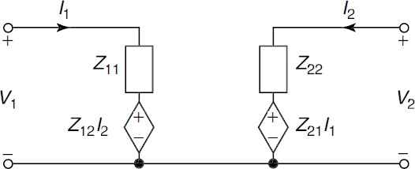

The network is to be reciprocal if Z12=Z21 Thenetworkistobesymmetricalif Z11=Z22
PROBLEMSONZ-PARAMETERS
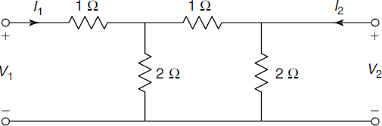
- FindZ-parametersforthenetworkshowninFig.

SOL:
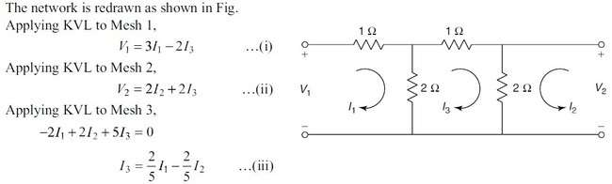

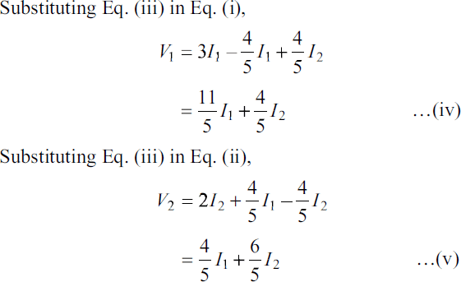
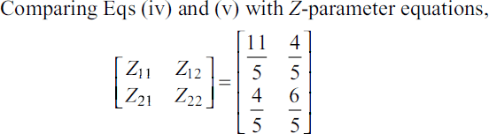

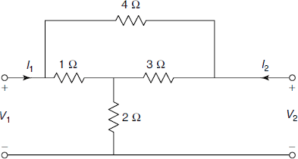
- Findtheopen-circuitimpedanceparametersforthenetworkshowninFig.Determine whether the network is symmetrical and reciprocal.

SOL:

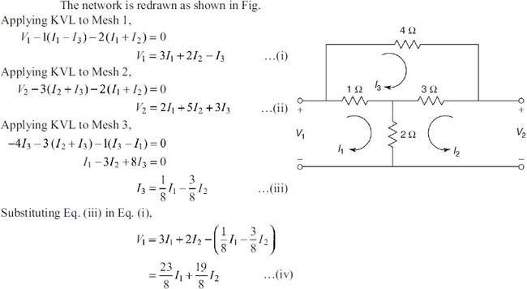
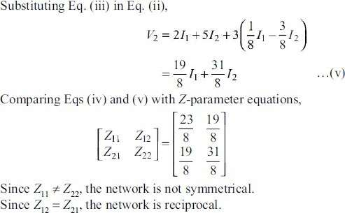
- FindZ21and Z22forthenetworkshownionthefig.
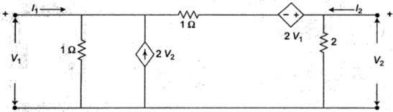

SOL:

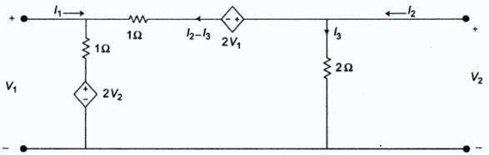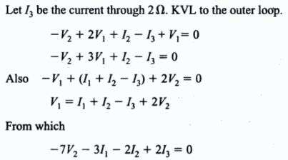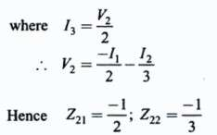

SHORT-CIRCUITADMITTANCEPARAMETERS(or)Y-PARAMETERS
The admittance parameters are also called Y-parameters. To determine Y-parameters, V1and V2 aretakenasindependentvariablesandI1 andI2 asdependentvariables.PortcurrentsI1 and I2 are expressed in terms of the voltages V1 and V2. The network equations are written as follows:
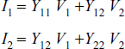
Theequationscanberepresentedinmatrixformas follows:
[I]=[Y][V]
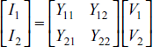
where Y11, Y12, Y21 and Y22 are admittance parameters and these can be determined as in the following.
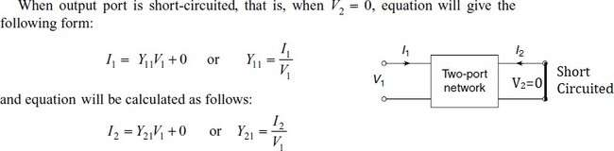
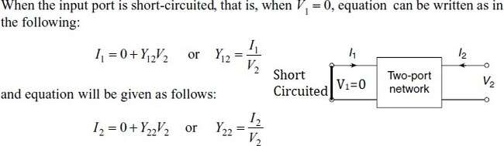

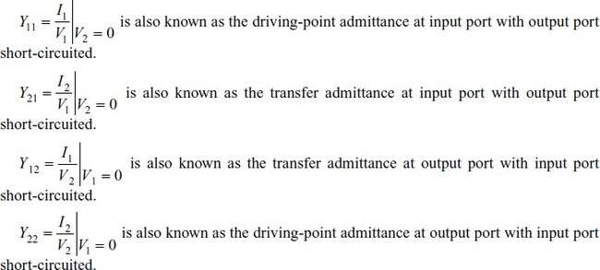

As these admittance parameters are measured with either input or output port short-circuited, these are called short-circuit admittance parameters.
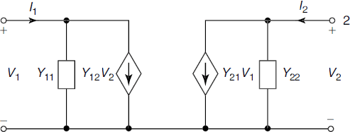
Theequivalentcircuitofthetwo-portnetworkintermsofYparametersisshowninFig.

If the network is reciprocal if Y12 = Y21Ifthenetworkissymmetricalif Y11=Y22
PROBLEMSONY-PARAMETERS
- FindY-parametersforthenetworkshowninFig.
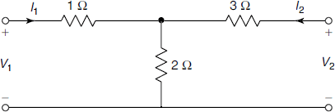
SOL:

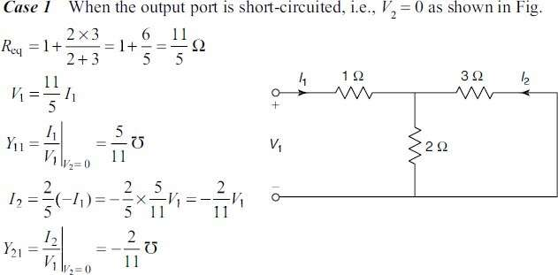
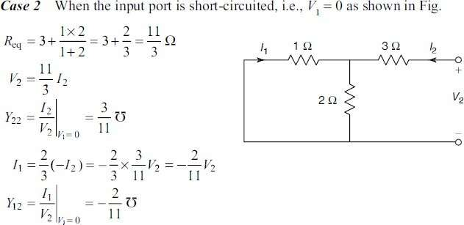
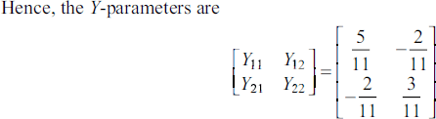

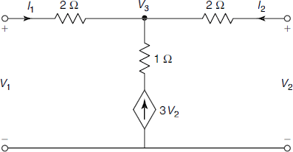
- FindY-parametersofthenetworkshowninFig.
SOL:
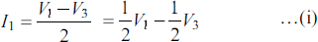
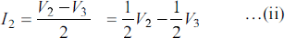
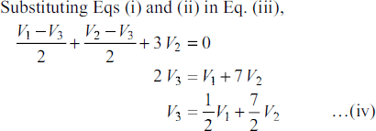
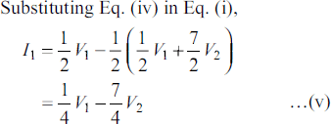
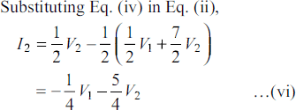

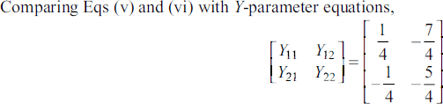
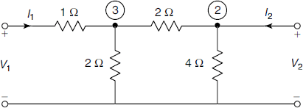
- Determine Y-parameters for the network shown in Fig. Determine whether the network issymmetrical and reciprocal.
SOL:
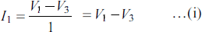
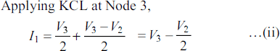
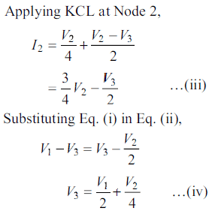
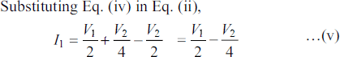

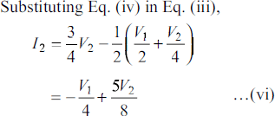
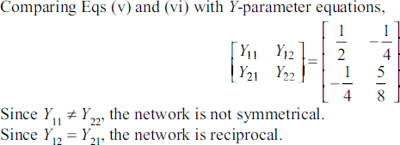

ΤRANSMISSIONPARAMETERS(or)ABCDPARAMETERS
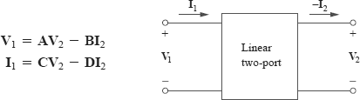
The transmission parameters or chain parameters or ABCD parameters serve to relate the voltage and current at the input port to voltage and current at the output port.

Here, the negative sign is used with I2 and not for parameters B and D. The reason the current I2carries a negative sign is that in transmission field, the output current is assumed to be coming out of the output port instead of going into the port.
Inmatrixform,wecanwrite
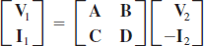
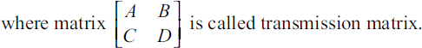

The two-port parameters in above equations provide a measure of how a circuittransmits voltage and current from a source to a load. They are useful in the analysis of transmission lines (such as cable and fiber) because they express sending-end variables (V1 and I1) in terms of the receiving-end variables (V2 and ‒I2). For this reason, they are called transmission parameters. Theyare also known as ABCD parameters. Theyare used in the design of telephone systems, microwave networks, and radars.

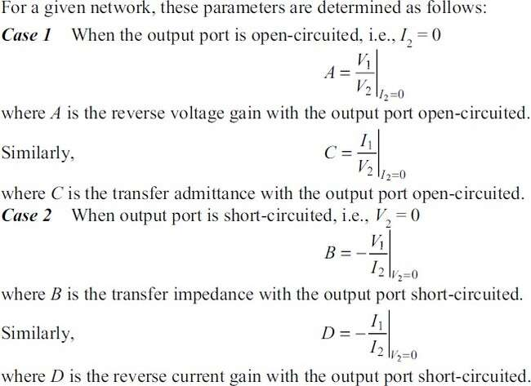
Insimpleform,
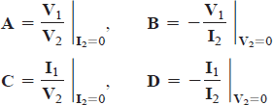
Thus,thetransmissionparametersarecalled, specifically,
A=Open-circuitvoltageratio
B=Negativeshort-circuittransferimpedance
C=Open-circuittransferadmittance
D=Negativeshort-circuitcurrentratio
A and D are dimensionless, B is in ohms, and C is in siemens. Since the transmission parameters provide a direct relationship between input and output variables, they are very useful in cascaded networks.

ThenetworkistobereciprocalifAD−BC=1 The network is to be symmetrical if A = D

PROBLEMSONABCD-PARAMETERS
- FindtheABCDparametersforthenetworkshowninthefig.
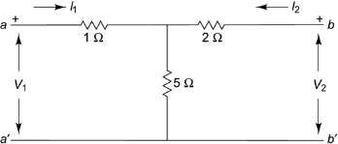
SOL:
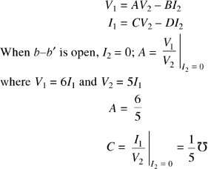
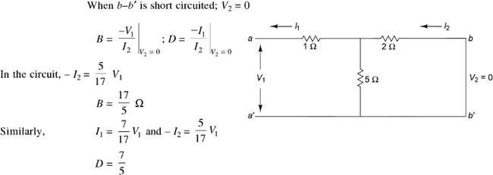

- ObtainABCDparametersforthenetworkshowninFig
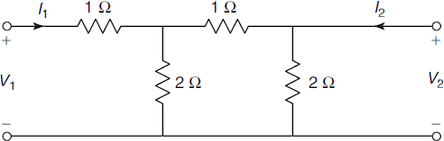

SOL:
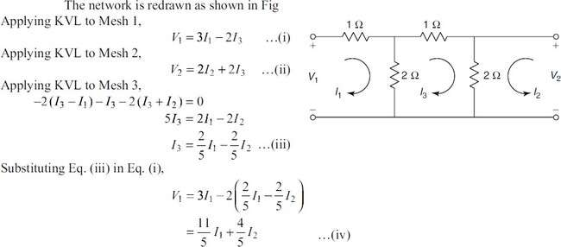
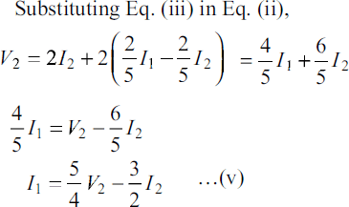
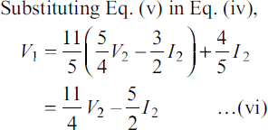
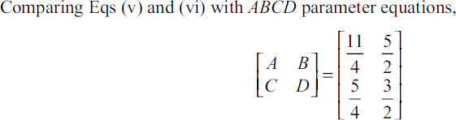

- Findtransmissionparametersforthetwo-portnetworkshowninFig
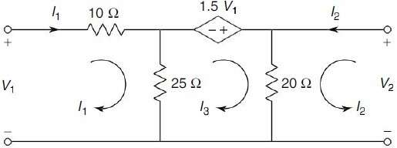
SOL:
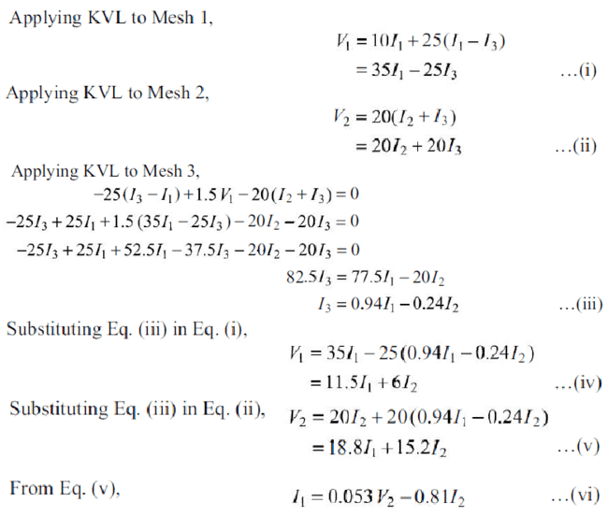
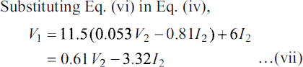

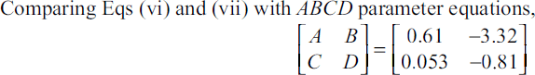

INVERSEΤRANSMISSIONPARAMETERS(or)A’B’C’D’ PARAMETERS
Theinversetransmissionparametersservetorelatethevoltageandcurrentatthe output port to the voltage and current at the input port.
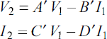
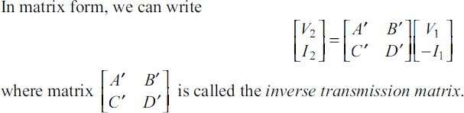
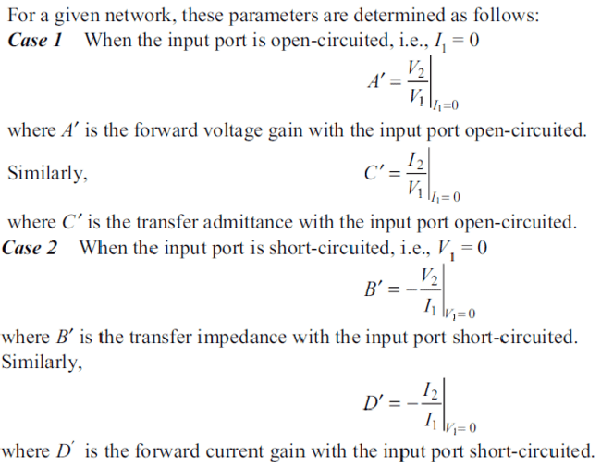

ThenetworkistobereciprocalifA’D’−B’C’=1 The network is to be symmetrical if A’ = D’

PROBLEMSONA’B’C’D’-PARAMETERS
- FindtheinversetransmissionparametersforthenetworkshowninFig
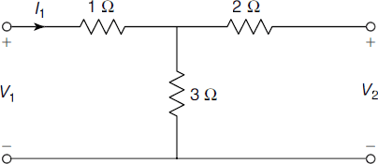
SOL:
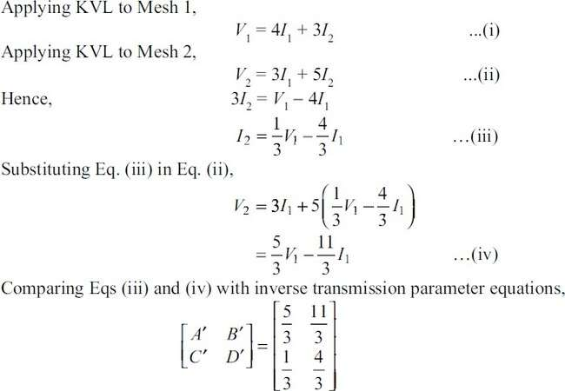
- FindtheinversetransmissionparametersforthenetworkshowninFig
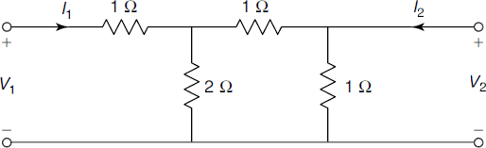

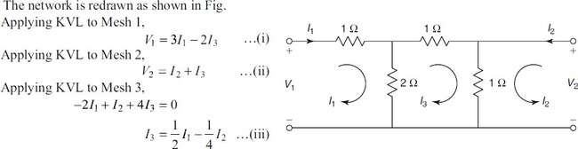
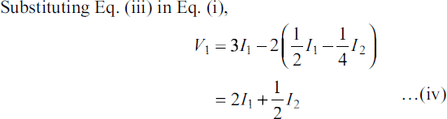
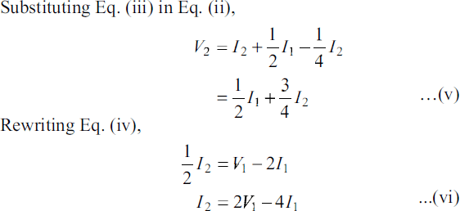
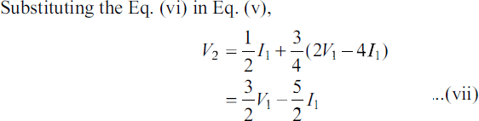
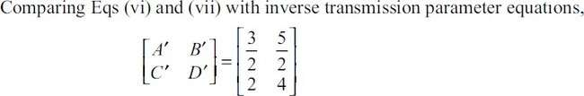

HYBRIDPARAMETERS(or)h-PARAMETERS
The hybrid parametersof a two-port network may be defined by expressing the voltage of input port V1 and current of output port I2 in terms of current of input port I1 and voltage of output port V2.
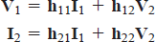
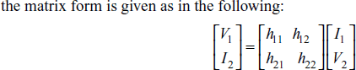

TheindividualhparameterscanbedefinedbysettingI1=0andV2=0.
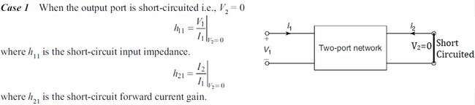
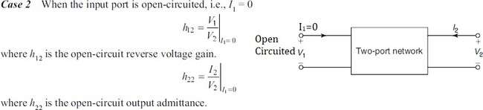

Insimpleform,
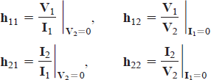

Thenetworkistobereciprocalif h12= −h21
Thenetworkistobesymmetricalif h11h22−h12h21=1

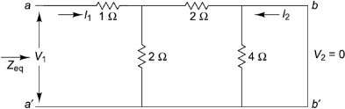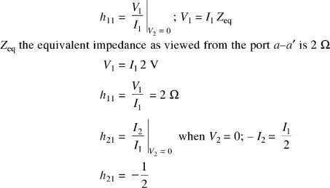
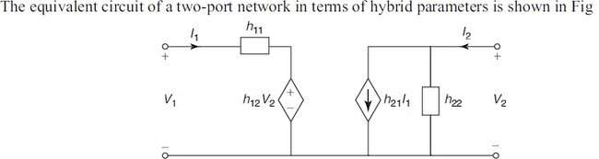
ItisevidentfromEq.thattheparametersrepresentimpedance,avoltagegain,acurrent gain, and admittance, respectively. Therefore, they are called the hybrid parameters.

PROBLEMSONh-PARAMETERS
- Findthehparametersofthenetworkshowninthefig.
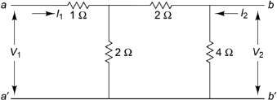
SOL:
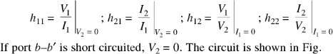

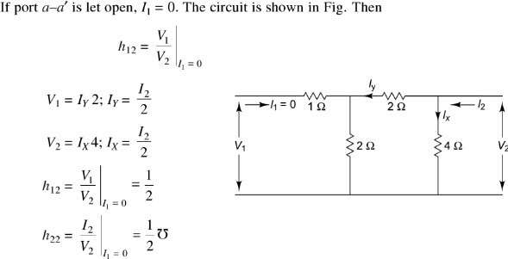

- Findthehybridparametersforthetwo-portnetworkofFig.
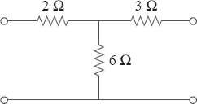
SOL:
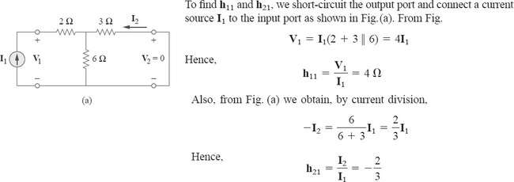

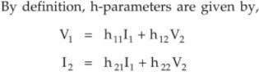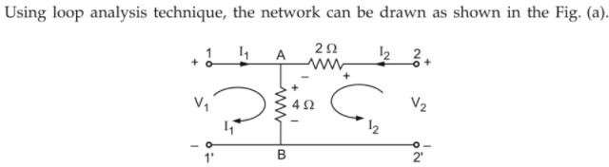

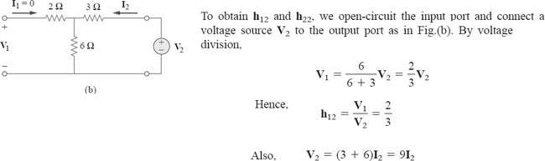
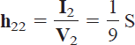

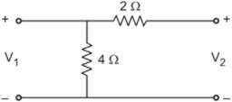
- Findthehybridparametersforthetwo-portnetworkofFig.
SOL:

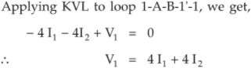

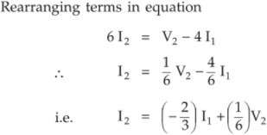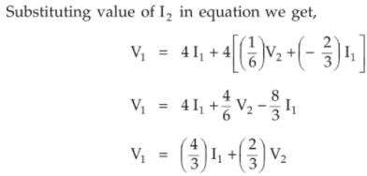

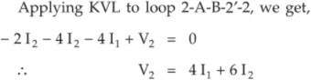

Hence
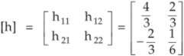

INVERSEHYBRIDPARAMETERS(or)g–PARAMETERS
The inverse hybrid parameters of a two-port network may be defined by expressing the current of the input port I1and voltage of the output port V2in termsof the voltage of the input port V1and the current of the output port I2.
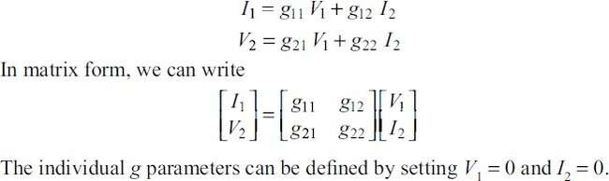

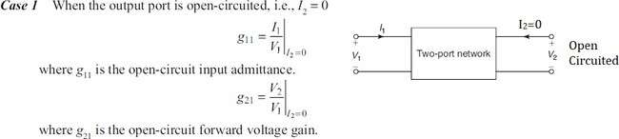
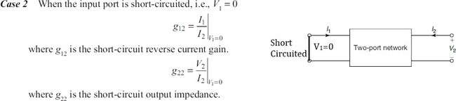

The equivalent circuit of a two-port network in terms of inverse hybrid parameters isshown in Fig.
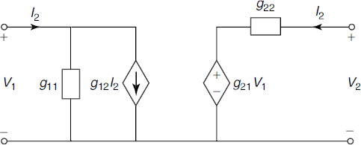
Thenetworkistobereciprocalif g12=− g21
Thenetworkistobesymmetricalif g11g22−g12g21=1
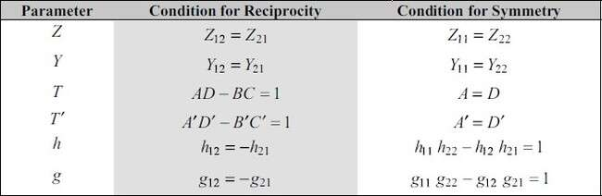
NOTE:Conditionsforreciprocityandsymmetry

PROBLEMSONg-PARAMETERS
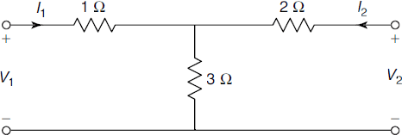
- Findg-parametersforthenetworkshown inFig.
SOL:
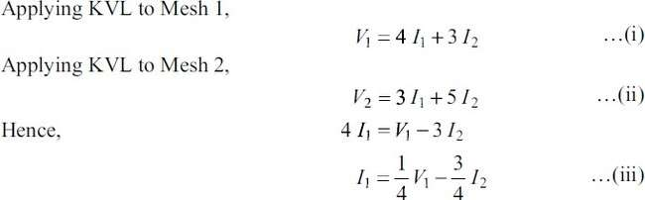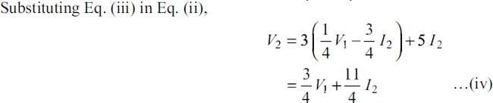
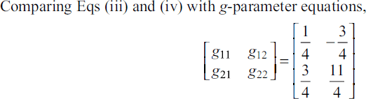
- Findg-parametersforthenetworkshown inFig.
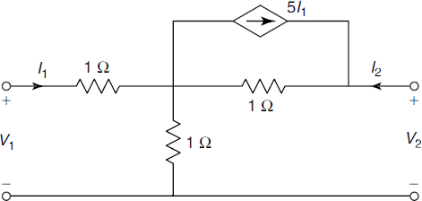

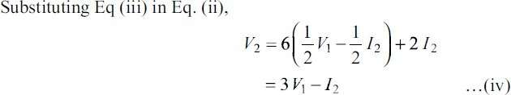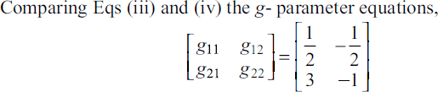
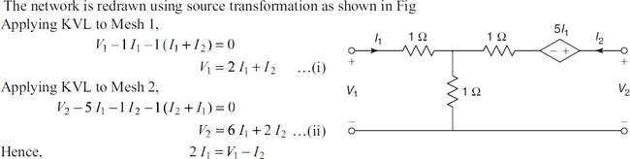
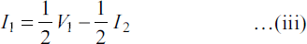
SOL:

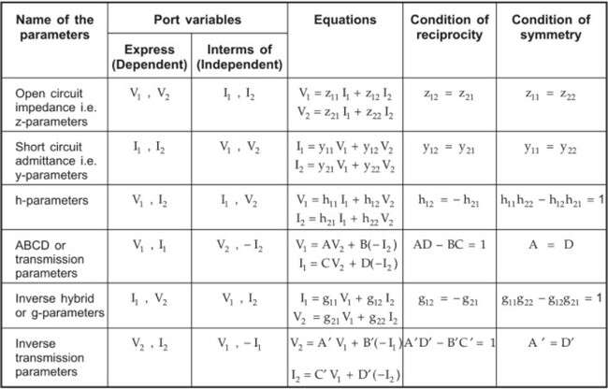
SUMMARYOFTWOPORTNETWORK PARAMETERS:

INTER-RELATIONSHIPSBETWEENTHETWO-PORTNETWORKPARAMETERS
(OR)
CORRELATIONOFTWO-PORTNETWORKPARAMETERSL

CASE-I:Z-PARAMETERSINTERMSOFOTHER PARAMETERS

  - Z-parametersinTermsofY-parameters:
Weknowthat,theequationsofY-parametersare
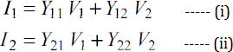
From equation(ii), Y22V2=I2–Y21V1
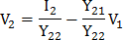
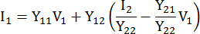
SubstituteV2inequation(i)

Let ΔY=Y11Y22–Y12Y21
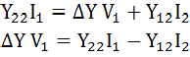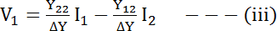

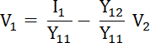
From equation(i), Y11V1=I1–Y12V2
SubstituteV1inequation(ii)
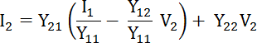

----(iv)
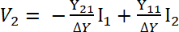
Weknowthat,theequationsofZ-parametersare

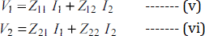
Comparingeq(v),(vi)witheq(iii),eq(iv)
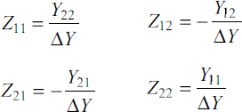
  - Z-parametersinTermsofABCD-parameters:
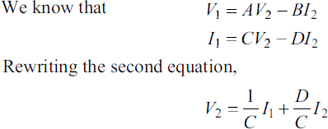
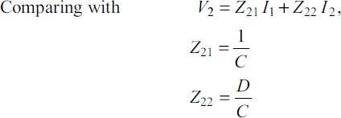

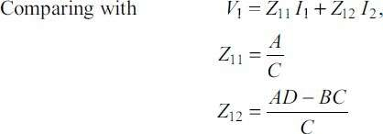
Hence

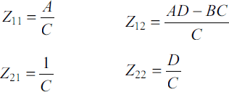
  - Z-parametersinTermsofHybrid(h)-parameters:
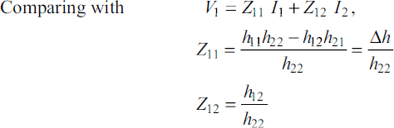
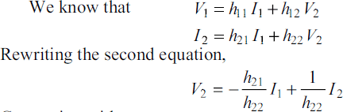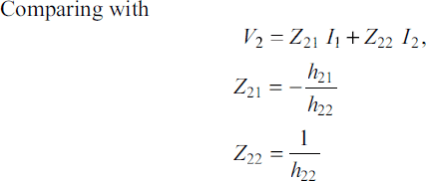

Hence
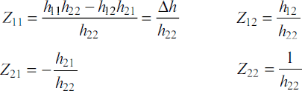

CASE-II:Y-PARAMETERSINTERMSOFOTHERPARAMETERS

  - Y-parametersinTermsofZ-parameters:
Weknowthat,theequationsofZ-parametersare
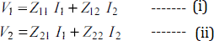
From equation(ii)
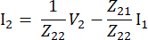
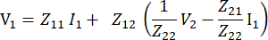SubstituteI2inequation(i)
Let
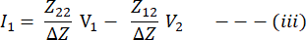
From equation(i)
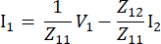
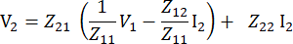
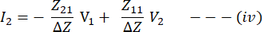
SubstituteI1inequation(ii)

Weknowthat,theequationsofY-parametersare
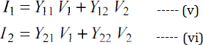
Comparingeq(v),(vi)witheq(iii),eq(iv)

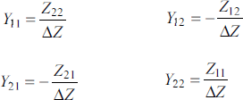
  - Y-parametersinTermsofABCD-parameters:
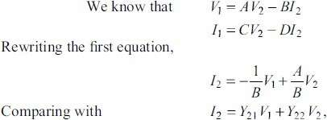
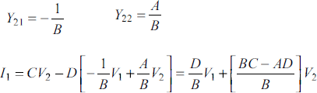
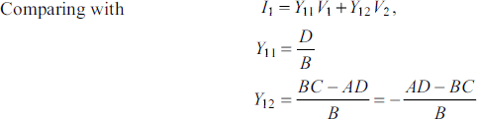

  - Y-parametersinTermsofHybrid(h)-parameters:
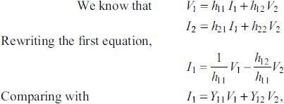
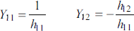

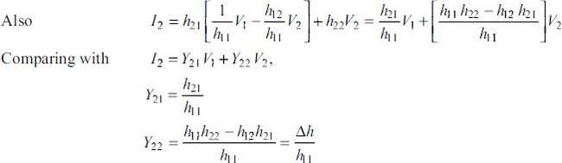

CASE-III:ABCD-PARAMETERSINTERMSOFOTHERPARAMETERS
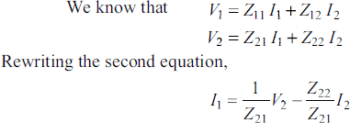
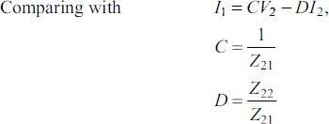
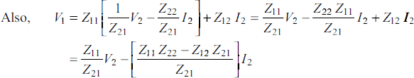
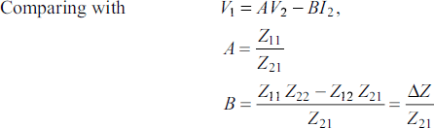
  - ABCD-parametersinTermsofZ-parameters:

  - ABCD-parametersinTermsofY-parameters:
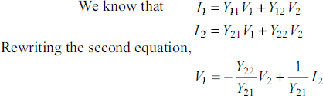
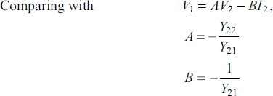
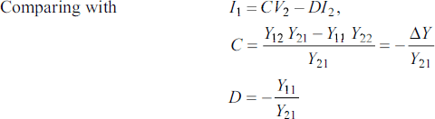

  - ABCD-parametersinTermsofHybrid(h)-parameters:
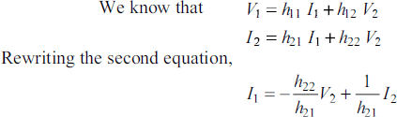
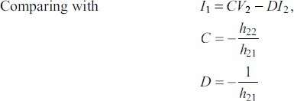

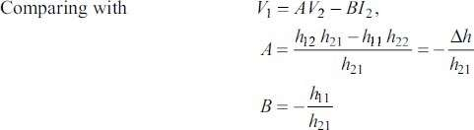
CASE-IV:HYBRID(h)-PARAMETERSINTERMSOFOTHER PARAMETERS
  - Hybrid(h)-parametersinTermsofZ-parameters:
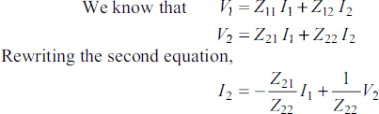
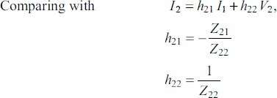
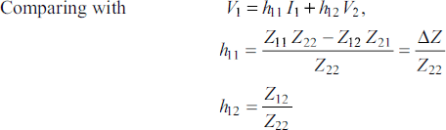

  - Hybrid(h)-parametersinTermsofY-parameters:
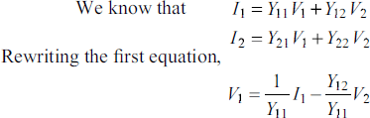

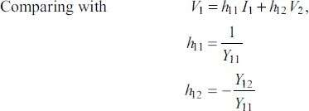
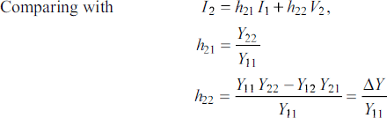

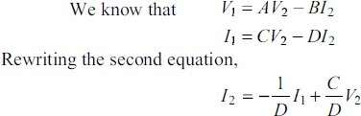
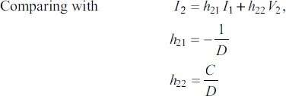
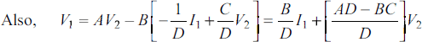
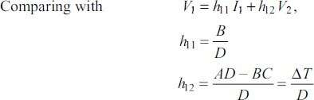
  - Hybrid(h)-parametersinTermsofABCD-parameters:

T-CIRCUITREPRESENTATIONOFTWO-PORTNETWORK
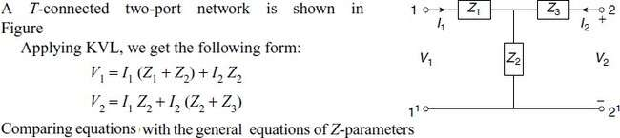
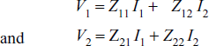
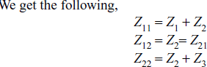

Fromtheaboveequations, theT-networkimpedancesare
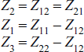

Π-CIRCUITREPRESENTATIONOFTWO-PORTNETWORK
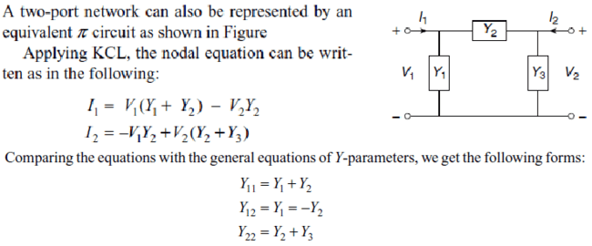
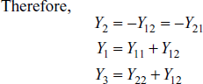

- TheZparametersofatwo-portnetworkareZ11=20Ω,Z22=30Ω,Z12=Z21=10Ω. Find Y and ABCD parameters.
SOL:
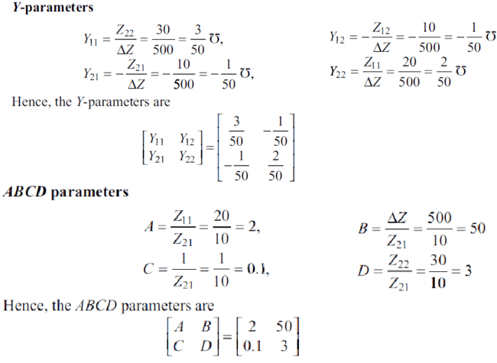
- The Currents I1and I2entering at Port 1 and Port 2 respectively of a two-port network are given by the following equations:
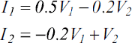
FindY,ZandABCDparametersforthenetwork.
SOL:
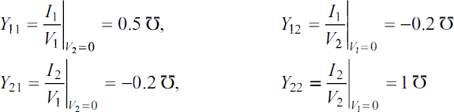

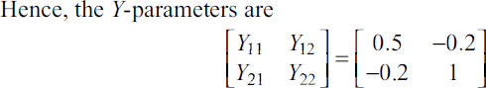
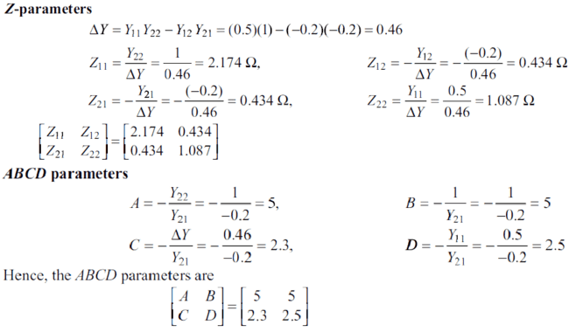

- TheZ-parametersofatwo-portnetworkare:Z11 =10Ω,Z12 =Z21 =5Ω,Z22 =20Ω. Find the equivalent T-network.
SOL:
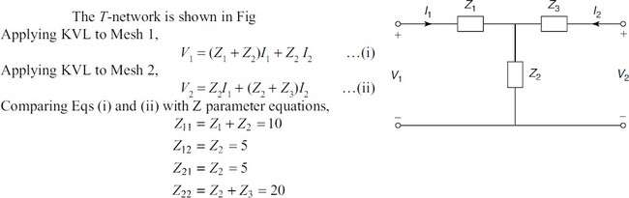
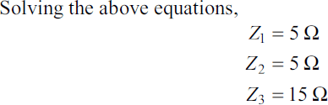

- TheAdmittanceparametersofatwo-portnetworkareY11=0.09mho,Y12=Y21=−0.05
mhoandY22=0.07mho.FindtheequivalentΠ-network.
SOL:
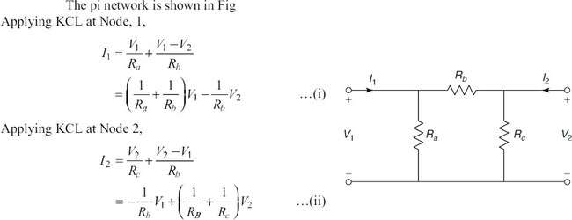
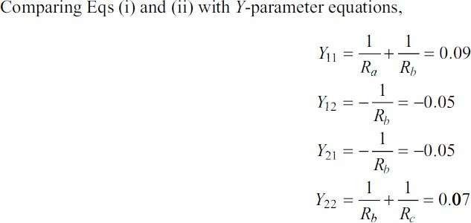
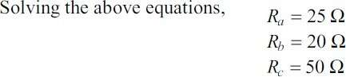

CONCEPTOFTRANSFORMEDNETWORK
In any network, the parameters can be solved by using differential equation method and using Laplace transform method. To analyze any network on a transform basis, the only additional step required is to represent all the network elements in terms of' complex impedance and admittance with associated initial energy sources. Therefore, we define the transform impedance and admittance and then find out their expression for each of the circuit elements like resistance, inductance, and capacitance.
For a single element, the transform impedance is defined as the ratio of the transform of the element voltage to the transform of the element current for zero initial current in an inductor and zero initial voltage in a capacitor.

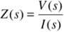
Similarly, the transform admittance is defined as the ratio oftransform of the elementcurrent for zero initial current in an inductor and zero initial voltage in a capacitor.
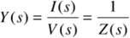

  - Resistance:Foraresistance,thevoltageandcurrentarerelatedinthetime domainbyOhm's law.
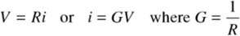
Thecorrespondingtransformequationsare
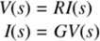
Thetransformimpedanceoftheresistor
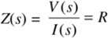
Similarly,thetransformadmittanceof'theresistor
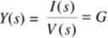
From the above results, we can say that the resistor is frequency independentto the complexfrequency.
  - Inductance:Forinductance,thetimedomainrelationbetweenthecurrentandvoltage inductance as
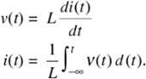
Theequivalenttransformequationforthe voltage
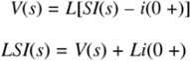
wherei(0+)istheinitialcurrentpresentintheinductorati=0+.
Iftheinitialcurrenti(0+)=0,thetransformimpedancefortheinductor
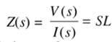
andthetransformadmittance becomes

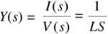
  - Capacitance:Forcapacitance,thetimedomainrelationbetweenvoltageandcurrentis expressed as
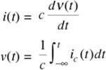
Theequivalenttransformequationforthevoltageexpressionis
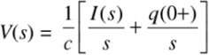
Theaboveequation becomes
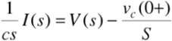
Byconsideringtheinitialchargeonthecapacitorzero. The equation becomes
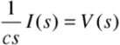
ThetransformimpedanceofthecapacitoristheratiooftransformvoltageV(s)tothetransform current I(s) and is
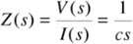
Thetransformadmittanceofthecapacitoristheratiooftransformcurrent I(s)tothetransform voltage V(s) is
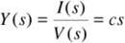
TWO-PORTPARAMETERSUSINGTRANSFORMEDVARIABLES

Forthetwo-portnetworkwithoutinternalsources,thedrivingpointimpedance function at port 1-1' is the ratio ofthe transformvoltage at port 1-1' tothe transformcurrent at the same port.
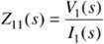
Similarly, the driving point impedance at port 2-2' is the ratio of transform current at the same port

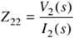
Forthetwo-portnetwork,thedrivingpointadmittanceisdefinedastheratioof the transform current at any port to the transform voltage at the same port.
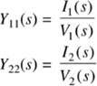
The four other network functions are called transfer functions. These functions give therelation between voltage or current at one port to the voltage or current at the other port as shown hereunder.

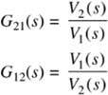
- VoltageTransferRatio:Itisdefinedastheratioofvoltagetransformatoneporttothe voltage transform at the other port and is denoted by G(s)
- CurrentTransferRatio:Itisdefinedastheratioofcurrenttransformatoneporttothe current transform at the other port and is denoted by 𝞪(s).
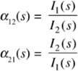
- TransferImpedance:Itisdefinedastheratioofvoltagetransformatoneporttothe current transform at the other port. and is denoted by Z(s).
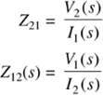
- TransferAdmittance:Itisdefinedastheratioofcurrenttransformatoneporttothe voltage transform at the other port and is denoted by Y(s).
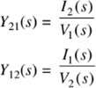
The above network functions are found by forming the system of equations using nodal ormeshanalysisandtakingthetransformsofequationsbysettingtheinitialconditiontozeroand solving for ratio of the response to excitation.

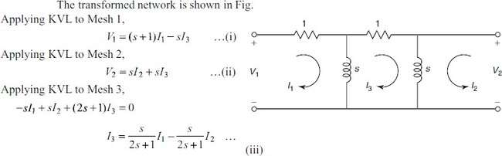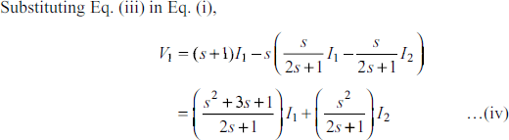
PROBLEMSONTRANSFORMEDNETWORKS
- FindtheZ-parametersforthenetworkshowninFig.
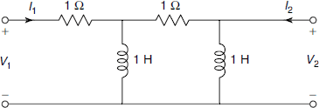
SOL:

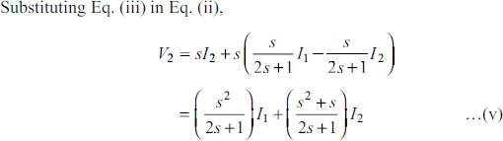
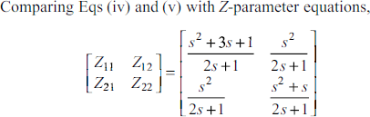

- DetermineY-parametersforthenetworkshowninFig.
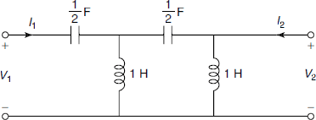
SOL:
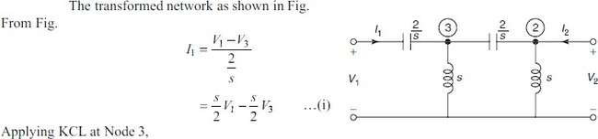
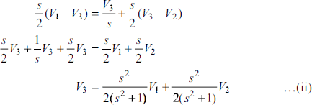
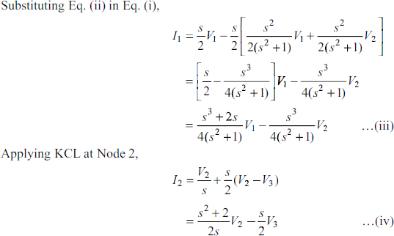

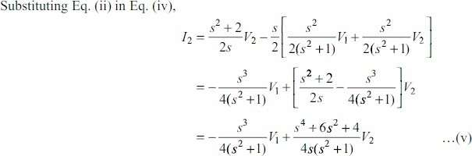
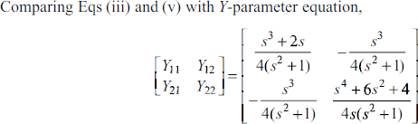

- DeterminethetransmissionparametersforthenetworkshowninFig
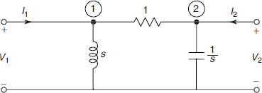
SOL:
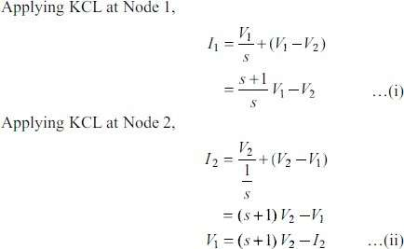

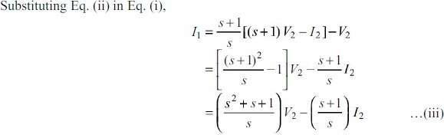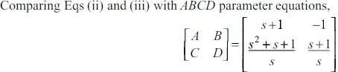

- Findh-parametersforthenetworkshown inFig.
SOL:

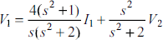
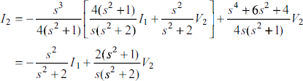
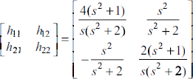

INTERCONNECTIONOFTWO-PORTNETWORKS
When the two networks are interconnected, the input and output quantities are to be determined with Cascade Connection, series and parallel connections. The cascade connection is useful to determine ABCD parameters of two interconnected networks; the series connection is useful to determine Z parameters of two interconnected networks; the parallel connection is useful to determine Y parameters of two interconnected networks. With the help ofrelationship between two-port parameters, the other parameters also are to be determined.

  - CASCADECONNECTION:

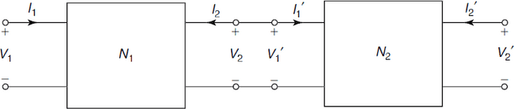
TheFigureshows two-portnetworksconnectedincascade.Inthecascadeconnection,the output port of the first network becomes the input port of the second network. Since it is assumed that input and output currents are positive when they enter the network, we have

LetA1,B1,C1,D1bethetransmissionparametersofthenetworkN1andA2,B2,C2,D2bethe transmission parameters of the network N2.
ForthenetworkN1,
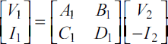
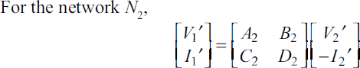
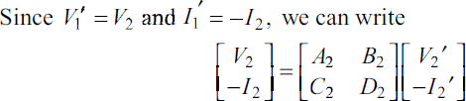
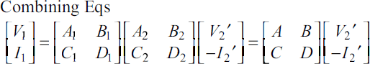

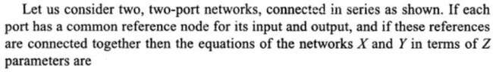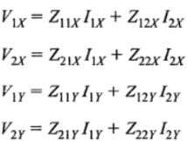

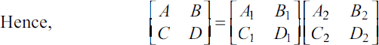
The aboveequation showsthat theresultant ABCDmatrixof the cascade connectionis the product of the individual ABCD matrices.

  - SERIESCONNECTION:

The Figure shows two-port networks connected in series. In a series connection, both the networks carry the same input current. Their output currents are also equal.
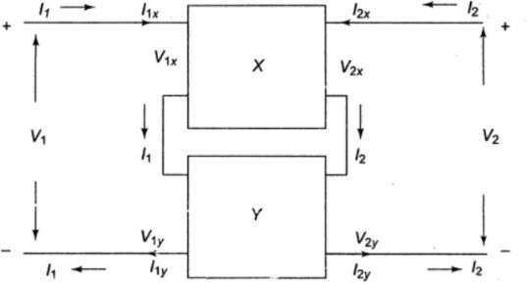

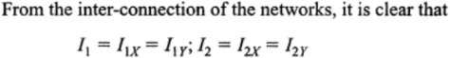

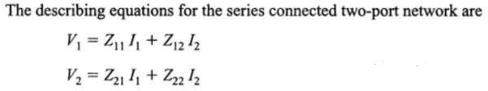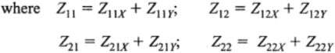
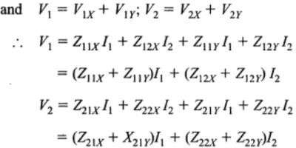

Thus,theresultantZ-parametermatrixfortheseries-connectednetworksisthesumof Z-parameters of each individual two-port network.

  - PARALLELCONNECTION:
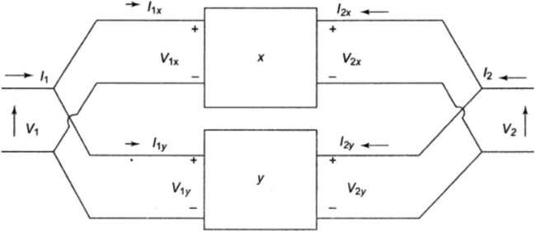
The Figure shows two-port networks connectedinparallel. In the parallel connection,the two networks have the same input voltages and the same output voltages.

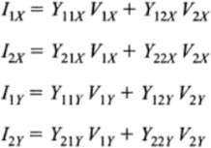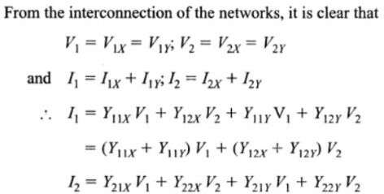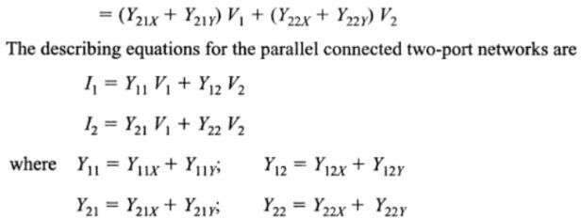

PROBLEMSONINTERCONNECTEDNETWORKS
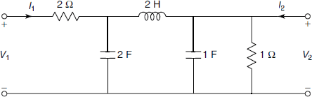
- DetermineABCDparametersfortheladdernetworkshowninFig.
SOL:
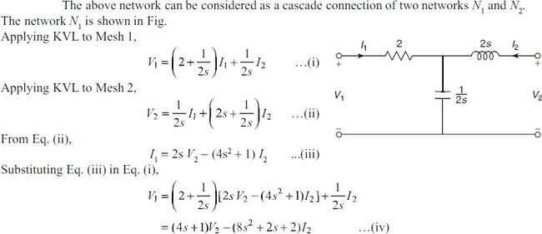
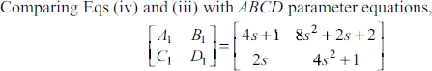
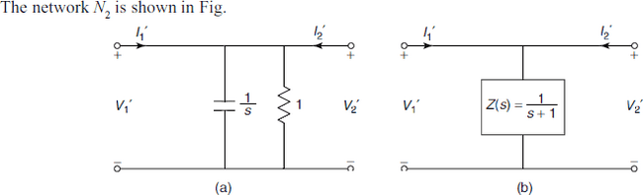
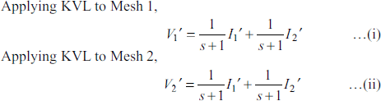

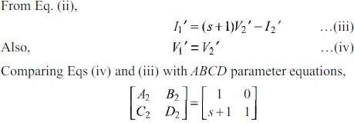
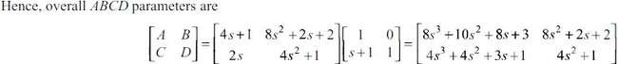

- FindY-parametersforthenetworkshown inFig.
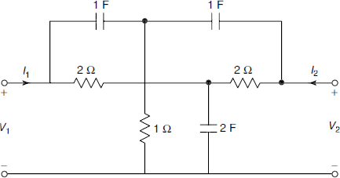
SOL:
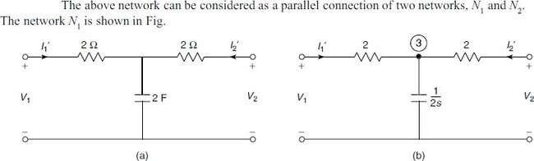

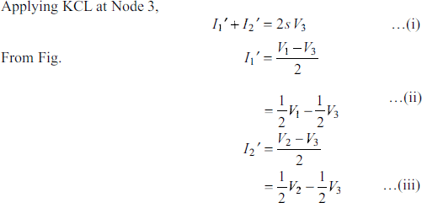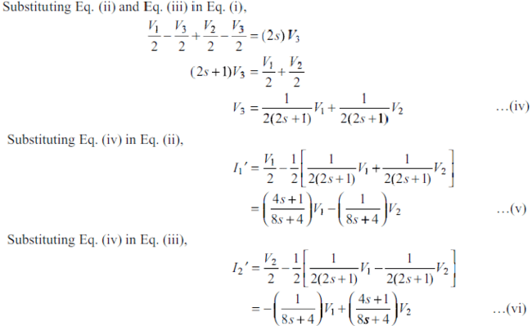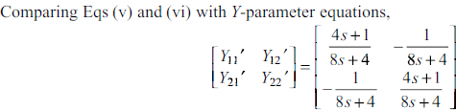

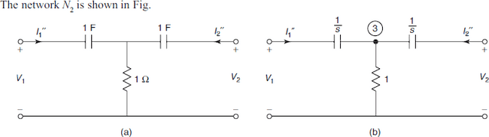
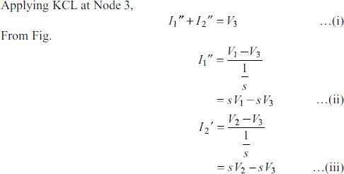
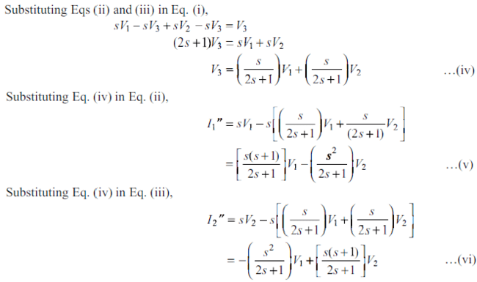

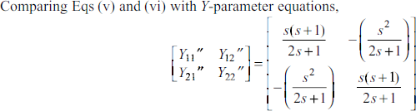
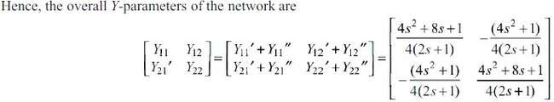
- Two identical sections of the network shown in Fig. are connected in series. Obtain Z-parameters of the overall connection.
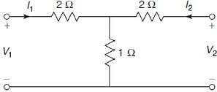
SOL:
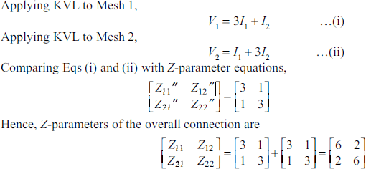

UNIT-IV

FOURIERTRANSFORMS

Introduction
The Fourier series expresses any periodic function into a sum of sinusoids. The Fourier transform is the extension of this idea to non-periodic functions by taking the limiting formofFourierserieswhenthefundamentalperiodismadeverylarge(infinite). Fourier transform finds its applications in astronomy, signal processing, linear time invariant (LTI) systems etc.
SomeusefulresultsincomputationoftheFouriertransforms:
- ∞𝑒^{−𝑎𝑥}sin𝜆𝑥𝑑𝑥= ^{𝜆}
∫0 𝑎2+𝜆2
- ∞𝑒^{−𝑎𝑥}cos𝜆𝑥𝑑𝑥= ^{𝑎}

∫0
- ∞sin𝜆𝑥
∫

𝑎2+𝜆2
𝜋

𝑑𝑥=,𝜆>0
0 𝑥 2
When𝜆=1, ∞𝑠𝑖𝑛𝑥𝑑𝑥=𝜋
∫0 𝑥 2
- sin𝑎𝑥=𝑒𝑖𝑎𝑥−𝑒−𝑖𝑎𝑥
2𝑖
- cos𝑎𝑥=𝑒𝑖𝑎𝑥+𝑒−𝑖𝑎𝑥
2
- ∞𝑒−𝑎2𝑥2𝑑𝑥=√𝜋

∫0
When𝑎=1,
2𝑎
∞𝑒−𝑥2𝑑𝑥=√𝜋
∫

0 2
- HeavisideStepFunctionorUnitstepfunction𝐻(𝑡)or𝑈(𝑡)={0,when𝑡<0
1,when𝑡≥0
At𝑡 = 0,𝐻(𝑡) issometimestakenas0.5orit maynothaveanyspecific value. Shifting at𝑡 = 𝑎
𝐻(𝑡− 𝑎)or𝑈(𝑡− 𝑎)={0,when𝑡<𝑎
1,when𝑡≥𝑎
- DiracDeltaFunctionorUnitImpulseFunctionisdefinedas𝛿(𝑡−𝑎)=0,t≠a
suchthat∫∞𝛿(𝑡−𝑎)𝑑𝑡=1,𝑎≥0.Itiszeroeverywhereexceptonepoint'a'.
0
Deltafunctioninsometimesthoughtofhavinginfinitevalueat𝑡= 𝑎.Thedelta function can be viewed as the derivative of the Heaviside step function

Dirichlet’sConditionsforExistenceofFourierTransform
Fouriertransformcanbeappliedtoanyfunction𝑓(𝑥)ifitsatisfiesthefollowing conditions:
- 𝑓(𝑥)isabsolutelyintegrable i.e.∫∞|𝑓(𝑥)|𝑑𝑥isconvergent.
−∞
- Thefunction𝑓(𝑥)hasafinitenumberofmaximaandminima.
- 𝑓(𝑥)hasonlyafinitenumberof discontinuitiesinanyfinite

FourierTransform,InverseFourierTransformandFourierIntegral
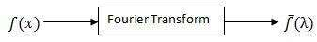
TheFouriertransformof𝑓(𝑥),−∞<𝑥<∞,denoted by𝑓̅(λ)whereλ∈N,isgivenby
𝐹{𝑓(𝑥)}≡𝑓̅(λ)=¹ ∞𝑒^{𝑖𝜆𝑥}𝑓(𝑥)𝑑𝑥 …①
√2𝜋∫−∞
AlsoinverseFouriertransformof𝑓̅(λ)gives𝑓(𝑥)as:
𝑓(𝑥)=1 ∞𝑒^{−𝑖𝜆𝑥}𝑓̅(λ)𝑑𝜆…②
√2𝜋∫−∞
Rewriting①as𝑓̅(λ)= ¹ ∞𝑒^{𝑖𝜆𝑡}𝑓(𝑡)𝑑𝑡 andusingin②, Fourierintegral
√2𝜋∫−∞
representationof 𝑓(𝑥)isgivenby:
𝑓(𝑥)=1 ∞ ∞𝑒^{𝑖𝜆(𝑡−𝑥)}𝑓(𝑡)𝑑𝑡𝑑𝜆
_{2𝜋}∫−∞∫−∞

FourierSineTransform(F.S.T.)
FourierSinetransformof𝑓(𝑥),0<𝑥<∞,denotedby𝑓𝑠̅(λ),isgiven by

2
{ } ()
𝐹𝑓(𝑥)≡𝑓̅λ=√
∞𝑓(𝑥)sin𝜆𝑥 𝑑𝑥…③

𝑠 𝑠
𝜋∫0

AlsoinverseFourierSinetransformof𝑓𝑠̅(λ)gives𝑓(𝑥)as:

2 ∞
𝑓𝑥=√ 𝑓̅(λ)sin𝜆𝑥𝑑𝜆…④
()
𝜋∫0 𝑠

Rewriting③as () 2 ∞𝑓(𝑡)sin𝜆𝑡𝑑𝑡 andusingin④,Fouriersineintegral
_{𝑠} 𝜋∫0
𝑓̅λ=√
representationof 𝑓(𝑥)isgivenby:

FourierCosineTransform(F.C.T.)
FourierCosinetransformof𝑓(𝑥),0<𝑥<∞,denotedby𝑓𝑐̅(λ),isgivenby

𝐹{𝑓(𝑥)}≡𝑓̅ (λ)=√2 ∞𝑓(𝑥)cos𝜆𝑥𝑑𝑥…⑤

𝑐 𝑐
𝜋∫0

AlsoinverseFourierCosinetransformof𝑓𝑐̅(λ)gives𝑓(𝑥)as:

2 ∞
𝑓𝑥=√ 𝑓̅(λ)cos𝜆𝑥𝑑𝜆…⑥
()
𝜋∫0 𝑐

Rewriting⑤as () 2 ∞𝑓(𝑡)cos𝜆𝑡𝑑𝑡andusingin⑥,Fouriercosineintegral
_{𝑐} 𝜋∫0
𝑓̅λ=√
representationof 𝑓(𝑥)isgivenby:
𝑓(𝑥)=2 ∞∞𝑓(𝑡)cos𝜆𝑡cos𝜆𝑥 𝑑𝑡𝑑𝜆
𝜋∫0∫0
Remark:
- Parameterλmaybetakenasp,sorωasperusualnotations.
- Fouriertransformof𝑓(𝑥)maybegivenby𝑓̅(λ)=¹ ∞𝑒^{−𝑖𝜆𝑥}𝑓(𝑥)𝑑𝑥,
√2𝜋∫−∞
thenInverseFouriertransformof𝑓̅(λ)isgivenby𝑓(𝑥)=1 ∞𝑒^{𝑖𝜆𝑥}𝑓̅(λ)𝑑𝜆
√2𝜋∫−∞

- SometimesFouriertransformof𝑓(𝑥)istakenas𝑓̅(λ)=
∞
∫−∞
𝑒^{𝑖𝜆𝑥}𝑓(𝑥)𝑑𝑥,

therebyInverse Fouriertransformisgivenby𝑓(𝑥)=1 ∞𝑒^{−𝑖𝜆𝑥}𝑓̅(λ)𝑑𝜆
∫
2𝜋−∞
∞
SimilarlyifFourierSinetransformistakenas 𝑓̅_{𝑠}(λ)=∫ 𝑓(𝑥)sin𝜆𝑥 𝑑𝑥,
0
thenInverse Sinetransformisgivenby𝑓(𝑥)=2 ∞𝑓̅(λ)sin𝜆𝑥 𝑑𝜆
𝜋∫0 𝑠
SimilaristhecasewithFourierCosinetransform.
Example1StategivingreasonswhethertheFouriertransformsofthefollowing

functionsexist: i.sin1
𝑥
Solution:i.Thegraphofsin1
𝑥
- 𝑒𝑥 iii.𝑓(𝑥)={1, if𝑥is rational
0,if𝑥is irrational
oscillatesinfinitenumberoftimesat𝑥=𝑛𝜋,𝑛∈Z

∴𝑓(𝑥)sin1
𝑥
ishavinginfinitenumberofmaximaandminimaintheinterval

(−∞,∞).HenceFouriertransformof 𝑓(𝑥)=sin1
𝑥
doesnotexist.

  - For𝑓(𝑥)=𝑒^{𝑥},∫∞|𝑒^{𝑥}|𝑑𝑥isnotconvergent.HenceFouriertransform of
−∞
𝑒^{𝑥}doesnotexist.
  - 𝑓(𝑥)={1, if𝑥is rational
0,if𝑥is irrational
ishavinginfinitenumberofmaximaand

minimaintheinterval(−∞,∞).HenceFouriertransformof𝑓(𝑥)doesnotexist.
Example2FindFourierSinetransformof

    - ¹
𝑥
    - 2𝑒^{−3𝑥}+ 3𝑒^{−2𝑥}

Solution:i.Bydefinition,wehave𝐹{𝑓(𝑥)}≡𝑓̅(λ)=√2 ∞𝑓(𝑥)sin𝜆𝑥𝑑𝑥

2 ∞1
()
∴𝑓̅λ=√
𝑠 𝑠

2𝜋 𝜋
𝜋∫0

_{𝑠} 𝜋∫0
sin𝜆𝑥𝑑𝑥=√.=√
𝑥 𝜋2 2

ii. Bydefinition,𝐹{𝑓(𝑥)}≡𝑓̅(λ)=√2 ∞𝑓(𝑥)sin𝜆𝑥𝑑𝑥

𝑠 𝑠
𝜋∫0

2 ∞
()
∴𝑓̅λ=√ (2𝑒^{−3𝑥}+3𝑒^{−2𝑥}) sin 𝜆𝑥𝑑𝑥
_{𝑠} 𝜋∫0

2 ∞ 2
2𝑒−3𝑥
=√ sin𝜆𝑥𝑑𝑥+√
∞3𝑒^{−2𝑥}sin𝜆𝑥𝑑𝑥

𝜋∫0

22𝑒−3𝑥
𝜋∫0

∞

23𝑒−2𝑥 ∞

=√[
𝜋
9+𝜆
2(−3sin𝜆𝑥−𝜆cos𝜆𝑥]
0
+ √[
𝜋
4+𝜆
2(−2sin𝜆𝑥−𝜆cos𝜆𝑥]
0

2 2𝜆
[
= √ 0+
]+√2[0+3𝜆
]=√2[2𝜆
+3𝜆
]=√2[ 5𝜆3+35𝜆 ]

𝜋 9+𝜆2
𝜋 4+𝜆2
𝜋9+𝜆2
4+𝜆2
𝜋(9+𝜆2)(4+𝜆2)

Example3FindFouriertransformofDeltafunction𝛿(𝑥−𝑎)
Solution:𝐹{𝛿(𝑥−𝑎)}=¹ ∞𝑒^{𝑖𝜆𝑥}.𝛿(𝑥−𝑎)𝑑𝑥
√2𝜋∫−∞

= 1
√2𝜋
𝑒𝑖𝜆𝑎

∞
∴∫−∞
𝑓(𝑡)
𝛿(𝑡−𝑎)𝑑𝑡=𝑓(𝑎) byvirtueoffundamentalpropertyofDeltafunction

where 𝑓(𝑡)isanydifferentiable function.
Example4ShowthatFourier sineand cosinetransformsof𝑥^{𝑛−1}are]𝑛sin𝑛𝜋and

]𝑛cos𝑛𝜋

respectively.
𝜆𝑛 2

𝜆𝑛 2
Solution:Bydefinition,∫∞𝑒^{−𝑡}𝑡^{𝑛−1}𝑑𝑡=]𝑛
0
Putting𝑡=𝑖𝜆𝑥sothat𝑑𝑡=𝑖𝜆𝑑𝑥
⇒∫∞𝑒^{−𝑖𝜆𝑥}(𝑖𝜆𝑥)𝑛−1𝑖𝜆𝑑𝑥=]𝑛
0

⇒ ∞𝑥𝑛−1𝑒−𝑖𝜆𝑥𝑑𝑥=]𝑛𝑖−𝑛
∫0 𝜆𝑛
⇒ ∞𝑥^{𝑛−1}(cos𝜆𝑥−𝑖sin𝜆𝑥)𝑑𝑥=]𝑛(cos𝑛𝜋−𝑖sin𝑛𝜋)
∫0 𝜆𝑛 2 2
∴𝑖^{−𝑛}=(cos𝑛𝜋−𝑖sin𝑛𝜋)
2 2
⇒ ∞𝑥^{𝑛−1}cos𝜆𝑥𝑑𝑥−𝑖 ∞𝑥^{𝑛−1}sin𝜆𝑥𝑑𝑥=]𝑛cos𝑛𝜋−𝑖]𝑛sin𝑛𝜋

∫0 ∫0

𝜆𝑛 2

𝜆𝑛 2

Equatingrealandimaginaryparts,we get
∞𝑥^{𝑛−1}cos𝜆𝑥𝑑𝑥=]𝑛cos𝑛𝜋and ∞𝑥^{𝑛−1}sin𝜆𝑥 𝑑𝑥=]𝑛sin𝑛𝜋

∫0 𝜆𝑛 2 ∫0

𝜆𝑛 2

⇒𝑓̅(λ)=]𝑛cos𝑛𝜋and𝑓̅(λ)=]𝑛sin𝑛𝜋

𝑐 𝜆𝑛 2
𝑠 𝜆𝑛 2

𝑥, 0<𝑥<1

Example 5 Find Fourier Cosine transform of 𝑓(𝑥)={2−𝑥,1<𝑥<2
0, 𝑥>2

Solution:Bydefinition,we have { } () 2 ∞𝑓(𝑥)cos𝜆𝑥𝑑𝑥

𝑐 𝑐
𝐹𝑓(𝑥)≡𝑓̅λ=√

∴𝑓̅(λ)=√2 ∞𝑓(𝑥)cos𝜆𝑥𝑑𝑥
𝜋∫0

_{𝑐} 𝜋∫0

2 1
[
=√ ∫𝑥cos𝜆𝑥𝑑𝑥+
0
𝜋
2
2
∫1(2−𝑥)cos𝜆𝑥𝑑𝑥+
∞
∫20.cos𝜆𝑥𝑑𝑥]

² [[(
= √
)(sin𝜆𝑥)
()(
cos𝜆𝑥 1 [(
)(sin𝜆𝑥) (
)( cos𝜆𝑥

𝑥
𝜋 𝜆
−1 −
𝜆2)]+
2−𝑥
−−1
𝜆
− 𝜆2)]]

2sin𝜆 cos𝜆 1
0
1
[
= √ + −
−cos2𝜆−sin𝜆+cos𝜆]=√2[2cos𝜆−cos2𝜆−1]

𝜋 𝜆
𝜆2
𝜆2
𝜆2
𝜆 𝜆2 𝜋
𝜆2

Example 6Find FourierSineand Cosine transformof𝑓(𝑥)=𝑒^{−𝑥}andhenceshowthat
∞cos𝑚𝑥𝑑𝑥=𝜋𝑒−𝑚= ∞𝑥sin𝑚𝑥𝑑𝑥
∫0 1+𝑥2 2 ∫0 1+𝑥2
Solution:TofindFourierSinetransform

2
{ } ()
𝐹𝑓(𝑥)≡𝑓̅λ=√
∞𝑓(𝑥)sin𝜆𝑥 𝑑𝑥

𝑠 𝑠
𝜋∫0

2 ∞ 2 𝜆
()
√
⇒𝑓̅λ=√ 𝑒^{−𝑥}sin𝜆𝑥𝑑𝑥= (
)……①

_{𝑠} 𝜋∫0
𝜋1+𝜆2

TakinginverseFourierSinetransformof①
2 ∞
()
𝑓𝑥=√ 𝑓̅(λ)sin𝜆𝑥𝑑𝜆
𝜋∫0 𝑠

⇒𝑓(𝑥)=2 ∞ 𝜆
𝑠𝑖𝑛𝜆𝑥𝑑𝜆…..②

𝜋∫0

1+𝜆2

Substituting𝑓(𝑥)=𝑒^{−𝑥}in②

⇒𝑒^{−𝑥}=2
∞𝜆𝑠𝑖𝑛𝜆𝑥𝑑𝜆

𝜋∫0

1+𝜆2

Replacing𝑥by𝑚onbothsides

⇒𝑒^{−𝑚}=2
∞ 𝜆𝑠𝑖𝑛𝜆𝑚𝑑𝜆

𝜋∫0

1+𝜆2

Nowbypropertyofdefiniteintegrals
𝑏
∫𝑎𝑓(𝑥)𝑑𝑥=
𝑏
∫𝑎𝑓(𝑦)𝑑𝑦

∴𝜋𝑒^{−𝑚}=
∞𝑥sin𝑚𝑥𝑑𝑥
….③

2 ∫0

1+𝑥2

SimilarlytakingFourierCosinetransformof𝑓(𝑥)=𝑒^{−𝑥}

2
{ } ()
𝐹𝑓(𝑥)≡𝑓̅λ=√
∞𝑓(𝑥)cos𝜆𝑥𝑑𝑥

𝑐 𝑐
𝜋∫0

⇒𝑓̅(λ)=√2 ∞𝑒^{−𝑥}cos𝜆𝑥𝑑𝑥=√2(1
)……④

_{𝑐} 𝜋∫0

𝜋1+𝜆2

TakinginverseFourierCosinetransformof④

2 ∞
𝑓𝑥=√ 𝑓̅(λ)cos𝜆𝑥𝑑𝜆
()

∫
𝜋0
⇒𝑓(𝑥)=2 ∞
𝑐

¹ cos𝜆𝑥𝑑𝜆…..⑤

𝜋∫0

1+𝜆2

Substituting𝑓(𝑥)=𝑒^{−𝑥}in⑤

⇒𝑒^{−𝑥}=2
∞cos𝜆𝑥𝑑𝜆

𝜋∫0

1+𝜆2

Replacing𝑥by𝑚onbothsides

⇒𝑒^{−𝑚}=2
∞cos𝜆𝑚𝑑𝜆

𝜋∫0

1+𝜆2

Againbypropertyofdefiniteintegrals
𝑏
∫𝑎𝑓(𝑥)𝑑𝑥=
𝑏
∫𝑎𝑓(𝑦)𝑑𝑦

∴𝜋𝑒^{−𝑚}=
∞cos𝑚𝑥𝑑𝑥
….⑥

2 ∫0

1+𝑥2

From③and⑥,weget
∞cos𝑚𝑥𝑑𝑥=𝜋𝑒−𝑚= ∞𝑥sin𝑚𝑥𝑑𝑥
∫0 1+𝑥2 2 ∫0 1+𝑥2

Example7FindFouriertransformof𝑓
(𝑥)
1−𝑥²,|𝑥|<1
={0, |𝑥|>1

andhenceevaluate
∞(𝑥cos𝑥−sin𝑥) 𝑥

∫0 𝑥3
cos𝑑𝑥
2

Solution:Fouriertransformof𝑓(𝑥)isgiven by
𝐹{𝑓(𝑥)} ≡𝑓̅(λ)=¹ ∞𝑒^{𝑖𝜆𝑥}𝑓(𝑥)𝑑𝑥
√2𝜋∫−∞
=1 1(1−𝑥²)𝑒^{𝑖𝜆𝑥}𝑑𝑥
√2𝜋∫−1

1 2 𝑒𝑖𝑥
−1
𝑒𝑖𝑥
𝑒𝑖𝑥 1

= [(1 −𝑥
√2𝜋
)(𝑖𝜆)−(−2𝑥)(𝑖2𝜆2)+(−2)(𝑖3𝜆3)]

=1[2𝑒𝑖− 2𝑒𝑖+2𝑒−𝑖+ 2𝑒−𝑖]

√2𝜋
𝑖2𝜆2
𝑖3𝜆3
𝑖2𝜆2
𝑖3𝜆3

=√2[−𝑒𝑖+𝑒−𝑖+𝑒𝑖−𝑒−𝑖] ∴𝑖²=−1and𝑖³=−𝑖
𝜋 𝜆2 𝑖𝜆3

=√2[−2cos𝜆+2sin𝜆]

𝜋 𝜆2
𝜆3

∴𝑓̅(λ)=2√2(sin𝜆−𝜆cos𝜆)…..①

√𝜋
𝜆3

TakinginverseFouriertransformof①
𝑓(𝑥)=1 ∞𝑒^{−𝑖𝜆𝑥}𝑓̅(λ)𝑑𝜆

⇒𝑓(𝑥)=2
√2𝜋∫−∞
∞𝑒−𝑖𝜆𝑥(sin𝜆−𝜆cos𝜆)𝑑𝜆

_{𝜋}∫−∞

𝜆3

⇒𝑓(𝑥)=2 ∞(cos𝜆𝑥−𝑖sin𝜆𝑥)(𝜆cos𝜆−sin𝜆)𝑑𝜆
∴𝑒^{−𝑖𝜆𝑥}=cos𝜆𝑥−𝑖sin𝜆𝑥

_{𝜋}∫−∞

𝜆3

⇒𝑓(𝑥)=2 ∞[cos𝜆𝑥(sin𝜆−𝜆cos𝜆)−𝑖sin𝜆𝑥(sin𝜆−𝜆cos𝜆)]𝑑𝜆….②

_{𝜋}∫−∞

Substituting𝑓

(𝑥)
𝜆3
1−𝑥²,|𝑥|<1
={0, |𝑥|>1in②
𝜆3

1−𝑥²,|𝑥|<1 2 ∞

sin𝜆−𝜆cos𝜆

sin𝜆−𝜆cos𝜆

⇒{0, |𝑥|>1=𝜋∫−∞[cos𝜆𝑥(
𝜆3 )−𝑖sin𝜆𝑥(
𝜆3 )]𝑑𝜆

Equatingrealpartsonbothsides,we get

∞ sin𝜆−𝜆cos𝜆
^{𝜋}(1−𝑥²),|𝑥|<1

∫−∞cos𝜆𝑥(
𝜆3 )𝑑𝜆={2
0, |𝑥|>1

Putting 𝑥=1onbothsides
2
∞cos𝜆(sin𝜆−𝜆cos𝜆)𝑑𝜆=𝜋(1−1)

∫−∞ 2

𝜆3 2 4

⇒2∞cos𝜆(sin𝜆−𝜆cos𝜆)𝑑𝜆 =3𝜋
∫
∴cos𝜆(sin𝜆−𝜆cos𝜆)isanevenfunctionof𝜆

0 2 𝜆3 8 2 𝜆3

Nowbypropertyofdefiniteintegrals
𝑏
∫𝑎𝑓(𝑥)𝑑𝑥=
𝑏
∫𝑎𝑓(𝑦)𝑑𝑦

∴ ∞(𝑥cos𝑥−sin𝑥) 𝑥
3𝜋

∫0 𝑥3
cos𝑑𝑥=−
2 16

Example8FindtheFouriercosine transformof𝑓(𝑥)= 1
1+𝑥2
Solution:TofindFouriercosinetransform

2
{ } ()
𝐹𝑓(𝑥)≡𝑓̅λ=√
∞𝑓(𝑥)cos𝜆𝑥𝑑𝑥

𝑐 𝑐
𝜋∫0

2 ∞
()
⇒𝑓̅λ=√
¹ cos𝜆𝑥𝑑𝑥…..①

_{𝑐} 𝜋∫0

1+𝑥2

Toevaluatetheintegralgivenby①
Let𝑔(𝑥)=𝑒^{−𝑥}……②

2
{ } ()
𝐹𝑔(𝑥)≡𝑔̅ λ=√
∞𝑔(𝑥)cos𝜆𝑥 𝑑𝑥

𝑐 𝑐
𝜋∫0

2 ∞
()
⇒𝑔̅ λ=√ 𝑒^{−𝑥}cos𝜆𝑥𝑑𝑥

_{𝑐} 𝜋∫0

2 𝑒−𝑥
= √
[

∞
(−cos𝜆𝑥+𝜆sin𝜆𝑥)]

𝜋1+𝜆2 0

⇒𝑔̅𝑐
() 2 1
𝜋1+𝜆
λ=√ 2

AgaintakingInverseFouriercosinetransform
𝑔(𝑥)=2 ∞ 1 cos𝜆𝑥𝑑𝜆

𝜋∫0
⇒𝑔(𝜆)=2 ∞

1+𝜆2
¹ cos𝜆𝑥𝑑𝑥

𝜋∫0

1+𝑥2

∞
⇒∫0
1

1+𝑥2
cos𝜆𝑥𝑑𝑥=𝜋
2
𝑔(𝜆)…..③

Using②in③,weget

⇒ ∞ 1
𝜋−𝜆

∫01+𝑥2cos𝜆𝑥𝑑𝑥=2𝑒
……④

Using④in①,weget

2 ∞ 1
()
𝑓̅λ=√
2𝜋
−𝜆
𝜋 −𝜆

_{𝑐} 𝜋∫0
1+𝑥2cos𝜆𝑥𝑑𝑥=√𝜋.2𝑒
=√𝑒
2

Example9FindtheFouriersinetransformof 𝑓(𝑥)=𝑒−𝑎𝑥
𝑥
anduseittoevaluate

∞𝑡𝑎𝑛⁻¹(𝑥)𝑠𝑖𝑛𝑥𝑑𝑥
∫
0 𝑎
Solution:TofindFouriersinetransform

2
{ } ()
𝐹𝑓(𝑥)≡𝑓̅λ=√
∞𝑓(𝑥)sin𝜆𝑥 𝑑𝑥

𝑠 𝑠
𝜋∫0

2 ∞𝑒−𝑎𝑥
()
⇒𝑓̅λ=√ sin𝜆𝑥𝑑𝑥
𝑠 𝜋∫0 𝑥
Toevaluatetheintegral,differentiatingbothsideswithrespectto𝜆

^{𝑑}𝑓̅(λ)=√2
∞𝑒−𝑎𝑥(cos𝜆𝑥)𝑥𝑑𝑥

𝑑𝜆𝑠
𝜋∫0 𝑥

2 ∞𝑒−𝑎𝑥𝑐𝑜𝑠𝜆𝑥𝑑𝑥= 2 𝑎
=
√
√

𝜋∫0

𝜋𝑎2+𝜆2

Nowintegratingbothsideswithrespectto𝜆

2 𝑎
()
𝑓̅λ=√∫
𝑑𝜆

𝑠 𝜋

𝑎2+𝜆2

⇒𝑓̅(λ)=√2𝑡𝑎𝑛⁻¹(𝜆)+𝑐
𝑠 𝜋 𝑎
when𝜆=0,𝑓𝑠̅(λ)=0,⇒c=0

∴𝑓𝑠̅(λ)
=√2
𝑡𝑎𝑛
−1(𝜆)

𝜋 𝑎
AgaintakingInverseFourierSinetransform
𝑓(𝑥)=2 ∞𝑡𝑎𝑛⁻¹(𝜆)sin𝜆𝑥𝑑𝜆
𝜋∫0 𝑎
Substituting𝑓(𝑥)=𝑒−𝑎𝑥onbothsides
𝑥

𝑒−𝑎𝑥=2
∞𝑡𝑎𝑛⁻¹(𝜆)sin𝜆𝑥𝑑𝜆

𝑥 𝜋∫0 𝑎
Putting𝑥=1onboth sides

𝜋𝑒−𝑎=
∞𝑡𝑎𝑛⁻¹𝜆
sin𝜆𝑑𝜆

2 ∫0
⇒ ∞ 𝑡𝑎𝑛⁻¹𝜆

𝑎
𝜋−𝑎

sin𝑥𝑑𝑥=𝑒
∫
0 𝑎 2

Example10If𝑡>0Showthati.
∞cos𝜆𝑡𝑑𝜆=𝜋𝑒−𝑎𝑡,𝑎>0

∫0𝜆2+𝑎2

2𝑎

ii. ∞𝜆sin𝜆𝑡𝑑𝜆=𝜋𝑒^{𝑎𝑡},𝑎≤0
∫0𝜆2+𝑎2 2
Solution:i.Let𝑓(𝑡)=𝜋𝑒^{−𝑎𝑡},𝑎>0,𝑡>0
2𝑎
TakingFouriercosinetransformof𝑓(𝑡),weget

2
{ } ()
𝐹𝑓(𝑡)≡𝑓̅λ=√
∞𝑓(𝑡)cos𝜆𝑡𝑑𝑡

𝑐 𝑐
𝜋∫0

=𝜋√2

∞𝑒^{−𝑎𝑡}cos𝜆𝑡𝑑𝑡

2𝑎
𝜋∫0

=1 𝜋 𝑎
𝑎√2𝑎2+𝜆2

AlsoinverseFouriercosinetransformof𝑓𝑐̅(λ)gives𝑓(𝑡)as:

𝑓(𝑡)=√2 ∞𝑓̅(λ)cos𝜆𝑡𝑑𝜆
𝜋∫0 𝑐

=1 𝜋√2 ∞ 𝑎
cos𝜆𝑡𝑑𝜆

√
𝑎 2
𝜋∫0

𝑎2+𝜆2

⇒𝑓(𝑡)=
∞cos𝜆𝑡𝑑𝜆

∫0𝜆2+𝑎2
∴ ∞cos𝜆𝑡𝑑𝜆=𝜋𝑒−𝑎𝑡,𝑎>0

∫0𝜆2+𝑎2

2𝑎

ii.Againlet
𝑔(𝑡)=
𝜋𝑒
2
𝑎𝑡
,𝑎≤0,𝑡>0

TakingFouriersinetransformof𝑔(𝑡),weget

2
{ } ()
𝐹𝑔(𝑡)≡𝑔̅ λ=√
∞𝑔(𝑡)sin𝜆𝑡𝑑𝑡

𝑠 𝑠
𝜋∫0

=𝜋√2
2
∞
∫0𝑒
𝑎𝑡
sin𝜆𝑡𝑑𝑡,𝑎≤0

𝜋

= 𝜋 ∞𝑒^{−𝑎𝑡}sin𝜆𝑡𝑑𝑡,𝑎>0
√2∫0

=√𝜋 𝜆
2𝑎2+𝜆2
AlsoinverseFouriersinetransformof𝑔̅𝑠(λ)gives 𝑔(𝑡)as:

2 ∞
𝑔𝑡=√ 𝑔̅(λ)sin𝜆𝑡𝑑𝜆
()
𝜋∫0 𝑠

= 𝜋√2 ∞
^{𝜆} sin𝜆𝑡𝑑𝜆

√2 𝜋∫0

𝑎2+𝜆2

⇒𝑔(𝑡)=
∞𝜆sin𝜆𝑡𝑑𝜆

∫0𝜆2+𝑎2
∴ ∞𝜆sin𝜆𝑡𝑑𝜆=𝜋𝑒𝑎𝑡,𝑎≤0

∫0𝜆2+𝑎2 2

−𝑥2

Example11ProvethatFouriertransformof𝑒
Solution:Fouriertransformof𝑓(𝑥)isgiven by
2is selfreciprocal.

𝐹{𝑓(𝑥)}≡𝑓̅(λ)=¹ ∞𝑒^{𝑖𝜆𝑥}𝑓(𝑥)𝑑𝑥
√2𝜋∫−∞

−𝑥2
1 ∞ −𝑥2

∴𝐹{𝑒
2} = 𝑓(𝜆)= ∫ 𝑒

2𝑒𝑖𝜆𝑥𝑑𝑥

√2𝜋−∞

1 ∞

−𝑥2
+𝑖𝜆𝑥

1 ∞ −12

= ∫ 𝑒2
𝑑𝑥= ∫ 𝑒2(𝑥
−2𝑖𝜆𝑥)

√2𝜋−∞ √2𝜋−∞

1 ∞ −12
()2
()2

= ∫ 𝑒2(𝑥
−2𝑖𝜆𝑥+
𝑖𝜆
−𝑖𝜆
⁾𝑑𝑥

√2𝜋−∞
1 ∞ −1(𝑥−𝑖𝜆)2+𝑖22

=2𝜋∫−∞𝑒2
√
−2
𝑒2 ∞ −1(𝑥−𝑖𝜆)2
2𝑑𝑥

= 2𝜋∫−∞𝑒2
√
𝑑𝑥

−2
𝑒2 ∞

−𝑧2

=√2𝜋∫−∞𝑒
2
𝑑𝑧 Byputting𝑧= (𝑥− 𝑖𝜆)

2𝑒
−2

2

∞−𝑧2

−𝑧2

= √2𝜋∫0
𝑒2
𝑑𝑧 𝑒
2 beingevenfunctionof𝑧

2𝑒
−2

2

∞−(

𝑧2
)

= ∫
0
√2𝜋
𝑒 √2
𝑑𝑧

Put^{𝑧}
√2

=𝑡⇒𝑑𝑧=√2𝑑𝑡
−2

∴ 𝑓(𝜆) = 2√2𝑒2 ∞𝑒^{−𝑡}2𝑑𝑡
√2𝜋 ∫0
−2 2

2𝑒2
√𝜋 −
∞−𝑡2
√𝜋

=
−𝑥2
.
√𝜋
−2
=𝑒
2
2 ∴∫0𝑒
𝑑𝑡=
2

∴𝐹{𝑒2}=𝑒2

HenceweseethatFouriertransformof𝑒
−𝑥2

2isgivenby𝑒
−𝑥2
−2

2.Variable𝑥istransformed

to𝜆.∴Wecansaythat Fouriertransformof𝑒2isself reciprocal.
Example12Find Fourier Cosinetransformof𝑒^{−𝑥}2.

Solution:Bydefinition,𝐹{𝑓(𝑥)}≡𝑓̅(λ)=√2 ∞𝑓(𝑥)cos𝜆𝑥𝑑𝑥

𝑐 𝑐
𝜋∫0

⇒𝑓̅(λ)=√2 ∞𝑒^{−𝑥}2cos𝜆𝑥𝑑𝑥

_{𝑐} 𝜋∫0

2 ∞
= √

𝑒−𝑥2(𝑒𝑖𝑥+𝑒−𝑖𝑥)𝑑𝑥

𝜋∫0 2
=1 ∞(𝑒−𝑥2𝑒𝑖𝜆𝑥+𝑒−𝑥2𝑒−𝑖𝜆𝑥)𝑑𝑥
√2𝜋∫0
=1 ∞(𝑒−𝑥2+𝑖𝜆𝑥+𝑒−𝑥2−𝑖𝜆𝑥)𝑑𝑥
√2𝜋∫0

2 𝑖
𝑖2
𝑖2

2 𝑖
𝑖2
𝑖2

1 ∞ −(𝑥
=
(𝑒
−2 (2)𝑥+(2)−(2))+𝑒−(𝑥
+2(2)𝑥 +(2)−(2)))𝑑𝑥

√2𝜋∫0

1 ∞ 𝑖2
𝑖22
𝑖2
𝑖22

= ∫ (𝑒−(𝑥−2)+
4+ 𝑒−(𝑥+2)+
4)𝑑𝑥

√2𝜋0

−2
𝑒4 ∞
𝑖2
∞ 𝑖2

= [∫ 𝑒−(𝑥−2)𝑑𝑥+∫ 𝑒−(𝑥+2)
𝑑𝑥]

√2𝜋 0 0

=𝑒
−24

[√𝜋+√𝜋]=√𝜋𝑒
−24

√2𝜋 2
2 √2𝜋
2
- −

⇒𝑓𝑐̅(λ)=e4
2
√
Or
FourierCosinetransformof𝑒^{−𝑥}2can alsobefoundusingthemethodgiven below:

2 ∞ 2
()
𝑓̅λ=√ 𝑒^{−𝑥}cos𝜆𝑥 𝑑𝑥
….①

_{𝑐} 𝜋∫0
Differentiatingbothsideswithrespecttoλ

⇒𝑑𝑓̅(λ)=−√2
∞𝑥𝑒^{−𝑥}2sin𝜆𝑥𝑑𝑥

𝑑𝜆𝑐
𝜋∫0

= √2
[sin𝜆𝑥.
𝑒−𝑥2∞
]

−√2
∞
∫0𝜆cos𝜆𝑥.
𝑒−𝑥2

𝑑𝑥

𝜋 2 0 𝜋 2

𝜆 2
=0−√
2
∞
∫0𝑒
−𝑥2
cos𝜆𝑥𝑑𝑥
….②

⇒𝑑

̅()

𝜆̅(
𝜋

) using①in②

𝑑𝜆𝑓𝑐λ=−2𝑓𝑐λ
𝑑𝑓𝑐(λ)
𝑑 𝜆
⇒ =−
𝑓𝑐̅(λ) 2
Integratingbothsideswithrespecttoλ
⇒log𝑓̅(λ)=−𝜆2+log𝑘,where log𝑘istheconstantof integration
𝑐 4
2
⇒𝑓𝑐̅(λ)=𝐾e⁻4…..③

⇒√2
∞𝑒−𝑥2
2
cos𝜆𝑥𝑑𝑥=𝑘e⁻4

𝜋0
∫
Puttingλ=0onbothsides
2 ∞𝑒−𝑥2𝑑𝑥=𝑘
√
𝜋∫0
⇒𝑘=√2.√𝜋=1…..④
𝜋 2 √2
Using④in③,weget

𝑓𝑐̅(λ)=
2
1e−4
√2

Example13FindFouriertransform of𝑥𝑒^{−𝑎𝑥}2,𝑎>0
Solution:Bydefinition,𝐹{𝑥𝑒^{−𝑎𝑥}2}=𝑓(𝜆)=¹ ∞ 𝑥𝑒^{−𝑎𝑥}2𝑒^{𝑖𝜆𝑥}𝑑𝑥

=1 ∞

𝑥𝑒−𝑎𝑥2+𝑖𝜆𝑥𝑑𝑥
√2𝜋∫−∞

√2𝜋∫−∞
2 𝑖 𝑖2 𝑖2

=1 ∞
−𝑎(𝑥
𝑥𝑒
−2(2𝑎)𝑥+(2𝑎)−(2𝑎))𝑑𝑥

√2𝜋∫−∞
1 ∞ 𝑖2𝑖22
= ∫ 𝑥𝑒−𝑎(𝑥−2𝑎)+4𝑎𝑑𝑥

√2𝜋−∞
2
−2
𝑒4𝑎 ∞

𝑖𝜆

−𝑎(𝑥−𝑖)

𝑖𝜆 ∞

−𝑎(𝑥−𝑖)

=√2𝜋[∫−∞(𝑥−2𝑎)𝑒
2
2𝑎
𝑑𝑥+2𝑎∫−∞𝑒
2𝑎
𝑑𝑥]

−2
=𝑒4𝑎[

∞𝑡𝑒−𝑎𝑡2
𝑑𝑡+𝑖𝜆

∞𝑒−𝑎𝑡2
𝑑𝑡],Putting(𝑥−𝑖𝜆)=𝑡

√2𝜋
−2
=𝑒4𝑎
∫−∞

[0+𝑖𝜆

∞𝑒−𝑎𝑡2
_{2𝑎}∫−∞

𝑑𝑡]

2𝑎

√2𝜋

−2

𝑎∫0
∴𝑡𝑒^{−𝑎𝑡}2isoddfunctionand𝑒^{−𝑎𝑡}2isevenfunctionin𝑡

=𝑒4𝑎
.𝑖𝜆
∞ 𝑒−(√𝑎𝑡)2
𝑑𝑡

√2𝜋
−2

=𝑒4𝑎
√2𝜋
𝑎∫0

.𝑖𝜆
𝑎√𝑎

∞𝑒−𝑧2

𝑑𝑧,Putting√𝑎𝑡=𝑧

−2
∫0

=𝑒4𝑎
√2𝜋

.𝑖𝜆
𝑎√𝑎

.√𝜋2
−2

∴∫∞𝑒^{−𝑧}2

𝑑𝑧=√𝜋
2

⇒𝑓(𝜆)=^{𝑖𝜆𝑒}4𝑎
0
2𝑎√2𝑎
Example14FindFouriercosineintegralrepresentationof𝑓(𝑥)={𝑥2,0<𝑥<𝑎
0 , 𝑥>𝑎
Solution: TakingFourierCosinetransform of𝑓(𝑥)={𝑥2,0<𝑥<𝑎
0 , 𝑥>𝑎

2
{ } ()
𝐹𝑓(𝑥)≡𝑓̅λ=√
∞𝑓(𝑥)cos𝜆𝑥𝑑𝑥

𝑐 𝑐
𝜋∫0

⇒𝑓̅ (λ)=√2 𝑎𝑥²cos𝜆𝑥 𝑑𝑥
_{𝑐} 𝜋∫0

=√2[(𝑥²)(𝑠𝑖𝑛𝜆𝑥)−(2𝑥)(−𝑐𝑜𝑠𝜆𝑥)+(2)(−𝑠𝑖𝑛𝜆𝑥)]𝑎

𝜋 𝜆
𝜆2
𝜆3 0

2
()
⇒𝑓̅λ=√
[(𝑎2−2)𝑠𝑖𝑛𝜆𝑎+2𝑎𝑐𝑜𝑠𝜆𝑎]

𝑐 𝜋

𝜆 𝜆3

𝜆2

NowtakingInverseFourierCosinetransform
2
𝑓(𝑥)=2 ∞[(𝑎−2)𝑠𝑖𝑛𝜆𝑎+2𝑎𝑐𝑜𝑠𝜆𝑎]cos𝜆𝑥𝑑𝜆

𝜋∫0

𝜆 𝜆3

𝜆2

ThisistherequiredFouriercosineintegralrepresentationof𝑓(𝑥)={𝑥2,0<𝑥<𝑎
0 , 𝑥>𝑎

Example15If𝑓(𝑥)={sin𝑥,0<𝑥<𝜋
0, 𝑜𝑡ℎ𝑒𝑟𝑤𝑖𝑠𝑒
, provethat

𝑓(𝑥)=1
∞2cos𝜆𝑥+cos(𝜋+𝑥)𝜆+cos(𝜋−𝑥)𝜆
𝑑𝜆.Henceevaluate
𝜋𝑡
∞cos2𝑑𝑡

𝜋∫0
1−𝜆2
∫01−𝑡2

Solution:Given𝑓(𝑥)={sin𝑥,0<𝑥<𝜋
0, 𝑜𝑡ℎ𝑒𝑟𝑤𝑖𝑠𝑒
To find Fourier cosine integral representation of𝑓(𝑥), taking Fourier Cosine transform of𝑓(𝑥)

𝑓̅(λ)=√2 ∞𝑓(𝑥)𝑐𝑜𝑠𝜆𝑥𝑑𝑥=√2
𝜋
sin𝑥𝑐𝑜𝑠𝜆𝑥𝑑𝑥

_{𝑐} 𝜋∫0

1
= √
𝜋∫0

^{𝜋}(sin(𝜆+ 1)𝑥−sin(𝜆− 1)𝑥)𝑑𝑥

2𝜋∫0

=√1
2𝜋
[−cos(𝜆+1)𝑥
(𝜆+1)
cos(𝜆−1)𝑥𝜋
+ ]
(𝜆−1) 0

1 cos(𝜆+1)𝜋 cos(𝜆−1)𝜋 1
[
=√ − + +
− 1]

2𝜋
(𝜆+1)
(𝜆−1)
(𝜆+1)
(𝜆−1)

1cos𝜆𝜋 cos𝜆𝜋 1
[
= √ − +
− 1]

2𝜋(𝜆+1) (𝜆−1) (𝜆+1)
(𝜆−1)

=√1[(𝜆−1)cos𝜆𝜋−(𝜆+1)cos𝜆𝜋+𝜆−1−𝜆−1]

2𝜋
(𝜆+1)(𝜆−1)
(𝜆+1)(𝜆−1)

1−2cos𝜆𝜋−2 21+cos𝜆𝜋
() [ ] [ ]
⇒𝑓λ=√ = √

𝑐 2𝜋
𝜆2−1
𝜋 1−𝜆2

TakingInverseFourierCosinetransform, () 2 ∞𝑓̅(λ)cos𝜆𝑥𝑑𝜆
𝑓𝑥=√

⇒𝑓(𝑥)=2 ∞[1+cos𝜆𝜋]cos𝜆𝑥𝑑𝜆
𝜋∫0 𝑐

𝜋∫0
1−𝜆2

=1 ∞2cos𝜆𝑥 +2cos𝜆𝜋cos𝜆𝑥𝑑𝜆

𝜋∫0
1−𝜆2

=1 ∞2cos𝜆𝑥+cos(𝜋+𝑥)𝜆+cos(𝜋−𝑥)𝜆
𝑑𝜆

𝜋∫0
1−𝜆2

⇒𝑓(𝑥)=1
∞2cos𝜆𝑥+cos(𝜋+𝑥)𝜆+cos(𝜋−𝑥)𝜆
𝑑𝜆

𝜋∫0
1−𝜆2

Putting𝑓(𝑥)={sin𝑥,0<𝑥<𝜋
0, 𝑜𝑡ℎ𝑒𝑟𝑤𝑖𝑠𝑒

⇒1 ∞2cos𝜆𝑥+cos(𝜋+𝑥)𝜆+cos(𝜋−𝑥)𝜆
𝑑𝜆={sin𝑥,0<𝑥<𝜋

𝜋∫0
1−𝜆2
0, 𝑜𝑡ℎ𝑒𝑟𝑤𝑖𝑠𝑒

Putting𝑥=𝜋onboth sides
2

1 ∞2cos𝜋+cos(𝜋+𝜋)𝜆+cos(𝜋−𝜋)𝜆

⇒𝜋∫0
2 2 2 𝑑𝜆=1
1−𝜆2

𝜋
⇒ ∞cos2𝑑𝜆=𝜋⇒
𝜋𝑡
∞cos2𝑑𝑡=𝜋

∫01−𝜆2
2 ∫0

1−𝑡2 2

Example 16 Solve the integral equation
∫∞𝑓(𝑥)𝑐𝑜𝑠𝜆𝑥𝑑𝑥
= {1− 𝜆,0≤𝜆≤1
0, 𝜆>1

Hencededucethat
0
∞𝑠𝑖𝑛2𝑡𝑑𝑡=𝜋

∫0 𝑡2 2

Solution:Giventhat
∞𝑓(𝑥)𝑐𝑜𝑠𝜆𝑥𝑑𝑥={1−𝜆,0≤𝜆≤1……①

∫0 0, 𝜆>1

⇒√2
2
∞𝑓(𝑥)𝑐𝑜𝑠𝜆𝑥𝑑𝑥={√
(1 − 𝜆),0≤𝜆≤1

𝜋∫0
𝜋
0,𝜆>1.

⇒𝑓𝑐̅(λ)={
2
√ 1− 𝜆,0≤𝜆≤1
( )
𝜋

0,𝜆>1.
TakingInverseFourierCosinetransform

𝑓(𝑥)=√2 ∞𝑓̅(λ)cos𝜆𝑥𝑑𝜆
𝜋∫0 𝑐
⇒𝑓(𝑥)=2 1(1−𝜆)cos𝜆𝑥𝑑𝜆

𝜋∫0
=2[(1 −𝜆
𝜋

2 𝑐𝑜𝑠𝑥

)(𝑠𝑖𝑛𝜆𝑥)−(−1)
𝑥

1 21−𝑐𝑜𝑠𝑥

(−𝑐𝑜𝑠𝜆𝑥)]
𝑥2
0
1
22𝑠𝑖𝑛2𝑥

=[−
𝜋
𝑥2
+𝑥2]=𝜋[
𝑥2
]= 2
𝜋 𝑥2

4𝑠𝑖𝑛2𝑥
⇒𝑓(𝑥)= ²….②
𝜋𝑥2
Using②in①,weget

∞4𝑠𝑖𝑛2𝑥
2
∫0 𝜋𝑥2

𝑐𝑜𝑠𝜆𝑥𝑑𝑥={
1− 𝜆,0≤𝜆≤1
0, 𝜆>1

Putting𝜆=0onboth sides
4 ∞𝑠𝑖𝑛2𝑥

⇒𝜋∫0
²𝑑𝑥=1
𝑥2

∞𝑠𝑖𝑛2𝑥 𝜋

⇒∫0
²𝑑𝑥=
𝑥2 4

Putting^{𝑥}=𝑡,𝑑𝑥=2𝑑𝑡
2
∴ ∞𝑠𝑖𝑛2𝑡2𝑑𝑡=𝜋⇒ ∞𝑠𝑖𝑛2𝑡𝑑𝑡=𝜋

∫0 4𝑡2
4 ∫0

𝑡2 2

Example17Findthefunction 𝑓(𝑥)ifitsCosinetransformisgivenby:

(i)

sin𝑎𝜆

1
(ii){√2𝜋
(𝑎−𝜆),𝜆<2𝑎
2

𝜆

Solution:(i)Given that𝑓̅(λ)=sin𝑎𝜆
0 , 𝜆≥2𝑎

𝑐 𝜆
TakingInverseFourierCosinetransform
𝑓(𝑥)=2 ∞𝑓̅(λ)cos𝜆𝑥𝑑𝜆
𝜋∫0 𝑐
⇒𝑓(𝑥)=2 ∞sin𝑎𝜆cos𝜆𝑥𝑑𝜆
𝜋∫0 𝜆

=1.2
2𝜋
∞2sin𝑎𝜆cos𝜆𝑥
∫0 𝜆
𝑑𝜆

=1 ∞sin(𝑎+𝑥)𝜆𝑑𝜆+1 ∞sin(𝑎−𝑥)𝜆𝑑𝜆
𝜋∫0 𝜆 𝜋∫0 𝜆
Now0<𝑥<∞ ∴𝑎+𝑥>0
¹[𝜋+𝜋],𝑎−𝑥>0𝑖.𝑒.𝑥<𝑎
∫

⇒𝑓(𝑥)={^{𝜋2} ²
∴ ∞sin𝜆𝑥 𝜋

1[𝜋
𝜋2
−𝜋
2
],𝑎−𝑥<0𝑖.𝑒.𝑥>𝑎
𝑑𝑥=,𝜆>0
0 𝑥 2

⇒𝑓(𝑥)={1,𝑥<𝑎
0, 𝑥>𝑎

1
(ii)Giventhat𝑓𝑐̅(λ)={√2𝜋
(𝑎−𝜆),𝜆<2𝑎
2

0 , 𝜆≥2𝑎
TakingInverseFourierCosinetransform

𝑓(𝑥)=√2 ∞𝑓̅(λ)cos𝜆𝑥𝑑𝜆
𝜋∫0 𝑐

2
()
⇒𝑓𝑥=√
2𝑎
¹(𝑎−𝜆)cos𝜆𝑥𝑑𝜆

𝜋∫0 √2𝜋 2
=1 2𝑎 (𝑎 −𝜆)cos𝜆𝑥𝑑𝜆
𝜋∫0 2
=1 [(𝑎−𝜆)(sin𝜆𝑥)−(−1)(−cos𝜆𝑥)]2𝑎

𝜋 2 𝑥
2 𝑥2 0

2
=1[−cos2𝑎𝑥+1]= 1 [1−cos2𝑎𝑥]=sin𝑎𝑥

𝜋 2𝑥2
2𝑥2
2𝜋𝑥2
𝜋𝑥2

Example18Findthefunction𝑓(𝑥)ifitsSinetransformisgiven by:

- 𝑒^{−𝑎𝜆} (ii) ^{𝜆}1+𝜆2
Solution:(i)Giventhat𝑓𝑠̅(λ)=𝑒^{−𝑎𝜆}
TakingInverseFourierSinetransform
𝑓(𝑥)=2 ∞𝑓̅(λ)sin𝜆𝑥𝑑𝜆
𝜋∫0 𝑠

⇒𝑓(𝑥)=2
∞𝑒−𝑎𝜆
2 𝑥

𝜋∫0
sin𝜆𝑥𝑑𝜆=
.
𝜋𝑎2
+𝑥2

- Giventhat𝑓̅(λ)= 𝜆
𝑠 1+𝜆2
TakingInverseFourierSinetransform
𝑓(𝑥)=2 ∞𝑓̅(λ)sin𝜆𝑥𝑑𝜆
𝜋∫0 𝑠
⇒𝑓(𝑥)=2 ∞ 𝜆 sin𝜆𝑥𝑑𝜆
𝜋∫01+𝜆2
=2 ∞ 𝜆2 sin𝜆𝑥𝑑𝜆=2 ∞(1+𝜆2)−1sin𝜆𝑥𝑑𝜆

𝜋∫0
=2

𝜆(1+𝜆2)
∞sin𝜆𝑥𝑑𝜆−2
𝜋∫0
∞sin𝜆𝑥

𝜆(1+𝜆2)

𝑑𝜆

𝜋∫0 𝜆
𝜋∫0

𝜆(1+𝜆2)

⇒𝑓(𝑥)=1−2
∞sin𝜆𝑥
𝑑𝜆
……①

𝜋∫0𝜆(1+𝜆2)
∞sin𝜆𝑥 𝜋
∴

∫0
Differentiatingwithrespectto𝑥
𝑑𝜆=,𝑥>0
𝜆 2

⇒𝑓′(𝑥)=0 −2 ∞𝜆cos𝜆𝑥𝑑𝜆
𝜋∫0𝜆(1+𝜆2)
⇒𝑓′(𝑥)=−2 ∞cos𝜆𝑥𝑑𝜆……②

𝜋∫0
Also𝑓′′(𝑥)=2

(1+𝜆2)
∞𝜆sin𝜆𝑥𝑑𝜆=𝑓(𝑥)

𝜋∫0 (1+𝜆2)
⇒𝑓′′(𝑥)−𝑓(𝑥)=0…..③
Thisisalineardifferentialequationwithconstantcoefficients
③maybewrittenas(𝐷²−1)𝑓(𝑥)=0
Auxiliaryequationis𝑚²− 1=0

⇒m=±1
Solutionof③isgivenby
𝑓(𝑥)=𝑐1𝑒^{𝑥}+𝑐2𝑒^{−𝑥}…..④
⇒ 𝑓′(𝑥) = 𝑐1𝑒^{𝑥} − 𝑐2𝑒^{−𝑥}…..⑤ Nowfrom①,𝑓(𝑥) = 1,at𝑥 = 0
Usingin④,weget𝑐1+𝑐2=1….⑥
Againfrom②,𝑓′(𝑥)=−2 ∞ 1 𝑑𝜆,at𝑥=0
𝜋∫0(1+𝜆2)
⇒𝑓′(𝑥)=−2[tan⁻¹𝜆]∞=−1at𝑥=0
𝜋 0
Usingin⑤,weget𝑐1−𝑐2=−1….⑦ Solving⑥and⑦,weget𝑐1=0,𝑐2=1 Using in ④,we get 𝑓(𝑥) = 𝑒^{−𝑥}
Note: Solution of the differential equation 𝑓′′(𝑥) − 𝑓(𝑥) = 0 maybe written directly as 𝑓(𝑥) = 𝑒^{−𝑥}
Example19FindtheFouriertransformofthe function𝑓(𝑥)=𝑒^{−𝑎|𝑥|},−∞<𝑥<∞
Solution:𝑓(𝑥)={𝑒𝑎𝑥,𝑥<0
𝑒^{−𝑎𝑥}𝑥≥0

Fouriertransformof𝑓(𝑥)isgivenby𝐹{𝑓(𝑥)}≡𝑓̅(λ)=
∞
∫−∞
𝑒^{𝑖𝜆𝑥}𝑓(𝑥)𝑑𝑥

⇒𝑓̅(λ)=
=
0
∫−∞
0
∫−∞
𝑒𝑎𝑥𝑒𝑖𝜆𝑥𝑑𝑥+

𝑒𝑥(𝑎+𝑖𝜆)𝑑𝑥+
∫∞𝑒−𝑎𝑥𝑒𝑖𝜆𝑥𝑑𝑥
∫∞𝑒−𝑥(𝑎−𝑖𝜆)𝑑𝑥
0
0

=[𝑒𝑥(𝑎+𝑖)]
0
(𝑎+𝑖𝜆)−∞
−[𝑒−𝑥(𝑎−𝑖)]
(𝑎−𝑖𝜆) 0
∞

⇒𝑓̅(λ)= 1
𝑎+𝑖𝜆
+ 1
𝑎−𝑖𝜆
= 2𝑎
𝑎2+𝜆2

Result:
∴𝐹{𝑒−𝑎|𝑥|}= 2𝑎
𝑎2+𝜆2
𝐹{𝑒−𝑎|𝑥|}=
2𝑎
𝑎²+²
⇒𝐹⁻¹[
2𝑎
𝑎²+²
]=𝑒−𝑎|𝑥|

−1 1
Example20Find𝐹 [ ₂ ₂]
(9+𝜆)(4+𝜆)

−1 1
Solution:𝐹 [ ₂ ₂]
(9+𝜆)(4+𝜆)
1
=𝐹
5

−1[− 1
9+𝜆2
+ 1]
4+𝜆2

1 1 1
−1[
=𝐹 − + ]
5 32+𝜆2 22+𝜆2

=−1𝐹−1[6
]+1𝐹⁻¹[4]

30 9+𝜆2 20 4+𝜆2

=−1𝑒−3|𝑥|+1𝑒−2|𝑥| ∴𝐹−1[2𝑎
]=𝑒−𝑎|𝑥|

30 20
𝑎2+𝜆2

Example21FindtheFouriertransformofthefunction𝑓(𝑥)=𝑒^{−𝑎𝑥}𝑈(𝑥),𝑎>0
where𝑈(𝑥)representsunitstepfunction

Solution:𝑓(𝑥)=𝑒^{−𝑎𝑥}{0,𝑥<0
1,𝑥≥0
={0, 𝑥<0
𝑒^{−𝑎𝑥},𝑥≥0

Fouriertransformof𝑓(𝑥)isgivenby𝐹{𝑓(𝑥)}≡𝑓̅(λ)=
∞
∫−∞
𝑒^{𝑖𝜆𝑥}𝑓(𝑥)𝑑𝑥

⇒𝑓̅(λ)=
=
∫∞𝑒−𝑎𝑥𝑒𝑖𝜆𝑥𝑑𝑥
∫∞𝑒−𝑥(𝑎−𝑖𝜆)𝑑𝑥
0
0

=−[
⇒𝑓̅(λ)= 1
𝑒−𝑥(𝑎−𝑖)∞
]
(𝑎−𝑖𝜆) 0

𝑎−𝑖𝜆
∴𝐹{𝑓(𝑥)}= 1
𝑎−𝑖𝜆
or𝐹{𝑒^{−𝑎𝑥}𝑈(𝑥)}= 1
𝑎−𝑖𝜆
Result:
𝐹{𝑒^{−𝑎𝑥}𝑈(𝑥)}=
1
𝑎−𝑖
⇒𝐹⁻¹[
1
𝑎−𝑖
]=𝑒^{−𝑎𝑥}𝑈(𝑥)=𝑒^{−𝑎𝑥}𝐻(𝑥)

Note: If Fourier transform of𝑓(𝑥)=𝑒^{−𝑎𝑥}𝑈(𝑥) is taken as

∞𝑒^{−𝑖𝑥}𝑒^{−𝑎𝑥}𝑈(𝑥)𝑑𝑥,then𝐹⁻¹[1
]=𝑒^{−𝑎𝑥}𝑈(𝑥)=𝑒^{−𝑎𝑥}𝐻(𝑥)

∫−∞

𝑎+𝑖

Example22Findtheinversetransformofthefollowingfunctions:

i. ¹
2−3𝑖𝜆−𝜆2
ii. ¹
8+6𝑖𝜆−𝜆2
iii. ⁵
6−5𝑖𝜆−𝜆2

Solution:i.𝐹 [ ]=𝐹 [ ]=𝐹 [ − ]
−1 1 −1 1 −11 1

2−3𝑖𝜆−𝜆2
(1−𝑖𝜆)(2−𝑖𝜆)
(1−𝑖𝜆)
(2−𝑖𝜆)

−1 1 −1 1
=𝐹 [ ]−𝐹 [ ]
(1−𝑖𝜆) (2−𝑖𝜆)

=𝑒^{−𝑥}𝐻(𝑥)−𝑒^{−2𝑥}𝐻(𝑥) ∴𝐹⁻¹[1
𝑎−𝑖𝜆
]=𝑒^{−𝑎𝑥}𝐻(𝑥)

(𝑒^{−𝑥}−𝑒^{−2𝑥}),𝑥≥0
−1 1
⇒𝐹 [ ]={

- 𝐹⁻¹[ 1
2−3𝑖𝜆−𝜆2
]=𝐹⁻¹[ 1
0, 𝑥<0
]=𝐹⁻¹[ 1 − 1 ]

8+6𝑖𝜆−𝜆2
(4+𝑖𝜆)(2+𝑖𝜆)
(4+𝑖𝜆) (2+𝑖𝜆)

−1 1 −1 1
=𝐹 [ ]−𝐹 [ ]
(4+𝑖𝜆) (2+𝑖𝜆)

=𝑒^{−4𝑥}𝐻(𝑥)−𝑒^{−2𝑥}𝐻(𝑥) ∴𝐹⁻¹[1
𝑎+𝑖𝜆
]=𝑒^{−𝑎𝑥}𝐻(𝑥)

(𝑒^{−𝑥}−𝑒^{−2𝑥}),𝑥≥0
−1 1
⇒𝐹 [ ]={

8+6𝑖𝜆−𝜆2
- 𝐹⁻¹[ 5 ]=5𝐹⁻¹[ 1
0, 𝑥<0
]=5𝐹⁻¹[ 1

− 1 ]

6−5𝑖𝜆−𝜆2
(2−𝑖𝜆)(3−𝑖𝜆)
(2−𝑖𝜆)
(3−𝑖𝜆)

−1 1 −1 1
=5𝐹 [ ]−5𝐹 [ ]
(2−𝑖𝜆) (3−𝑖𝜆)

=5𝑒^{−2𝑥}𝐻(𝑥)−5𝑒^{−3𝑥}𝐻(𝑥) ∴𝐹⁻¹[1
𝑎−𝑖𝜆
]=𝑒^{−𝑎𝑥}𝐻(𝑥)

5(𝑒^{−2𝑥}−𝑒^{−3𝑥}),𝑥≥0
−1 5
⇒𝐹 [ ]={

6−5𝑖𝜆−𝜆2
0, 𝑥<0

Example23FindtheFouriertransformof𝑓(𝑥)= 1
2−𝑖𝑥

Solution:Weknow𝐹⁻¹[ 1
𝑎−𝑖𝜆
]=𝑒^{−𝑎𝑥}𝐻(𝑥)

⇒𝐹⁻¹ [ 1
2−𝑖𝜆
]=𝑒^{−2𝑥}H(𝑥)

⇒1 ∞ 1𝑒−𝑖𝜆𝑥𝑑𝜆=𝑒−2𝑥H(𝑥)
2𝜋∫−∞2−𝑖𝜆
Interchanging𝑥and𝜆,weget

1 ∞ 1
∫

2𝜋−∞2−𝑖𝑥
𝑒^{−𝑖𝜆𝑥}𝑑𝑥=𝑒^{−2𝜆}H(𝜆)
={0 , 𝜆<0
𝑒^{−2𝜆},𝜆≥0

⇒ ∞ 1𝑒−𝑖𝜆𝑥𝑑𝑥={0, 𝜆<0

∫−∞2−𝑖𝑥
2𝜋𝑒^{−2𝜆},𝜆≥0

⇒F{ 1
2−𝑖𝑥
}={0, 𝜆<0
2𝜋𝑒^{−2𝜆},𝜆≥0

PropertiesofFourierTransforms

Linearity:If 𝑓(𝜆)and 𝑔(𝜆)areFouriertransformsof𝑓(𝑥)and𝑔(𝑥)respectively,then

𝐹{𝑎𝑓(𝑥)+𝑏𝑔(𝑥)}=𝑎𝑓(𝜆)+𝑏𝑔(𝜆)
Proof:𝐹{𝑎𝑓(𝑥)+𝑏𝑔(𝑥)}=1 ∞[𝑎𝑓(𝑥)+𝑏𝑔(𝑥)]𝑒^{𝑖𝜆𝑥}𝑑𝑥
∫
√2𝜋−∞
=𝑎1 ∞𝑓(𝑥)𝑒^{𝑖𝜆𝑥}𝑑𝑥+𝑏1 ∞𝑔(𝑥)𝑒^{𝑖𝜆𝑥}𝑑𝑥

√2𝜋∫−∞

=𝑎𝑓(𝜆)+𝑏𝑔(𝜆)

√2𝜋
∫−∞

Changeofscale:If𝑓(𝜆)isFouriertransformsof𝑓(𝑥),then
𝐹{
𝑓(𝑎𝑥)}=

1𝑓
𝑎
(𝜆)
𝑎

Proof: 𝐹{𝑓(𝑎𝑥)}=1 ∞𝑓(𝑎𝑥).𝑒^{𝑖𝜆𝑥}
√2𝜋∫−∞
Putting𝑎𝑥=𝑡⇒𝑎𝑑𝑥=𝑑𝑡
1 ∞ 𝑡𝑑𝑡 1 1 ∞
∴𝐹{𝑓(𝑎𝑥)}= ∫ 𝑓(𝑡). 𝑒^{𝑖𝜆}𝑎.=. ∫ 𝑓(𝑡).𝑒^{𝑖(}𝑎)𝑡𝑑𝑡

√2𝜋
=1𝑓
𝑎
−∞
(𝜆)
𝑎
𝑎 𝑎
√2𝜋−∞

ShiftingProperty:If𝑓(𝜆)isFouriertransformsof𝑓(𝑥),then𝐹{𝑓(𝑥−𝑎)}=𝑒^{𝑖𝜆𝑎}𝑓(𝜆)
Proof: 𝐹{𝑓(𝑥−𝑎)}=1 ∞𝑓(𝑥−𝑎).𝑒^{𝑖𝜆𝑥}
√2𝜋∫−∞
Putting(𝑥− 𝑎)=𝑡⇒𝑑𝑥=𝑑𝑡
∴𝐹{𝑓(𝑥−𝑎)}=1 ∞𝑓(𝑡).𝑒^{𝑖𝜆(𝑡+𝑎)}𝑑𝑡

=𝑒𝑖𝜆𝑎1
√2𝜋∫−∞
∞𝑓(𝑡).𝑒^{𝑖𝜆𝑡}𝑑𝑡

=𝑒^{𝑖𝜆𝑎}𝑓(𝜆)

√2𝜋∫−∞

ModulationTheorem:If𝑓(𝜆)isFouriertransformsof𝑓(𝑥),then

- 𝐹{𝑓(𝑥)cos𝑎𝑥}=¹{𝑓(𝜆+𝑎)+𝑓(𝜆−𝑎)}
2
- F[𝑓(𝑥)cos𝑎𝑥]= ¹{𝑓(𝜆+𝑎) +𝑓(𝜆−𝑎)}
s 2 𝑠 𝑠
- F[𝑓(𝑥)sin𝑎𝑥]= ¹{𝑓(𝜆+𝑎)−𝑓(𝜆−𝑎)}
c 2 𝑠 𝑠
- F[𝑓(𝑥)cos𝑎𝑥]= ¹{𝑓(𝜆+𝑎) +𝑓(𝜆−𝑎)}
c 2 𝑐 𝑐

- F[𝑓(𝑥)sin𝑎𝑥]= ¹{𝑓(𝜆−𝑎) −𝑓(𝜆+𝑎)}
s 2 𝑐 𝑐
Proof:i.𝐹{𝑓(𝑥)cos𝑎𝑥}=1 ∞𝑓(𝑥)cos𝑎𝑥.𝑒^{𝑖𝜆𝑥}

√2𝜋∫−∞
=1 ∞

𝑓(𝑥)𝑒𝑖𝑎𝑥+𝑒−𝑖𝑎𝑥𝑒𝑖𝜆𝑥𝑑𝑥

√2𝜋∫−∞ 2

=1[1
∞𝑓(𝑥)𝑒𝑖(𝜆+𝑎)𝑥𝑑𝑥+1
∞𝑓(𝑥)𝑒𝑖(𝜆−𝑎)𝑥𝑑𝑥]

2√2𝜋∫−∞ √2𝜋∫−∞
=1{𝑓(𝜆+𝑎) +𝑓(𝜆−𝑎)}
2

2 ∞
ii. F[() ]
𝑓𝑥cos𝑎𝑥=√ 𝑓(𝑥)cos𝑎𝑥
sin𝜆𝑥𝑑𝑥

s 𝜋∫0

1 2
= √

∞𝑓(𝑥)[sin(𝜆+𝑎)𝑥+sin(𝜆−𝑎)𝑥]𝑑𝑥

2 𝜋∫0

=1[√2 ∞𝑓(𝑥)sin(𝜆+𝑎)𝑥𝑑𝑥+√2
∞𝑓(𝑥)sin(𝜆−𝑎)𝑥𝑑𝑥]

2 𝜋∫0

=¹{𝑓
- 𝑠
𝜋∫0

(𝜆+𝑎)+𝑓𝑠(𝜆−𝑎)}

2 ∞
iii.F[() ]
𝑓𝑥sin𝑎𝑥=√ 𝑓(𝑥)sin𝑎𝑥
cos𝜆𝑥𝑑𝑥

c 𝜋∫0

=1√2 ∞𝑓(𝑥)[sin(𝜆+𝑎)𝑥−sin(𝜆−𝑎)𝑥]𝑑𝑥
2 𝜋∫0

=1[√2 ∞𝑓(𝑥)sin(𝜆+𝑎)𝑥𝑑𝑥−√2
∞𝑓(𝑥)sin(𝜆−𝑎)𝑥𝑑𝑥]

2 𝜋∫0

=¹{𝑓
2 𝑠
𝜋∫0

(𝜆+𝑎)−𝑓𝑠(𝜆−𝑎)}

2 ∞
iv. F[() ]
𝑓𝑥cos𝑎𝑥=√ 𝑓(𝑥)cos𝑎𝑥
cos𝜆𝑥𝑑𝑥

c 𝜋∫0

=1√2 ∞𝑓(𝑥)[cos(𝜆+𝑎)𝑥+cos(𝜆−𝑎)𝑥]𝑑𝑥
2 𝜋∫0

=1[√2 ∞𝑓(𝑥)cos(𝜆+𝑎)𝑥𝑑𝑥+√2
∞𝑓(𝑥)cos(𝜆−𝑎)𝑥𝑑𝑥]

2 𝜋∫0

=¹{𝑓
2 𝑐
𝜋∫0

(𝜆+𝑎)+𝑓𝑐(𝜆− 𝑎)}

2 ∞
v.F[() ]
𝑓𝑥sin𝑎𝑥=√ 𝑓(𝑥)sin𝑎𝑥
sin𝜆𝑥𝑑𝑥

s 𝜋∫0

=1√2 ∞𝑓(𝑥)[cos(𝜆−𝑎)𝑥−cos(𝜆+𝑎)𝑥]𝑑𝑥
2 𝜋∫0

=1[√2 ∞𝑓(𝑥)cos(𝜆−𝑎)𝑥𝑑𝑥−√2
∞𝑓(𝑥)cos(𝜆+𝑎)𝑥𝑑𝑥]

2 𝜋∫0
𝜋∫0

=¹{𝑓
2 𝑐

(𝜆−𝑎)−𝑓𝑐(𝜆+ 𝑎)}

Convolutiontheorem:Convolutionoftwofunctions𝑓(𝑥)and𝑔(𝑥)isdefinedas

𝑓(𝑥)*𝑔(𝑥)=
∞
∫−∞
𝑓(𝑢)𝑔(𝑥−𝑢)𝑑𝑢

If𝑓(𝜆)and𝑔(𝜆)areFouriertransformsof𝑓(𝑥) and 𝑔(𝑥)respectively,then Convolution theorem for Fourier transforms states that

𝐹{𝑓(𝑥)*𝑔(𝑥)}=𝐹{𝑓(𝑥)}.𝐹{𝑓𝑔(𝑥)}≡𝑓(𝜆).𝑔(𝜆)

Proof:Bydefinition𝑓̅(λ)=¹ ∞𝑒^{𝑖𝜆𝑥}𝑓(𝑥)𝑑𝑥and𝑔̅(λ)=
∞𝑒^{𝑖𝜆𝑥}𝑔(𝑥)𝑑𝑥

√2𝜋∫−∞
Now 𝑓(𝑥)*𝑔(𝑥)=

∞
∫−∞

𝑓(𝑢)𝑔(𝑥−𝑢)𝑑𝑢
∫−∞

∴𝐹{𝑓(𝑥)*𝑔(𝑥)}=
∞
∫−∞
𝑒𝑖𝜆𝑥[
∞
∫−∞
𝑓(𝑢)𝑔(𝑥−𝑢)𝑑𝑢]𝑑𝑥

Changingtheorderofintegration,weget

∴𝐹{𝑓*𝑔}=
∞ ∞
𝑓(𝑢)[ 𝑒^{𝑖𝜆𝑥}𝑔(𝑥−𝑢)𝑑𝑥]𝑑𝑢

∫−∞ ∫−∞
Putting𝑥−𝑢=𝑡⇒𝑑𝑥=𝑑𝑡intheinnerintegral,weget

𝐹{𝑓*𝑔}=
∞
𝑓(𝑢)[
∞𝑒^{𝑖𝜆(𝑢+𝑡)}𝑔(𝑡)𝑑𝑡]𝑑𝑢

∫−∞
∞
=
∫−∞
𝑒^{𝑖𝜆𝑢}𝑓(𝑢)[

∞𝑒^{𝑖𝜆𝑡}𝑔(𝑡)𝑑𝑡]𝑑𝑢

∫−∞ ∫−∞

= ∫−∞
∞
𝑒^{𝑖𝜆𝑢}𝑓(𝑢)𝑔(𝜆)𝑑𝑢

= 𝑔(𝜆)
∞
∫−∞
𝑒^{𝑖𝜆𝑢}𝑓(𝑢)𝑑𝑢

=𝑓(𝜆).𝑔(𝜆)
Example24Find the Fouriertransformof𝑒^{−𝑥}2.HencefindFouriertransformsof
2 −𝑥2 2 2

i.𝑒−𝑎𝑥
,𝑎>0ii.𝑒

2 iii.𝑒2(𝑥−3)
- 𝑒^{−𝑥}
cos2𝑥

Solution:F{𝑒^{−𝑥}2}=𝑓(𝜆)=¹
∞𝑒−𝑥2𝑒𝑖𝜆𝑥𝑑𝑥

∫
√2𝜋−∞
=1 ∞𝑒−𝑥2+𝑖𝜆𝑥𝑑𝑥
√2𝜋∫−∞

2 𝑖
𝑖2
𝑖2

=1 ∞
−(𝑥
𝑒
−2(2)𝑥+(2)−(2))𝑑𝑥

√2𝜋∫−∞

1 ∞

𝑖2

𝑖22

= ∫ 𝑒−(𝑥−2)+4
𝑑𝑥

√2𝜋−∞
−2 2

𝑒4 ∞
𝑖

= ∫ 𝑒−(𝑥−2)
𝑑𝑥

√2𝜋 −∞
−2

=𝑒4
∞𝑒^{−𝑧}2𝑑𝑧 Byputting𝑧=(𝑥−𝑖𝜆)

√2𝜋∫−∞ 2
2

=2𝑒−4
∞−𝑧2
−𝑧2

√2𝜋∫0𝑒
−2
𝑑𝑧 𝑒

2
beingevenfunctionof𝑧

2𝑒4 √𝜋

1 −

∴𝑓(𝜆)= .
√2𝜋 2
=𝑒
√2
4…..①

∴We have𝐹{𝑓(𝑥)}=𝑓(𝜆)=1
√2
𝑒−𝜆24
if𝑓(𝑥)=𝑒^{−𝑥}2

- Now𝐹{𝑒^{−𝑎𝑥}2}=𝐹{𝑒^{(√𝑎√𝑥)}2}

=1
√𝑎
𝑓(𝜆) Bychangeofscaleproperty….②
√𝑎

−𝑎𝑥2
1 2
1 1 −( )
1 −2

∴𝐹{𝑒
}= .𝑒
√𝑎√2

4√𝑎
= 𝑒
√2𝑎
4𝑎 Using①in②

- Putting𝑎=1
2

2
in i.
2.
− 2

𝐹{𝑒
−𝑥2
}=¹
√2.1
2
.𝑒

.4=𝑒⁻
2
2

- Tofind𝐹{𝑒^{−2(𝑥−3)}3}, Put𝑎=2ini.

𝐹{𝑒^{−2𝑥}2}=

2
2
1𝑒−8
2
1−2

∴𝐹{𝑒−2(𝑥−3)
}=𝑒^{3𝑖𝜆}.𝑒
2
8∴Byshiftingproperty 𝐹{𝑓(𝑥−𝑘)}=𝑒^{𝑖𝜆𝑘}𝑓(𝜆)

- TofindFouriertransformof𝐹{𝑒^{−𝑥}2𝑐𝑜𝑠2𝑥}

𝐹{𝑓(𝑥)cos𝑎𝑥}=¹𝑓(𝜆+𝑎)+𝑓(𝜆−𝑎)Bymodulationtheorem
2

Now𝐹{𝑒^{−𝑥}2

}≡𝑓(𝜆)=
1𝑒
√2
2

−4.

∴𝐹{𝑒^{−𝑥}2
𝑐𝑜𝑠2𝑥}=
1[1
2√2
(+2)2

𝑒⁻ 4 +
1𝑒
√2
(−2)2

− 4 ]

Example25UsingConvolutiontheorem,find𝐹⁻¹[ 1 ]
12−7𝑖𝜆−𝜆2

Solution:𝐹⁻¹[ 1
]=𝐹⁻¹[ 1 ]=𝐹⁻¹[ 1
. 1 ]

12−7𝑖𝜆−𝜆2
(4−𝑖𝜆)(3−𝑖𝜆)
(4−𝑖𝜆)
(3−𝑖𝜆)

NowbyConvolutiontheorem

𝐹{𝑓(𝑥)*𝑔(𝑥)}=𝑓(𝜆).𝑔(𝜆)⇒𝐹⁻¹[𝑓(𝜆).𝑔(𝜆)]=𝑓(𝑥)*𝑔(𝑥)

−1 1 1
∴𝐹 [ .
]=𝐹⁻¹[ 1
]* 𝐹⁻¹[ 1 ]

(4−𝑖𝜆)
(3−𝑖𝜆)
(4−𝑖𝜆)
(3−𝑖𝜆)

=𝑒^{−4𝑥}𝐻(𝑥)*𝑒^{−3𝑥}𝐻(𝑥) ∴𝐹⁻¹[1]=𝑒^{−𝑎𝑥}𝐻(𝑥)
𝑎−𝑖𝜆

∞
=∫−∞
𝑒^{−4𝑢}𝐻(𝑢)𝑒^{−3(𝑥−𝑢)}𝐻(𝑥−𝑢)𝑑𝑢

=𝑒−3𝑥

∞
∫−∞
∴𝑓(𝑥)*𝑔(𝑥)=
𝑒^{−𝑢}𝐻(𝑢)𝐻(𝑥−𝑢)𝑑𝑢
∞
∫−∞
𝑓(𝑢)𝑔(𝑥−𝑢)𝑑𝑢

Now𝐻(𝑢)𝐻(𝑥−𝑢)={1, 𝑢≥0,𝑥−𝑢≥0, 𝑖.𝑒.0≤𝑢≤𝑥
0,𝑢<0,𝑥− 𝑢<0, 𝑖.𝑒.𝑢<0 and𝑢>𝑥

−1 1 −3𝑥
∴𝐹 [ ]=𝑒
^{𝑥}𝑒^{−𝑢}𝑑𝑢=−𝑒^{−3𝑥}[𝑒^{−𝑢}]^{𝑥}=−𝑒^{−3𝑥}[𝑒^{−𝑥}−1],𝑥≥0

12−7𝑖𝜆−𝜆2
∫0 0
=𝑒^{−3𝑥}− 𝑒^{−4𝑥},𝑥≥0

𝑒−3𝑥−𝑒−4𝑥,𝑥≥0
−1 1
⇒𝐹 [ ]={

12−7𝑖𝜆−𝜆2
0, 𝑥<0

Example26FindtheinverseFouriertransformsof^{𝑒}3𝑖
2−𝑖𝜆
Solution:i.Weknowthat𝐹⁻¹[1]=𝑒^{−𝑎𝑥}𝐻(𝑥)
𝑎−𝑖𝜆
∴𝐹⁻¹ [1]=𝑒^{−2𝑥}𝐻(𝑥)
2−𝑖𝜆

NowByshiftingproperty𝐹{𝑓(𝑥−𝑘)}=𝑒^{𝑖𝜆𝑘}𝑓(𝜆)

⇒𝐹⁻¹[𝑒^{𝑖𝜆𝑘}𝑓(𝜆)]=𝑓(𝑥−𝑘)
∴𝐹⁻¹[𝑒3𝑖]=𝑒^{−2(𝑥−3)}𝐻(𝑥−3)
2−𝑖𝜆

FourierTransformsofDerivatives
Let𝑢(𝑥,𝑡)beafunctionoftwoindependentvariables𝑥and𝑡,suchthatFourier

transformof𝑢(𝑥,𝑡)is denotedby𝑢(𝜆,𝑡)i.e𝑢(𝜆,𝑡)=
∞
∫−∞
𝑒^{𝑖𝜆𝑥}𝑢(𝑥,𝑡)𝑑𝑥

Againlet𝑢,𝛛𝑢
𝛛𝑥
,𝛛2𝑢,…→0as𝑥→±∞,
𝛛𝑥2

ThenFouriertransformsof^{𝛛𝑢},𝛛2𝑢,…withrespectto𝑥aregivenby:
𝛛𝑥𝛛𝑥2

- 𝐹{𝛛𝑢}=
∞ ∞
𝑒 𝑑𝑥=𝑒 𝑢] −𝑖𝜆
𝑖𝜆𝑥𝛛𝑢 [𝑖𝜆𝑥
∞𝑒^{𝑖𝜆𝑥}𝑢𝑑𝑥=−𝑖𝜆 𝑢(𝜆,𝑡)

𝛛𝑥
∫−∞

𝛛𝑥
−∞ ∫−∞

𝐹{𝛛2𝑢}=
∞𝑒𝑖𝜆𝑥𝛛2𝑢𝑑𝑥=[𝑒𝑖𝜆𝑥𝛛𝑢]∞−𝑖𝜆
∞𝑒^{𝑖𝜆𝑥}𝛛𝑢𝑑𝑥=(−𝑖𝜆)²𝑢(𝜆,𝑡)

𝛛𝑥2
⋮
∫−∞

𝛛𝑥2

𝛛𝑥−∞
∫−∞

𝛛𝑥

𝐹{𝝏𝑛𝑢}=(−𝑖)^{𝑛}𝑢(,𝑡)
𝝏𝑥𝑛
- Fourier sinetransform of𝛛2𝑢is givenby:
𝛛𝑥2
𝛛𝑢 [ 𝛛𝑢

𝐹{𝛛2𝑢}=
∞2 ∞
sin𝜆𝑥𝑑𝑥=sin𝜆𝑥 ] −𝜆
∞cos𝜆𝑥𝛛𝑢𝑑𝑥

𝑠𝛛𝑥2
∫0𝛛𝑥2
∫
𝛛𝑥0 0

𝛛𝑥

=0−𝜆[cos𝜆𝑥.𝑢(𝑥,𝑡)]∞−𝜆²
∞sin𝜆𝑥𝛛2𝑢𝑑𝑥

∴𝐹𝑠

{𝝏2𝑢}=𝑢(0,𝑡)−²𝑢
𝝏𝑥
2 𝑠

(,𝑡)
₀ ∫0

𝛛𝑥2

- Fourier cosine transform of𝛛2𝑢is given by:
𝛛𝑥2

𝐹{𝛛2𝑢}=
∞𝛛2𝑢cos𝜆𝑥𝑑𝑥=[cos𝜆𝑥𝛛𝑢]∞+𝜆
∞sin𝜆𝑥𝛛𝑢𝑑𝑥

𝑐𝛛𝑥2
∫0𝛛𝑥2
∫
𝛛𝑥0 0

𝛛𝑥

=−[𝛛𝑢]
2
+𝜆[sin𝜆𝑥 .𝑢(𝑥,𝑡)]∞−𝜆² ∞cos𝜆𝑥𝛛𝑢𝑑𝑥

𝛛𝑥
𝑥=0
₀ ∫0

𝛛𝑥2

∴𝐹
{𝝏2𝑢}=−[𝝏𝑢]
−²𝑢
(,𝑡)

𝑐𝝏𝑥2
𝝏𝑥𝑥=0 𝑐

- Fouriertransformsof^{𝛛𝑢}withrespectto𝑥aregivenby:
𝛛𝑡

𝐹{𝛛𝑢}=
∞𝑒𝑖𝜆𝑥𝛛𝑢𝑑𝑥=𝑑
∞𝑒^{𝑖𝜆𝑥}𝑢(𝑥, 𝑡)𝑑𝑥

𝛛𝑡
∫−∞

𝛛𝑡
_{𝑑𝑡}∫−∞

∴𝐹{𝝏𝑢}=𝑑𝑢(,𝑡)
𝝏𝑡 𝑑𝑡

Similarly𝐹
{𝝏𝑢}=𝑑𝑢
(,𝑡)

𝑠𝝏𝑡 𝑑𝑡 𝑠

𝐹{𝝏𝑢}=𝑑𝑢
(,𝑡)

𝑐𝝏𝑡 𝑑𝑡 𝑐

Applications of Fourier Transforms to boundary value problems Partialdifferentialequationtogetherwithboundary andinitialconditionscanbeeasily solved using Fourier transforms. In one dimensional boundaryvalue problems, the partial differential equations can easily be transformed into an ordinary differential equation by applyingasuitabletransformandsolutiontoboundaryvalueproblemisobtainedby applyinginversetransform.Intwodimensionalproblems,itissometimesrequiredto apply the transforms twice and the desired solution is obtained by double inversion.
Algorithmtosolvepartialdifferentialequationswithboundaryvalues:
- Apply the suitable transform to given partial differential equation. For this check the range of 𝑥
  - If−∞<𝑥<∞,thenapplyFouriertransform.
  - If0<𝑥<∞,thencheckinitialvalueconditions
    - Ifvalueof𝑢(0,𝑡)isgiven,thenapplyFouriersinetransform

    - Ifvalueof[𝛛𝑢]
𝛛𝑥

𝑥=0
isgiven,thenapplyFouriercosinetransform

Anordinarydifferentialequationwillbeformedafterapplyingthetransform.
- Solvethedifferentialequationusingusualmethods.
- ApplyBoundaryvalueconditionstoevaluatearbitraryconstants.
- Applyinversetransformtogettherequiredexpressionfor𝑢(𝑥,𝑡).
Example27Thetemperature𝑢(𝑥,𝑡)atanypointofaninfinitebarsatisfiestheequation
^{𝛛𝑢}=𝛛2𝑢,−∞<𝑥<∞,𝑡>0andtheinitialtemperaturealongthelength
𝛛𝑡 𝛛𝑥2
ofthebarisgivenby𝑢(𝑥,0)={1𝑓𝑜𝑟|𝑥|<1
0𝑓𝑜𝑟|𝑥|>1
Determinetheexpressionfor 𝑢(𝑥,𝑡).
Solution:Asrangeof𝑥is(−∞,∞),applyingFouriertransformtobothsidesofthe given equation :
𝐹{𝛛𝑢}=𝐹{𝛛2𝑢}

𝛛𝑡
𝛛𝑥2

⇒𝑑𝑢(𝜆,𝑡)=−𝜆²𝑢(𝜆,𝑡)∴𝐹{𝛛𝑢}=𝑑𝑢(𝜆,𝑡)and𝐹{𝛛2𝑢}=(−𝑖𝜆)²𝑢(𝜆,𝑡)

𝑑𝑡
𝛛𝑡
𝑑𝑡
𝛛𝑥2

Rearrangingtheordinarydifferentialequationinvariableseparableform:

⇒𝑑𝑢
𝑢
=−𝜆²𝑑𝑡…① where𝑢≈𝑢(𝜆,𝑡)

Solving①usingusualmethodsofvariableseparabledifferentialequations
log𝑢=−𝜆²𝑡+log𝐴

⇒log𝑢
𝐴
=−𝜆²𝑡

⇒𝑢(𝜆,𝑡)=𝐴𝑒 ^{−𝜆}2𝑡…②
Putting𝑡=0onbothsides
⇒𝑢(𝜆,0)=𝐴…③
Nowgiventhat𝑢(𝑥,0)={1𝑓𝑜𝑟|𝑥|<1
0𝑓𝑜𝑟|𝑥|>1
TakingFouriertransformonbothsides,weget
⇒𝑢(𝜆,0)=¹ ∞𝑢(𝑥,0)𝑒^{𝑖𝜆𝑥}𝑑𝑥
√2𝜋∫−∞
=1 1𝑒 ^{𝑖𝜆𝑥}𝑑𝑥
√2𝜋∫−1

=¹
√2𝜋
¹[𝑒
𝑖𝜆
𝑖𝜆𝑥1
−1
]

=1 1[𝑒𝑖𝜆−𝑒−𝑖𝜆]=1
2𝑖[𝑒𝑖−𝑒−𝑖]

√2𝜋
⇒𝑢(𝜆,0)= 2
√2𝜋
𝑖𝜆
𝑠𝑖𝑛𝜆…④
𝜆
√2𝜋
𝑖𝜆
2𝑖

From③and④,weget

𝐴=2
√2𝜋
𝑠𝑖𝑛𝜆…⑤
𝜆

Using⑤in②,weget

𝑢(𝜆,𝑡)=2
√2𝜋
𝑠𝑖𝑛𝜆
𝜆
𝑒−𝜆2𝑡

TakingInverseFouriertransform
𝑢(𝑥,𝑡)=1 ∞𝑒^{−𝑖𝜆𝑥}𝑢(𝜆,𝑡)𝑑𝜆
√2𝜋∫−∞

⇒𝑢(𝑥,𝑡)=2
∞𝑠𝑖𝑛𝜆
𝑒−𝜆2𝑡𝑒−𝑖𝜆𝑥𝑑𝜆

2𝜋∫−∞𝜆
⇒𝑢(𝑥,𝑡)=1 ∞𝑠𝑖𝑛𝜆𝑒^{−𝜆}2𝑡(cos𝜆𝑥−𝑖sin𝜆𝑥)𝑑𝜆
_{𝜋}∫−∞𝜆
⇒𝑢(𝑥,𝑡)=2 ∞𝑒^{−𝜆}2𝑡(sin𝜆cos𝜆𝑥)𝑑𝜆 ∴(sin𝜆sin𝜆𝑥)isoddfunctionof𝜆
𝜋∫0 𝜆 𝜆
Example28UsingFouriertransform,solvetheequation^{𝛛𝑢}=𝑘𝛛2𝑢,0<𝑥<∞,𝑡>0

subjecttoconditions:
𝛛𝑡
𝛛𝑥2

  - 𝑢(0,𝑡)=0, 𝑡>0
  - 𝑢(𝑥,0)=𝑒^{−𝑥},𝑥>0
  - 𝑢and^{𝛛𝑢}both tendto zero as 𝑥→±∞
𝛛𝑥
Solution:Asrangeof𝑥is(0,∞),andalsovalueof𝑢(0,𝑡)isgivenininitialvalue conditions, applying Fourier sine transform to both sides of the given equation:
𝐹{𝛛𝑢}=𝑘𝐹{𝛛2𝑢}
𝑠𝛛𝑡 𝑠𝛛𝑥2

⇒𝑑𝑢
𝑠
𝑑𝑡
(𝜆,𝑡) =𝑘𝜆𝑢(0,𝑡)−𝑘𝜆²𝑢𝑠
(𝜆,𝑡)

∴𝐹{𝛛𝑢}=𝑑𝑢
(𝜆,𝑡)and𝐹{𝛛2𝑢}=𝜆𝑢(0,𝑡)−𝜆²𝑢
(𝜆,𝑡)

𝑠𝛛𝑡 𝑑𝑡𝑠
𝑠𝛛𝑥2 𝑠

⇒𝑑𝑢
𝑠
𝑑𝑡
(𝜆,𝑡) =−𝑘𝜆²𝑢𝑠
(𝜆,𝑡) ∴𝑢(0,𝑡)=0

Rearrangingtheordinarydifferentialequationinvariableseparableform:

⇒𝑑𝑢
𝑢

=−𝑘𝜆²𝑑𝑡…① where𝑢≈𝑢𝑠
(𝜆,𝑡)

Solving①usingusualmethodsofvariableseparabledifferentialequations
log𝑢=−𝑘𝜆²𝑡+ log𝐴

⇒log𝑢
𝐴
=−𝑘𝜆²𝑡

⇒𝑢(𝜆,𝑡)=𝐴𝑒^{−k𝜆}2𝑡…②
𝑠
Putting𝑡=0onbothsides
⇒𝑢𝑠(𝜆,0)=𝐴…③
Nowgiventhat𝑢(𝑥,0)=𝑒^{−𝑥}
TakingFouriersinetransformonbothsides,weget

⇒𝑢
(𝜆,0)=√2 ∞𝑢(𝑥,0)sin𝜆𝑥𝑑𝑥

_{𝑠} 𝜋∫0

=√2 ∞𝑒^{−𝑥}sin𝜆𝑥𝑑𝑥

⇒𝑢𝑠
𝜋∫0

2
(𝜆,0)=√
𝜋

𝜆 1+𝜆2…

From③and④,weget
④

𝐴=√2
𝜋
𝜆 1+𝜆2…

Using⑤in②,weget
⑤

𝑢𝑠
(𝜆,𝑡)=√2
𝜋
𝜆1+𝜆2
𝑒−𝑘𝜆2𝑡

TakingInverseFouriersinetransform

2 ∞
𝑢𝑥,𝑡=√ 𝑢(𝜆,𝑡)sin𝜆𝑥𝑑𝜆
( )

∫
𝜋0
⇒𝑢(𝑥,𝑡)=2 ∞

𝑠

^{𝜆} 𝑒^{−𝑘𝜆}2𝑡sin𝜆𝑥𝑑𝜆

𝜋∫01+𝜆2
Example29 Thetemperature𝑢(𝑥,𝑡)inasemi-infiniterod0<𝑥<∞isdetermined
bythedifferentialequation^{𝛛𝑢}=2𝛛2𝑢subjecttoconditions:

𝛛𝑡
𝛛𝑥2

- 𝑢=0,when𝑡=0,𝑥≥0
- ^{𝛛𝑢}=−𝑘(𝑎𝑐𝑜𝑠𝑡𝑎𝑛𝑡),when 𝑥=0,𝑡>0
𝛛𝑥

Solution:Asrangeof𝑥is(0,∞),andalsovalueof[𝛛𝑢]
𝛛𝑥

𝑥=0
isgivenininitialvalue

conditions,applyingFouriercosinetransformtobothsidesoftheequation:
𝐹{𝛛𝑢}=2𝐹{𝛛2𝑢}
𝑐𝛛𝑡 𝑐𝛛𝑥2

⇒𝑑𝑢
𝑐
𝑑𝑡
(𝜆,𝑡)=−2[𝛛𝑢]
𝛛𝑥

𝑥=0

−2𝜆²𝑢𝑐
(𝜆,𝑡)

∴𝐹{𝛛𝑢}=𝑑𝑢
2
(𝜆,𝑡)and𝐹{𝛛𝑢}=−[𝛛𝑢]
−𝜆²𝑢
(𝜆,𝑡)

𝑐𝛛𝑡 𝑑𝑡𝑐
𝑐𝛛𝑥2

𝛛𝑥
𝑐
𝑥=0

⇒𝑑𝑢
𝑐
𝑑𝑡
(𝜆,𝑡)=2𝑘−2𝜆²𝑢𝑐
(𝜆,𝑡)

⇒𝑑𝑢+2𝜆²𝑢=2𝑘…① where𝑢≈𝑢
𝑑𝑡
𝑐
(𝜆,𝑡)

Thisisalineardifferentialequationoftheform^{𝑑𝑦}+𝑃𝑦=𝑄
𝑑𝑥
where𝑃=2𝜆²,𝑄=2𝑘
IntegratingFactor(IF)=𝑒^{∫𝑃𝑑𝑡}=𝑒^{∫2𝜆}2𝑑𝑡=𝑒^{2𝜆}2𝑡
Solutionof① isgivenby
𝑢.𝑒^{2𝜆}2𝑡=∫2𝑘.𝑒^{2𝜆}2𝑡𝑑𝑡+𝐴

⇒𝑢.𝑒^{2𝜆}2𝑡=
2𝑘𝑒22𝑡

2𝜆2
+𝐴

⇒𝑢𝑐
(𝜆,𝑡)=𝑘
𝜆2
+𝐴𝑒^{−2𝜆}2𝑡…②

Putting𝑡=0onbothsides

⇒𝑢𝑐
(𝜆,0)=𝑘
𝜆2
+ 𝐴…③

Nowgiventhat𝑢(𝑥,0)=0
TakingFouriercosinetransformonbothsides,weget
∞
⇒𝑢_{𝑐}(𝜆,0)= ∫0𝑢(𝑥,0)cos𝜆𝑥𝑑𝑥=0

⇒𝑢𝑐(𝜆,0)=0…④
From③and④,weget
𝐴=−𝑘…⑤
𝜆2
Using⑤in②,weget

𝑢𝑐
(𝜆,𝑡)=𝑘(1−𝑒^{−2𝜆}2𝑡)
𝜆2

TakingInverseFouriercosinetransform
𝑢(𝑥,𝑡)=2 ∞𝑢(𝜆,𝑡)cos𝜆𝑥𝑑𝜆

𝜋∫0

2𝑘 ∞
𝑐
1−𝑒−22𝑡

⇒𝑢(𝑥,𝑡)= ∫ ( )cos𝜆𝑥𝑑𝜆
𝜋0 𝜆2
Example30UsingFouriertransforms,solvetheequation^{𝛛𝑦}=𝑘𝛛2𝑦,𝑥>0 ,𝑡>0

subjecttoconditions:
- 𝑦=𝛼,𝑤ℎ𝑒𝑛𝑥=0,𝑡>0
- 𝑦=0,𝑤ℎ𝑒𝑛𝑡=0,𝑥>0
𝛛𝑡
𝛛𝑥2

Solution:Asrangeof𝑥is(0,∞),andalsovalueof𝑦(0,𝑡)isgivenininitialvalue conditions, applying Fourier sine transform to both sides of the given equation:
𝐹{𝛛𝑦}=𝑘𝐹{𝛛2𝑦}
𝑠𝛛𝑡 𝑠𝛛𝑥2

⇒𝑑𝑦
𝑑𝑡𝑠
(𝜆,𝑡)=𝑘𝜆𝑦(0,𝑡) −𝑘𝜆²𝑦
(𝜆,𝑡)

2
𝑠
∴𝐹{𝛛𝑦}=𝑑𝑦(𝜆,𝑡)and𝐹{𝛛𝑦}=𝜆𝑦(0,𝑡)−𝜆²𝑦(𝜆,𝑡)

𝑠𝛛𝑡 𝑑𝑡𝑠
𝑠𝛛𝑥2 𝑠

⇒𝑑𝑦
𝑑𝑡𝑠
(𝜆,𝑡)=𝑘𝛼𝜆−𝑘𝜆²𝑦
(𝜆,𝑡) ∴𝑦(0,𝑡)=𝛼

⇒𝑑𝑦+𝑘𝜆²𝑦=𝑘𝛼𝜆…① where𝑦≈𝑦
𝑠
𝑑𝑡 𝑠
(𝜆,𝑡)

Thisisalineardifferentialequationoftheform^{𝑑𝑦}+𝑃𝑦=𝑄
𝑑𝑥
where𝑃=𝑘𝜆²,𝑄=𝑘𝛼𝜆
IntegratingFactor(IF)=𝑒^{∫𝑃𝑑𝑡}=𝑒^{∫𝑘𝜆}2𝑑𝑡=𝑒^{𝑘𝜆}2𝑡
Solutionof① isgivenby
𝑦.𝑒^{𝑘𝜆}2𝑡=∫𝑘𝛼𝜆.𝑒^{𝑘𝜆}2𝑡𝑑𝑡+𝐴

⇒𝑦.𝑒^{𝑘𝜆}2𝑡=
𝑘𝛼𝜆𝑒𝑘2𝑡

𝑘𝜆2

+𝐴

⇒𝑦𝑠
(𝜆,𝑡)
𝛼
=+ 𝐴𝑒
𝜆
−𝑘𝜆2𝑡…②

Putting𝑡=0onbothsides

⇒𝑦𝑐
(𝜆,0)=𝛼+𝐴…③
𝜆

Nowgiventhat𝑦(𝑥,0)=0
TakingFouriersinetransformonbothsides,weget
∞
⇒𝑦𝑠(𝜆,0)=∫0𝑦(𝑥,0)sin𝜆𝑥𝑑𝑥=0

⇒𝑦𝑠(𝜆,0)=0…④
From③and④,weget
𝐴=−𝛼…⑤
𝜆
Using⑤in②,weget

𝑦𝑠
(𝜆,𝑡)=𝛼 (1−𝑒^{−𝑘𝜆}2𝑡)
𝜆

TakingInverseFouriersinetransform
𝑦(𝑥,𝑡)=2 ∞𝑦(𝜆,𝑡)sin𝜆𝑥 𝑑𝜆

𝜋∫0

2𝛼 ∞
𝑠
1−𝑒−𝑘2𝑡

⇒𝑦(𝑥,𝑡)=
𝜋∫0(
)sin𝜆𝑥𝑑𝜆
𝜆

Example31Aninfinitestringisinitiallyatrestanditsinitialdisplacementisgiven by𝑓(𝑥),−∞<𝑥<∞. Determine the displacement 𝑦(𝑥,𝑡) of the string.

Solution:Theequationofthevibratingstringisgivenby
𝛛2𝑦=𝑐2𝛛2𝑦
𝛛𝑡2 𝛛𝑥2
Initialconditions are
- ^{𝛛𝑦}] =0

𝛛𝑡
𝑡=0

- 𝑦(𝑥,0)=𝑓(𝑥)
TakingFouriertransformonbothsides
𝐹{𝛛2𝑦}=𝑐²𝐹{𝛛2𝑦}
𝛛𝑡2 𝛛𝑥2
⇒𝑑2𝑦(𝜆,𝑡)=−𝑐²𝜆²𝑦(𝜆,𝑡) where𝐹{𝑦(𝑥,𝑡)}≡𝑦(𝜆,𝑡)
𝑑𝑡2

⇒𝑑2𝑦+𝑐²𝜆²𝑦=0…① where𝑦≈𝑦(𝜆,𝑡)
𝑑𝑡2
Solutionof①isgivenby
𝑦(𝜆,𝑡)=𝐴cos𝑐𝑝𝑡+ 𝐵sin𝑐𝑝𝑡…②
Putting𝑡=0onbothsides
𝑦(𝜆,0)=𝐴…③
Giventhat𝑦(𝑥,0)=𝑓(𝑥)

⇒𝑦(𝜆,0)=𝑓(𝜆)…④
From③and④

𝐴=𝑓(𝜆)…⑤
Using⑤in ②

𝑦(𝜆,𝑡)=𝑓(𝜆)cos𝑐𝑝𝑡+𝐵sin𝑐𝑝𝑡…⑥
⇒𝛛𝑦=−𝑐𝑝𝑓(𝜆)sin𝑐𝑝𝑡+ 𝑐𝑝𝐵cos𝑐𝑝𝑡
𝛛𝑡

⇒𝛛𝑦]
=𝑐𝑝𝐵…⑦

𝛛𝑡
𝑡=0

Alsogiventhat^{𝛛𝑦}]
=0… 

𝛛𝑡
𝑡=0

From⑦and,weget𝐵=0…⑨
Using⑨in⑥,weget

𝑦(𝜆,𝑡)=𝑓(𝜆)cos𝑐𝑝𝑡
TakinginverseFouriertransform
𝑦(𝑥,𝑡) =1 ∞𝑦(𝜆,𝑡)𝑒^{−𝑖𝜆𝑥}𝑑𝜆
√2𝜋∫−∞
⇒𝑦(𝑥,𝑡)=1 ∞𝑓(𝜆)cos𝑐𝑝𝑡𝑒^{−𝑖𝜆𝑥}𝑑𝜆
√2𝜋∫−∞
Exercise2A
- FindtheFouriertransformof𝑓(𝑥)=𝑎− |𝑥|,|𝑥|≤𝑎
{ 0, |𝑥|≤𝑎
2
Henceprovethat ∞sin𝑥𝑑𝑥=𝜋
∫0 𝑥2 2
- Solve the integral equation∫∞𝑓(𝑥)cos𝜆𝑥𝑑𝑥=𝑒^{−𝜆},𝜆>0
0
𝑥,0<𝑥<1
- ObtainFouriersineintegralofthefunction𝑓(𝑥)={2− 𝑥,1<𝑥<2
0,𝑥>2

- ProvethatFourierintegralofthefunction𝑓(𝑥)={1, |𝑥|≤1
0, 𝑜𝑡ℎ𝑒𝑟𝑤𝑖𝑠𝑒
- FindtheFouriersineandcosinetransformsof𝑥𝑒^{−𝑎𝑥}
isgivenby

𝑓(𝑥)=2 ∞sin𝜆cos𝜆𝑥𝑑𝜆. Henceshowthat ∞sin𝑥𝑑𝑥=𝜋
∫

𝜋∫0 𝜆

0 𝑥 2

- Thetemperature𝑢(𝑥,𝑡)atanypointofasemiinfinitebarsatisfiestheequation
^{𝛛𝑢}=𝛛2𝑢,0<𝑥<∞,𝑡>0,subjecttoconditions
𝛛𝑡 𝛛𝑥2

  - 𝑢(0,𝑡)=0,t>0
  - .𝑢(𝑥,0)={1, 0<𝑥<1
0, 𝑥>1

Determinetheexpressionfor𝑢(𝑥,𝑡)

- Determinethedistributionoftemperatureinthesemiinfinitemedium,𝑥≥ 0, whenthe endat𝑥=0ismaintainedat zerotemperatureandinitialdistributionoftemperatureis
𝑓(𝑥).

- 2(1−cos𝑎𝜆)

- 𝑓(𝑥)= 2
Answers

3. 𝑓(𝑥)=2

∞(2 sin𝜆−sin2𝜆)sin𝜆𝑥𝑑𝜆

𝜆2

𝜋(1+𝑥2)
𝜋∫0

𝜆2

2 2
- ^{2𝑎𝜆} , ^{𝑎−𝜆} 6.𝑢(𝑥,𝑡) =2 ∞1−cos𝜆𝑒^{−𝜆}2𝑡sin𝜆𝑥𝑑𝜆

(𝑎2+𝜆2)2

(𝑎2+𝜆2)2
𝜋∫0 𝜆

7.𝑢(𝑥,𝑡)=2 ∞ 𝑓̅(𝜆)𝑒^{−𝑐}2𝜆2𝑡sin𝜆𝑥𝑑𝜆
𝜋∫0 𝑠

UNIT-V

Filters

